Manual and Tutorial videos

RadarOpus
Version 2.1

Links to Tutorial Videos

Click in the boxes to start tutorial videos.
See below video to see how to do this:
View video: Video size & streaming quality

Ask for this manual to be sent to you digitally,
so that you can click on all the video links.

Manual updated 7 Febr 2019

Table of content

User Account & Data Protection 3
Intro Tutorial Videos 5
Overview of all tutorial videos 8
Introduction 10
Find 21
Take 24
Search 28
Quick Search box 32
Search & Languages 33
Remedy Info & Remedy Search 36
Advanced Search 38
Remedy Comparison 43
Clipboards & Analysis 46
Repertory Additions 54
Content Updater 57
Families & Maps 60
Tools 63
References 69
Patient File 72
Clificol 97
Vithoulkas Expert System 98
Paul Herscu - Cycles and Segments 99
Boenninghausen Method 105
Dimitriadis - Boenninghausen 113
Disease Classification of Hahnemann 115
Miasmatic Analysis: 121

User Account & Data Protection
Although this topic has been mentioned briefly in the installation manual, below are some more details.

The RadarOpus software complies with the technical guidelines of both legislations*:
- In the USA there is the HIPAA (Health Insurance and Accountability Act, 1996).
- In the EU on 25 May 2018 new legislation GDPR will become active (General Data Protection Regulation).
(*) From version 2.1 onwards also high-level data encryption will be applied on the Backup files

When you start RadarOpus you will be asked if you like to create an account
- There is the Local Account to protect the patient data in RadarOpus
- You can also receive a Clificol password (the first feature of the RadarOpus-Cloud)

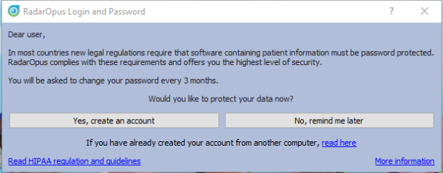
Step 1: Do you want to create an account?
For 30 days you will be reminded to create a local account.

Note: If you do not create an account, there is no problem. You will be able to continue to work without an account.
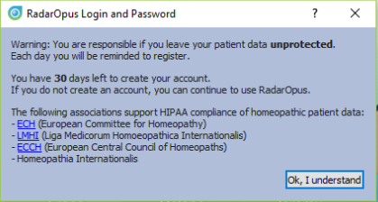
But if you are a profession practitioner we advise you to do so otherwise you do not comply with the above-mentioned regulations regarding the protection of software which contain patient information with a password and data encryption.

You may skip the creation of an account with: No, remind me later.

Note: Even after 30 days, it will still be possible to create an account at any moment you want to do so.

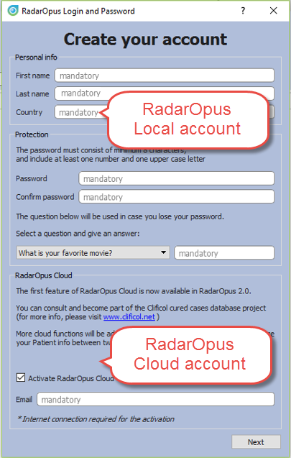
Step 2: Creating an account RadarOpus & Clificol
If you do select “Yes, create an account now“

The account creation consists of two parts:

- Local account
You can create only a Local account to protect your RadarOpus patient information. A “local account” will be the login when you start RadarOpus.

- Please enter a First & Last name and a Password
- Select a Security question & give an answer

- RadarOpus Clificol (cloud account)
You can also select to create a RadarOpus-Cloud account.
At this moment you will receive access to the Clificol database.

Clificol is an extensive cured cases database:
- For more information see www.clificol.net
- Login to the Clificol database http://intranet.clificol.net

You will receive a login and password to Clificol.
This Login and password will be used for future cloud functions also.
Step 3:
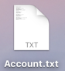
- Save your RadarOpus Cloud Password !!
After registration, on the desktop will be placed a file called Account.txt

Print or note down the login details.
Make sure you delete this Account.txt file and clean your trash box.

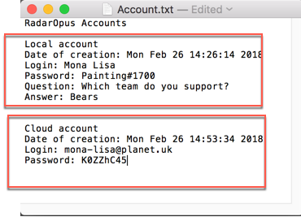
The file will contain two logins & passwords

- The Local RadarOpus account:
The login name & password you entered

- The Clificol (RadarOpus Cloud) account:
Your email address.
And a password which is given to you.

Step 4:
- Confirm RadarOpus Clificol (Cloud account)
You will receive an email. Before you can use the Clificol (RadarOpus Cloud) account, you need to confirm your RadarOpus Cloud (Clificol) account via this email.

How to create a Local or Cloud account later at any moment
You can create a Local account also later at any moment you want to do so.
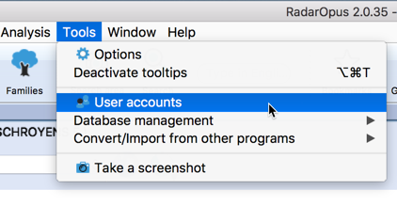
Go to Tools, then User accounts.

- You can create Local account (or change the password).

- You can create Clificol (RadarOpus Cloud) account.

How to change your Name & Address details
You can also make changes to your Name and Address details via the menu Tools, then User accounts

Your practitioner name and address details are used on the invoices.

The Login and Password protects your RadarOpus database.
If you restore your backup for example to a different computer into RadarOpus, you will need to login with the same Login and Password. For more information also read the installation manual

Database and Backup are Password protected & Encrypted*
- The RadarOpus database itself is password protected and encrypted*.
- Also, the RadarOpus Backup (Tools, Database management, Backup) is protected and encrypted*.
(*) From version 2.1 onwards the database and the backup will be encrypted. The backup is secure enough to be stored in a cloud drive

Note: If you would restore a RadarOpus backup into RadarOpus on different computer, you will need to use your login and password to start the software.

Intro Tutorial Videos

Tutorial videos – A Quick Tour
The following tutorial videos will give an overview of the basic functions, so you will be able to work out your first case quickly. For more details see further in the manual.

Select in YouTube:  Full Screen  and  HD 720 or 1080 Quality  Ask for links to  German and Dutch videos | 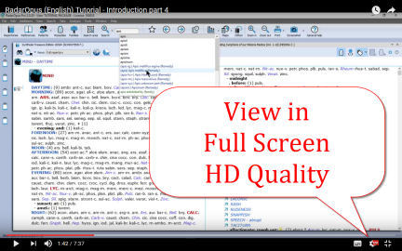
Introduction part 1  See video: Introduction part 1  - Table of contents of: Repertory, References, Patients, Remedies, Families.  - Different windows (Tabs),  - Hotkeys: Alt 1, Alt 2, Alt 3.  - Check the Default settings for your country (ask for the best settings for your country)  - Two methods to save the symptom clipboards (the Analysis) | 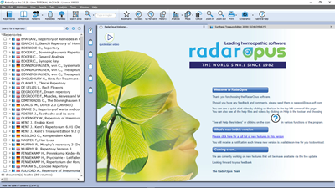
Introduction part 2
See video: Introduction part 2

- Find a symptom when you know where it is.
- with the mouse, with the keyboard
- take a symptom with drag and drop
- Find a symptom, starting from the current location
- click on the symptom path
- use the backspace key

Introduction part 3  See video: Introduction part 3  - Simple search on words  - Take a symptom into a clipboard  - Advanced search: word search  - Using more symptom clipboards  - Search in all documents  - Analysis methods  - Save the analysis to a folder.  - Recall the analysis | 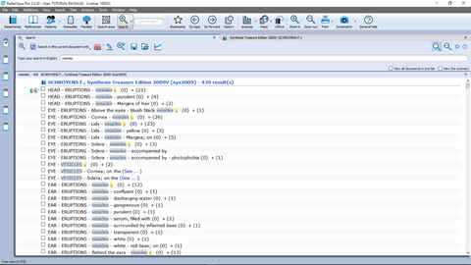
Introduction part 4  See video: Introduction part 4  - Remedy search through Synthesis  - Remedy comparison through Synthesis | 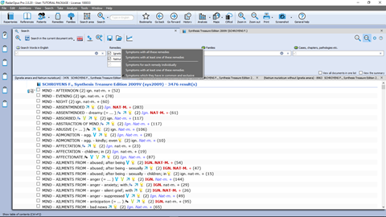
Save clipboards separately  See video: Save separately  - Save clipboards in a quick way, outside of the patient file, but still securely inside RadarOpus. It is called “save to a folder”.  Have your patient information stored in a secure way.  - Export and send to a colleague (not secure) | 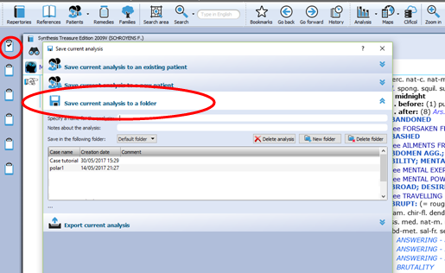
Save clipboards to the patient file (manually)  See video: Save to patient file manually  - Save clipboards manually to the patient file.  Have your patient information stored in a secure way. | 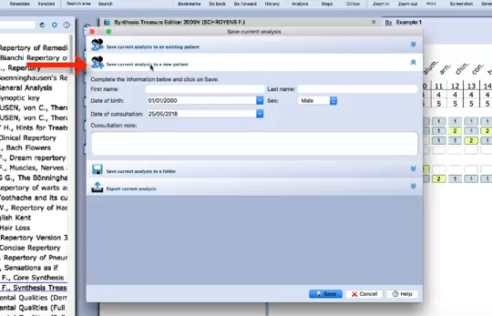
The patient file basics  See video: Patient file basics  - The basics how to work with the patient file, and how the symptom clipboards are saved automatically.  Have your patient information stored in a secure way! | 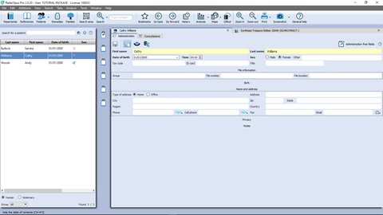
Symptom Clipboards
Symptom clipboards - part 1  See video: Clipboards part 1  - Move symptoms between clipboards  - Use several clipboards  - Move a symptom within a clipboard  - Sort symptoms | 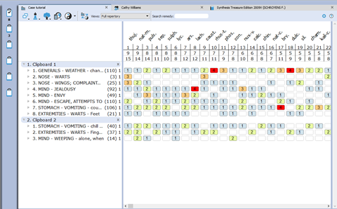
Symptom clipboards - part 2  See video: Clipboards part 2  - Analysis methods  - Symptom intensity  - Combine / group symptoms  - Word search using AND, OR  - Elimination  - Excluding  - Show excluded remedies | 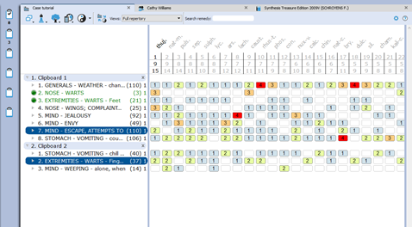
Remedy / Word Search
Using the Search area  See video: Search area  - Search only through one or more sections of the repertory | 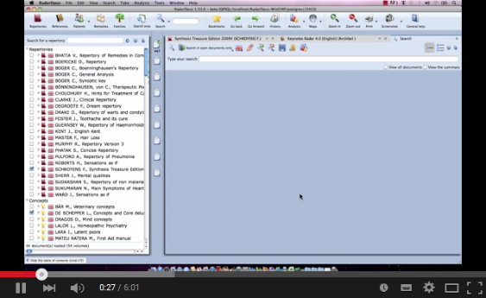
Select the default search location  See video: Default search location  - How to set the default book(s) in which a search is done.  - Example: Word search, Remedy search | 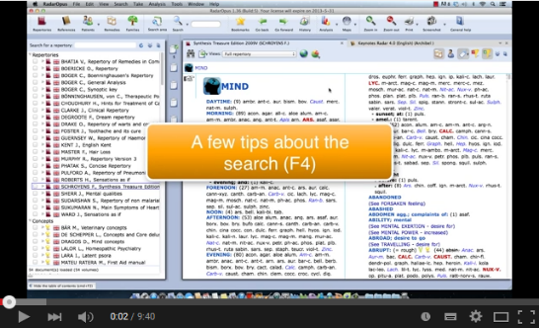
Remedy comparison & search area  See video: Remedy comparison  - How to compare remedies only through a specific search area | 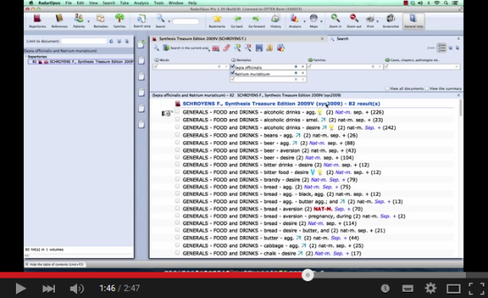
A demonstration of several functions
Demonstration “topic warts”
See video: Dr Subrata Banerjea “warts”

- Search for documents on a topic
- Word search
- Open a new search tab
- Take the search result into a clipboard
- Graph of the search result

Overview of all tutorial videos

List of Tutorial Videos
All these video links are also mentioned throughout the rest of the manual.

Topics | Video link
General & installation
How to view these videos: change size and quality | Video size & streaming quality
Installation: Import of Radar 10.5 cases | Import cases
Introduction
A few new introduction videos  These videos will get you started quickly | Introduction part 1  Introduction part 2  Introduction part 3  Introduction part 4
A General quick tour  (Find, take, search, analyze, save the analysis – patient file) | General Quick Tour part 1  General Quick Tour part 2
Table of Contents of Remedies | TOC of Remedies
Table of Contents of Families | TOC of Families
Repertory Views  Views buttons | Repertory Views Intro (11:57)  Repertory Views Buttons (6:46)
Two Views Buttons | Views buttons
Creating a startup Document mix | Startup Document mix
The symptom path (in the repertory) | Symptom Path
Find
Find symptoms in the repertory (Hierarchical browsing)  Find from current location | Find with F2 and F3
Fast Find and using Backspace  Using the Backspace | Fast Find (2 min)  Using the backspace (5 min)
Take
Taking symptoms into a clipboard | Taking symptoms
Take a symptom with cross references | Take with cross references
Search
The simple search: (part 1) | Simple search: part 1
How to set the default search location | Default search location
Take symptoms from search result: (part 2) | Simple search: part 2 “Take”
The simple search (overview) | Simple search: overview
The simple search: Using Operators | Simple search: operators
The simple search: Use more Search Tabs | Simple search: using more tabs
Search in a: Temporary document selection | Search in a document selection
Search in a: Search area (in only a part of the repertory) | Search in a search area
Fast Search tutorial (using “?“) | Fast Search
Graphical search result + several search tabs | Search result graphically and search tabs
Quick Remedy info
Overview of remedy searches or open a MM (part 1) (part 2) | Overview part 1  Overview part 2
Examples Remedy search (part 1) | Has been replaced
Examples Remedy search (part 2) | Remedy search part 2
Remedy search: Limit to degree or rubric size | Remedy search degree or rubric size
Remedy search via drag and drop | Remedy search Drag &Drop
Advanced Search
Advanced search window: Words, Remedies, Families | Advanced search introduction
Advanced search: Remedy search
Advanced search: Search area (part 1)  Advanced search: Search area (part 2) | Search area 1  Search area 2
Advanced search: Case remedy | Search for a case remedy
Search result: Open more search tabs | Search result graphically
Advanced search: Remedy Comparison
Remedy comparison (short version) | Remedy Comparison (short version)
Remedy comparison (long version) | Remedy Comparison
Remedy comparison: in a search area, open a second search tab
Overview video: using the topic “warts” from Subrata Banerjea | Subrata Banerjea “topic warts”
Clipboards & Save the analysis (manually)
Save the analysis (clipboards) to a folder | Save analysis to a folder
Save the analysis to the patient file (manually) | Save to a patient
Save the analysis to the patient file (automatically) | Using the patient file part 1
Two new symptom clipboard videos (RadarOpus 2.0) | Symptom clipboards part 1 (new)  Symptom clipboards part 2 (new)
Symptom clipboards (older version) | Symptom clipboards (older version)
The Analysis
General introduction analysis window | See videos about the clipboards
Show remedies excluded from the analysis (eliminative, families) | Show excluded remedies from analysis
Analysis methods - Modules
Boenninghausen Pocketbook (Allen): Polar analysis | Boenninghausen polar analysis
Heiner Frei: Polarity analysis | Heiner Frei polarity analysis
Herscu: Cycles and Segments | Herscu Cycle and Segments
Vithoulkas Expert System (VES)
Families & Maps
Family classification introduction | Family classification intro
Family search in the repertory | Families search part 1  Families search part 2
Maps: Kingdoms (Will Taylor)  Periodic table (Jan Scholten) | Use Maps Kingdoms (Will Taylor)  Use Maps Periodic table (Jan Scholten)
More Tools
Remedy Information Window
Languages and translation tools
Concepts: Veterinary – Morrison - Petrucci | Using Concepts
Repertory additions
Making repertory additions part 1 | Making repertory additions part 1
Import & share repertory additions | Import repertory additions
References: Materia Medica, Journals, Therapeutics
Browse in Materia Medica, Journals, etc. | Browse Reference documents
Patient file
Save an analysis to the patient file (manually) | See: Clipboards
Save the analysis to the patient file (automatically) | Using the patient file part 1
Patient search
Patient search
Backups and Restore
Making a backup | Making a backup
Content updater
How to use the content updater (check for updates) | Content updater

Introduction

RadarOpus “Engines”
There are a few ‘engines’ of RadarOpus available: Mini, Silver, Gold, Diamond, each step with more functions and featured. This manual shows screenshots mostly of the Diamond engine.
For an exact overview of all the functions available in each engine, please see separate leaflet.
- Mini: 1 symptom clipboard
- Silver: 3 symptom clipboards, simple patient file
- Gold: 6 symptom clipboards, repertory views, personal aditions, medium patient file
- Diamond: 12 symptom clipboards, repertory views, advanced personal additions, families repertory, concepts, advanced patient file.

Introduction to RadarOpus
The revolutionary concept of RadarOpus is that all homeopathic information is available from within one program. There is now only one interface, one database, one homeopathic Library.
You can search in only one repertory, in a few selected books, or in your whole library.
In the RadarOpus Library you can have access to: (depending on your package)
Repertories:
- Real Repertories: Synthesis (several versions & languages), Murphy, Boenninghausen, etc.
- Concepts: a concept (an idea, pathology or theme) points to related repertory rubrics.
- Families: grouping of remedies based on relationships (several groupings are possible).
References:
- Real Materia Medica: Allen, Hering, Boericke, etc.
- Cases / Philosophy / Therapeutics / Journals, etc.
Patient data
- Patient file (+ Analyses): administrative and consult info.
- Analyses separately saved to a Folder (saved outside of the patient file).
- Clificol: a central database for verification and scientific research.
Remedy and Author (sources) information
- Proving websites: with recent information, provings background, order info, etc.
- General background info like: Multimedia, Family-info, Wikipedia, Google images, etc.
- Author and source background info
Internet
- Full integration and direct access to internet (optional)
Languages
- Repertories and materia medica are optionally available in several languages.
Maps, Wizards and Modules
- RadarOpus also has a wide range of add on modules and wizards.

Homeopathic quality and reliability
Because in recent years the homeopathic development has been so extensive, and some homeopathic approaches are growing so far apart, RadarOpus has set the goal to integrate all, but at the same time making sure to indicate (tagging) carefully what type of information and how reliable it is. And giving the user full control over what type of homeopathic information he wants to work with. If you show in Synthesis the author references, you can see exactly from which source an addition is coming.

In RadarOpus quality and reliability come first.
Some other repertories went into another direction of having quickly more and more content first. Other repertories start to focus on “clinical symptoms” (pathology names).
This trend has a negative effect on individualization and homeopathic quality. RadarOpus in contrast has set as target to increase reliability and quality even more than has already been achieved with Synthesis.
For future editions of Synthesis, the goal is to achieve a 100% level of homeopathic transparency and reliability, and tracing back all additions to its original materia medica sources.

Introduction Part 1

Tutorial videos: introduction
Please see the above already mentioned section: Intro Tutorial Videos number 1 - 4
These first videos will give an overview of the key features of RadarOpus, so you can quickly work out your first case.

How to start RadarOpus
- (On Mac): you can start RadarOpus from the folder Applications then a folder RadarOpus, then the program icon RadarOpus.

- (On Windows): you use the shortcut on your Desktop, or from the Start menu, go to All programs, then go to the folder RadarOpus, and click on the RadarOpus icon.

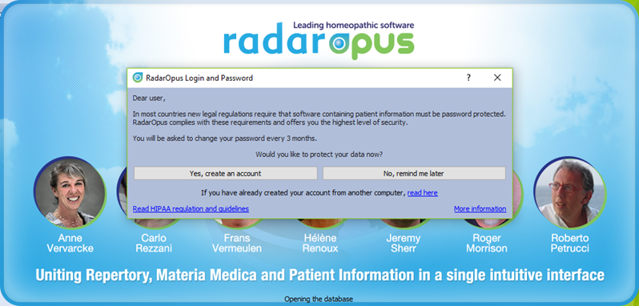
A user account
For information how to setup an account see previous chapter User account.

The first time you start RadarOpus you will be asked to create an account.
In most countries, new legal regulations require that software which contains patient information must be password protected and have an encrypted database*.
RadarOpus complies to the HIPAA regulation for Patient data protection!

RadarOpus will ask you for 30 days to create an account. If you have not created an account after 30 days, you will be able to continue to work without an account. You can create an account at any time later again.

*Attention: It is no longer allowed to have any patient information stored in non-password, and non-encrypted files. You are not even allowed to send an email to a colleague with any patient name mentioned.
You may also not store such patient files in a cloud drive or on your own computers drive.
Please check the regulations in your country.

Account.txt document
Attention: On your desktop will have been placed a file called Account.txt
It contains a password to login to: Clificol & RadarOpus Cloud
(this is a different password compared to local account password)

Print or note down the login details and keep it in a safe place.
You should delete this “Account.txt” file, also from your trash box.

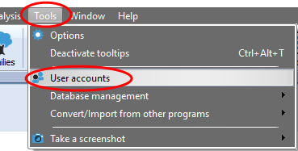
Create an account after 30 days
After 30 days you will no longer receive a reminder to create an account. If at a later moment you want to create an account, go to Tools, then User accounts.
Then select Account and Cloud

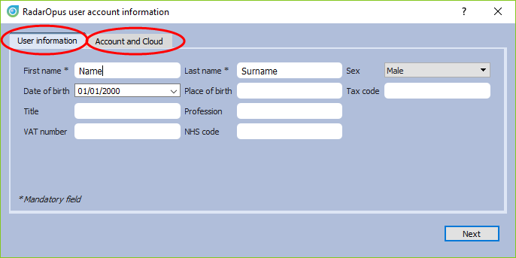
There are two tabs:
- User information
These details will be used for example in the patient file when you print an invoice or prescription.

- Account and Cloud
Here you can create a password protected account.

For more information also read the chapter User Account.

Welcome Window
When RadarOpus starts the first time the Welcome window will open. You can close the Welcome Window and select not to see it again. You can always open it again via the menu bar Help.

Startup documents
Each time you start RadarOpus it will open with the last documents you had open when closing RadarOpus. If you would like to start RadarOpus always with a certain selection of documents opened automatically, you can create a startup book mix. (See elsewhere for more info)

Be sure you check out also the General Help icon and especially the Context Sensitive Help icon, which offer a rich amount of help text and videos and check out this additional user manual and videos!

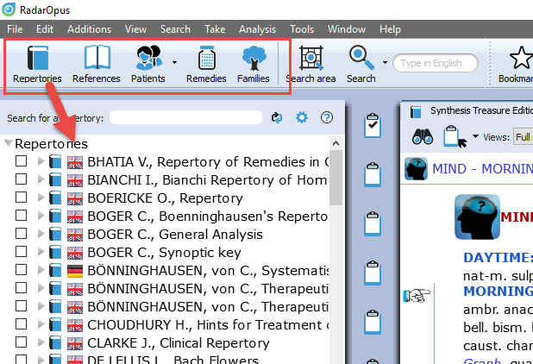
The Table Of Contents (TOC)
The first five icons in the toolbar let you display the Table Of Contents (TOC) of:

- Repertories (Repertories, Concepts, Families)
- References (MM’s, Journals, Therapeutics, etc.)
- Patients: a list of all patients in the patient file
- Remedies: a list of all remedy abbreviations
- Families: a list of all available family groupings

You can also use the hotkeys to open these five Table Of Contents.
- (On Windows): Ctrl+1 (Repertories), Ctrl+2 (References), Ctrl+3 (Patients), Ctrl+4 (Remedies), Ctrl+5 (Families).
- (On Mac): Cmd+1 (Repertories), Cmd+2 (Patients), Cmd+3 (Remedies), Cmd+4 (Remedies), Ctrl+5 (Families).

Switch between Windows (Tabs) with Hotkeys
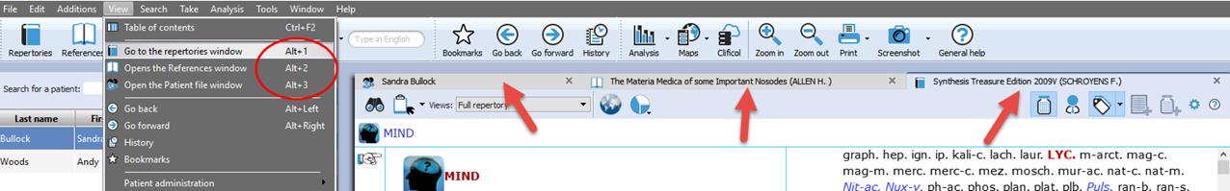
After you have opened a Repertory window, a Reference window and a Patient window, you can also use hotkeys to switch between these three main windows: Alt+1, Alt+2, Alt+3
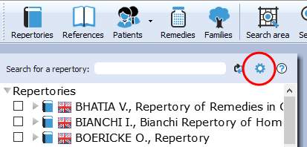
Local options
Many windows have a local options button, which allows you to select some settings to adapt to your preference.

Tip: Advised default settings
Make sure you check if there is a list with Advised default settings which works best for your country.

For example, in the table of contents of Repertories and References, it is best to select: Show All Languages. This will always show all books you have available in your package.

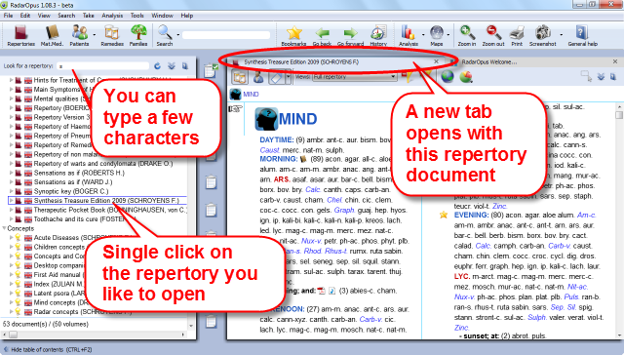
Open a Repertory
From TOC of the Repertories, you can open one of the repertories with a single click on its name.

A Window (Tab) will open for that repertory.

All Repertories in one Tab, all References in another Tab
All items in the list of repertories will open in the same Tab, all on top of each other.
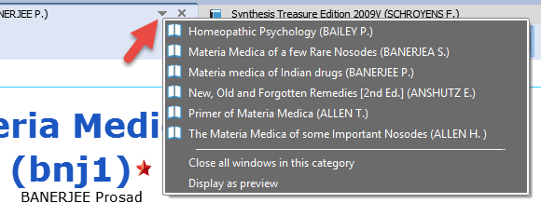
If you open items from the list of references, they will all open in a second Tab.

A small triangle indicates there are more documents open in that Tab. With a click on another title you can open it.
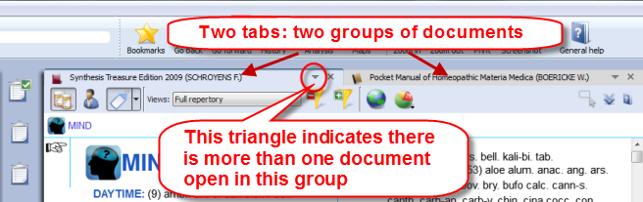
In this example there are two tabs, one for the repertories and one for references. The triangle in the right upper corner indicates that there is more than one document available in that tab.

Other tool bar icons
There are several other tool bar icons. Some are self-explanatory, and some will be discussed in this manual later on.

TOC of the Remedies
There is also a Table of Contents with a list of all remedy names. This Remedies TOC enables you to quickly open the Remedy Information Window (RIW) of that remedy.
See video: TOC of Remedies
From the RIW you can consult keynote MM info, see the family info and other members of that family, as well as do a remedy search in your whole Library etc.
For more information see in the chapter: Remedy Information Window

TOC of the Families
There is also a Table of Contents with a list of all family-levels. This Families TOC has two main functions:
- It opens the associated “Families-repertory” to that level, so you can see all other members of that family.
See video: TOC of Families
- You can use a Right mouse click to limit or highlight your analysis to this family-level.
For more information about using Families and the use of this TOC: see the chapter about Families.

General program options: Change ‘Menu language’ etc.
The general program options can be changed via the menu.
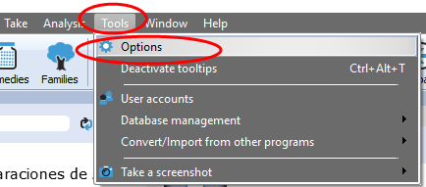
- [On Windows]: Tools, then Options.
- [On Mac]: via the RadarOpus menu, then Preferences.
In some languages, it is located in the menu Tools then Options.

You will find for instance the following options:
- Language: Here you can change the general language of the menu bar.
- User account: Set a Login and Password
- Database management: Making a RadarOpus backup
- Convert / Import information from an older RadarClassic (8, 9, 10 or 10.5)
- Your name and address on the invoice and prescription: this can set via Patient file submenu

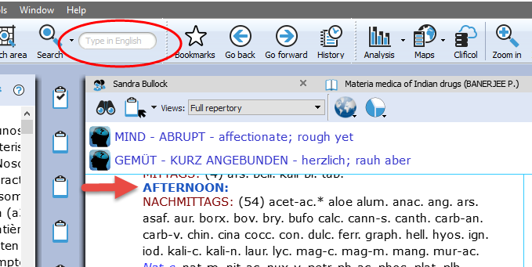
The language of the Search box
This Quick search box allows to do a simple Word search.
You must type in the language of the current document.
If you have a bi-lingual Synthesis or other document open, then you should type in the first language shown in that document.

If you open for example a German materia medica document, then you will need to type in German.
If you show the Synthesis repertory in English, with a second language German, you can search in English.

Tip:
You can also open the Simple (word) search window if you press on the keyboard the question mark “?” or the F4 key. Or you can open the Advanced search with F5 key.

If you know the exact location of the symptom use the Find option, to browse to that symptom.
For more information see below.

The language in Synthesis: How to show a second language
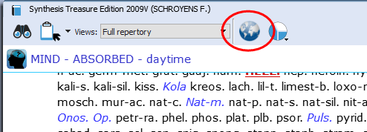
Read more in the chapters Synthesis and Search how you can show a second language in Synthesis, and search in both languages.

If you have an additional language in your package, you can display it via the World icon, then Additional languages.

[For Mac users] Tips & a few hotkeys (print, copy & paste)

Switch the Function keys (F1, F2, etc.)
By default, the function keys on a Mac keyboard are assigned to the special Mac functions.
If you would like to use the F1, F2, F3 keys directly without needing to hold down the Fn key then you can change this. From your Apple icon, select Preferences, then search for this option in the Keyboard section.

Right mouse click (Secondary click) or Two finger tap (Trackpad)
Go to your Apple icon, then Preferences to check the settings for the Trackpad. Make sure it is set to what you prefer best. Keep in mind that Ctrl+Click is also similar to a right mouse click
Having trouble when typing? (the cursor always jumps to a different position)
If you are having trouble when you are typing text, that the cursor jumps each time to a different location, then this is caused because you touch the trackpad with the ball of your hand. The solution is to deactivate the option: “Tap to click”. Go to the Apple icon, Preferences, then Trackpad.

Making Screenshots
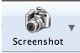
In RadarOpus there is a button in the main toolbar to make a screenshot of the whole screen. But Mac also has general hotkeys to make screenshots of only a particular section of the screen or the whole screen.
See video: copy-paste (MAC users)

Hotkey on Mac | Function
Shift+Cmd+3 | Takes a screen shot of the entire screen
Shift+Cmd+4 | Allows to select a specific area of the screen
Shift+Cmd+4 (spacebar) | First press Shift+4, then press spacebar: this will allow you to select one of the windows, if different programs are open.
“Camera button” | From the camera icon in RadarOpus you can make a full screen copy or a copy of the current window.

Copy and paste symptoms from the Repertory, the Clipboard or from a Reference window.
It is possible to copy and paste a symptom (with or without the remedies) anywhere in the Repertory. You can also do this in a symptom Clipboard or in any Reference document.

Hotkey on Mac | Function
Cmd+C | If you do not have any symptom selected in a clipboard:  - This copies the Analysis, then go to your text editor and press  Cmd+V and this will paste the analysis in a RTF format.
Cmd+C | When you have selected one or more symptoms:  - In the repertory: copies the symptom text + the remedies.  - In the clipboards also.
Cmd+C | In a clipboard, if you do not have any symptom selected:  - This copies the Analysis
Shift+Cmd+C | - In the repertory: copies the symptom text only  - In the clipboards/analysis: idem
Cmd+A | - In the clipboards/analysis: first select all symptoms in a clipboard with Cmd+A. Then you can use Shift+Cmd+C to copy the symptom text only, or Cmd+C to copy the symptoms with the remedies.
Cmd+V | - This pastes the copied info to e.g. a Word document.

[For Windows users] Tips & a few hotkeys (print, copy & paste)
See video: copy-paste (Windows users)

Hotkey on Windows | Function
PrintScr | - This keyboard key makes a screen shot of the entire screen (although nothing appears to happen). Then switch to Word and press Ctrl+V to paste it to Word. You can also past it into Paint and then again select only a particular section.
“Camera button” | - From the camera icon in RadarOpus you can make a full screen copy or a copy of the current window.

Copy and paste symptoms from the Repertory, the Clipboard or a Reference window.
It is possible to copy and paste a symptom (with or without the remedies) anywhere in the Repertory. You can also do this in a symptom Clipboard or in any Reference document.

Hotkey on Windows | Function
Ctrl+C | If you do not have any symptom selected in a clipboard:  - This copies the Analysis, then go to your text editor and press  Cmd+V and this will paste the analysis in a RTF format.
Ctrl+C | - In the repertory: copies the symptom text + the remedies.  - In the clipboards also
Shift+Ctrl+C | - In the repertory: copies the symptom text only  - In the clipboards/analysis: idem
Ctrl+A | - In the clipboards/ analysis: first select all symptoms in a clipboard with Ctrl+A. Then you can use Shift+Ctrl+C to copy the symptom text only, or Ctrl+C to copy the symptoms with the remedies.
Ctrl+V | - This Pastes the copied info to e.g. a Word document.

Introduction Part 2: The Repertory Window:
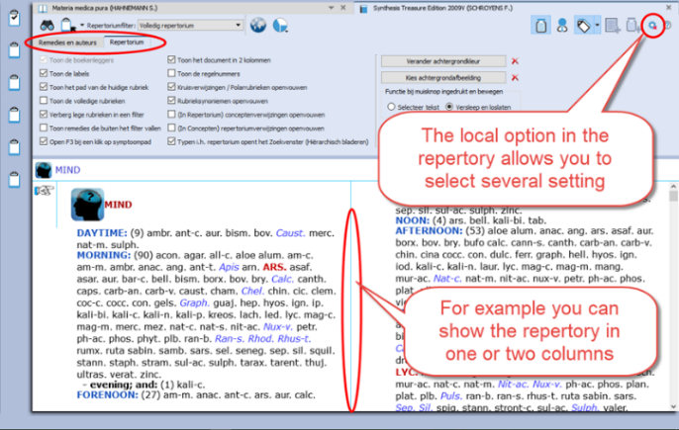
Local Options
Have a look at this Local Options of the repertory window to see the options that can be set to your preferences. For example:
- One or two columns display
- Expand/collapse cross-references (advised expanded)
- Expand/collapse concepts (advised collapsed)
- Show the symptom tags (advised on)
- Show tooltips on remedies and authors (advised on)

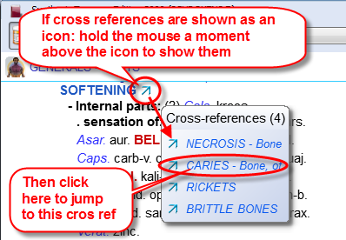
Cross-references can be shown as arrow icons only (collapsed). To see the cross-references, you need to hover your mouse a moment above the icon to open a (tooltip) window with the list of cross-references.
Click on one of the cross-references to jump to that rubric.

If you like to show all cross-references fully (expanded or collapsed), you can change this via the Local Options menu in the right upper corner.

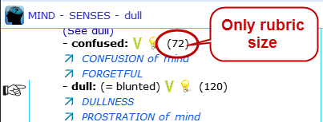
Spacebar Toggle
The Spacebar has a special function in a repertory window.
Press on it three times and it will switch between three different displays:
- Only the number of remedies
- Show also the remedy abbreviations
- Show also authors (source references)
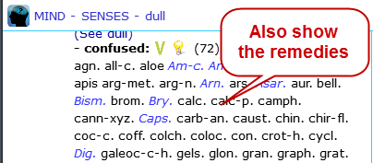
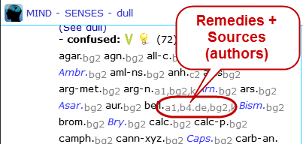

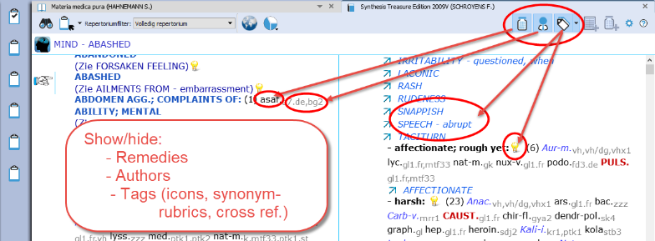
Show: remedies, author (source) references or “tags”
How to use the three buttons at the right upper corner of the repertory: turn on/ off the remedies, the source references (authors), and also the tags (labels)

Attention: The Tags button will hide/show the Referring rubrics (synonym rubrics), Cross references, and Concepts icons

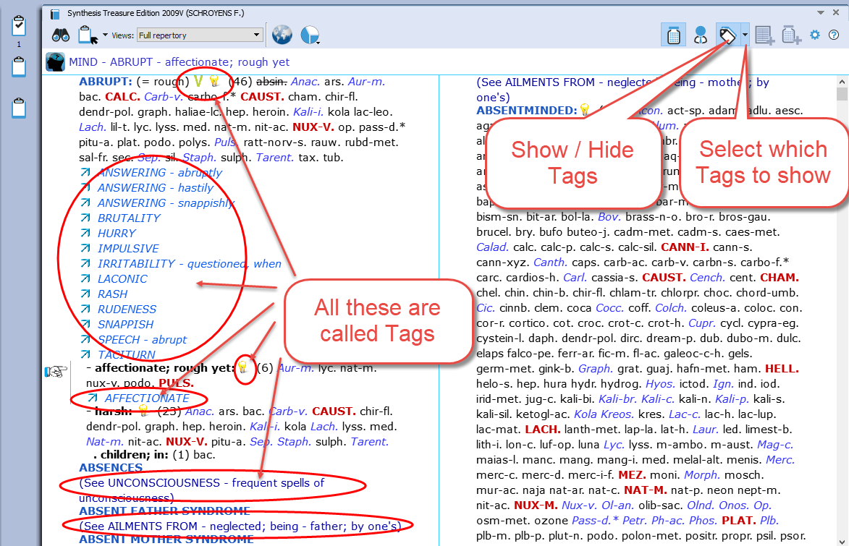
About Tags
Any symptom in the repertory or in the materia medica can have one or more Tags connected to it.
Tags are:
- Bookmarks,
- Miasma labels
- Cross-References,
- Synonym rubric links,
- Concepts link, etc.

With the main Tags button, you can select to show the tags on/ off.
With the sub-button you can select from a list which type of tags should be shown.

Local options
- you can select to show all cross references (expanded) or only icon (collapsed)
- the same for the concepts, you can show them expanded or collapsed to an icon.
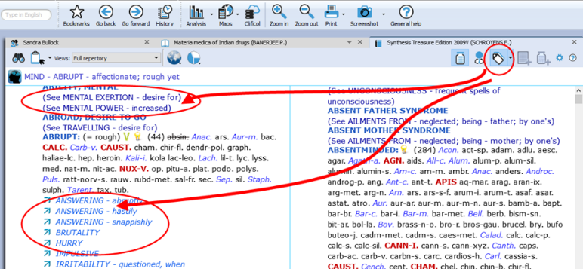
Referring rubrics (Synonyms):
The empty referring rubrics (synonyms) point to the synonym rubrics that have remedies in them.

Attention:
“the Show/Hide Tags” button will also hide the referring rubrics and cross references.
More explanation about tags can be found elsewhere.

Repertory Views
With Repertory Views you can select which sources (a source is an author and a document) you want to see in your repertory.
See video: Repertory Views intro (11:57)
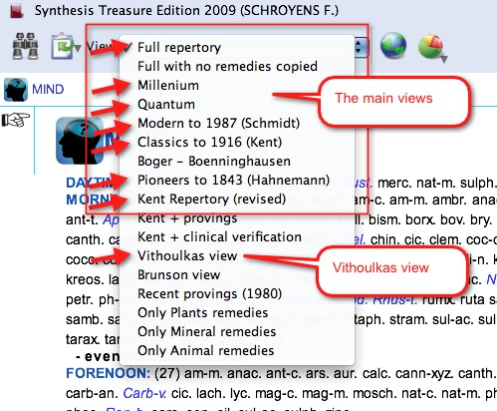
The main views, which are listed from more sources to fewer sources, are (from above downwards):
- Full Synthesis (with also remedies copied from sub-rubrics to the main rubric, if appropriate). This contains all sources, including e.g. Jan Scholten- non-proving sources, dream and meditation sources.
- Full Synthesis (not with these remedies copied from sub-rubrics to the main rubric)
- Millennium (which contain many of the new remedies, this view is considered progressive)
- Quantum (which contains only the more traditional remedies, but still modern sources like Desk Top Guide by Roger Morrison are included)
- Modern till 1987 (Schmidt) (this view contains all sources up till Pierre Schmidt)
- Pioneers till 1843 (Hahnemann) (this view contains all sources until the death of Hahnemann)
- Kent Repertory (revised) (This view is the starting point of all the above views and contains the original Kent Repertory, slightly modified and corrected. The Food and Drink symptoms (Desires and Aversions) for example are all located in the chapter Generalities.

Note: The functionality of the repertory views will be extended greatly in future live updates.
e.g. you will for example be able to apply a view based on a family selection

The two View-option buttons
There are two Views-option buttons. One shows/ hides the number of remedies which are excluded from a view. The second button can show/ hide rubrics which do not have any remedies in that view.
See video: Views buttons (6:46)
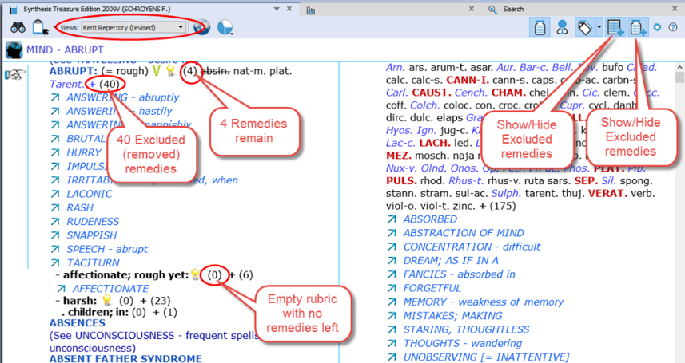
Show/ hide remedies excluded from a View
Applying a Repertory-View is like applying a filter.
Some remedies will fall outside of that view. There are also rubrics which can have all remedies removed in a certain Repertory View.

View buttons
The two Views icons let you show/hide the number of removed remedies.
You can also show/hide the symptoms which do now have any remedies remaining in a View
When you hold your mouse over the number of excluded remedies, you will see which remedies are excluded.

Repertory translations (Two languages)
Please see the chapter Search & Languages for more information how to show in your language or how to show an additional second language. And how to search for words in different languages.

The Symptom Path
At the top you can see the Symptom path of the current symptom or rubric. The symptom path shows you the current symptom which the hand indicator is pointing to.
See video: Symptom Path
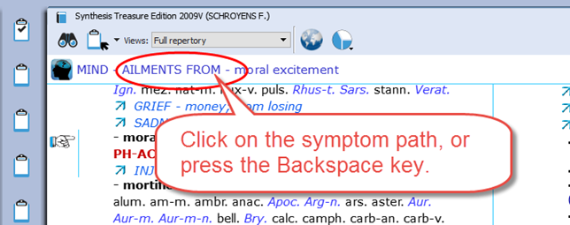

A click on the Symptom Path opens the ‘Find from current location’ (F3)

You can also press one or more times on the Backspace on the keyboard.

Tip:
It is possible to change the function of a click on the symptom path, so that a click on the symptom path only navigates one or more levels upwards, and will not open the Find window.
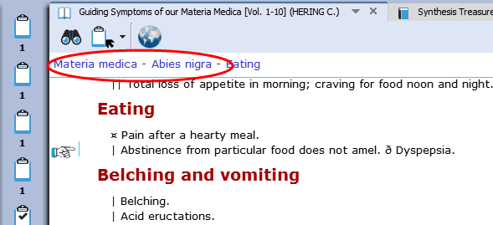
The symptom path in a Reference document
In a reference document, you can also click on the symptom path.

Creating a Startup Document mix
It is possible to define one or more document-selections (document mix) and then select one of them as Startup mix.
See video: Startup Document mix

Then RadarOpus will automatically open these documents for you.
In your startup documents, you can include not only a repertory and some materia medica books, but also a concept-document or other type of documents.
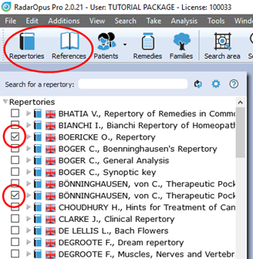
- First use the selection boxes to select documents. This can be from Repertories and from the References Table Of Contents.
- Secondly you go to the menu File, then Save selection as a document mix.
- The third step is that you go to File, then use Select a default document mix.

Tip: via the local options you can show or hide the selection boxes.

Find

Find symptoms in the Repertory: Hierarchical browsing (F2)
Make sure you view the Introduction videos, which also cover the topics:
- Find a new symptom
- and Find from the current position
See video: Find with F2 and F3
One of the most frequently used functions is ‘Finding’ symptoms in the repertory when you know where they are located.
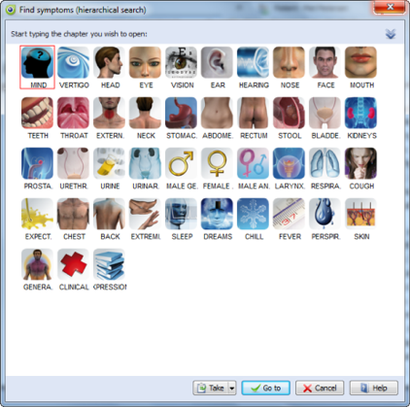
With Find, you first select the Chapter, then the Next level (e.g. main rubric), then again, a Next level (sub-rubric).

You can start to ‘Find’ in several ways:
- Just start to type the first characters of the chapter on the keyboard.
- Via the keyboard function key: F2
- With the Local Find button in the toolbar of the document window
- From the Main toolbar, open the Search sub-button, then select Find a rubric
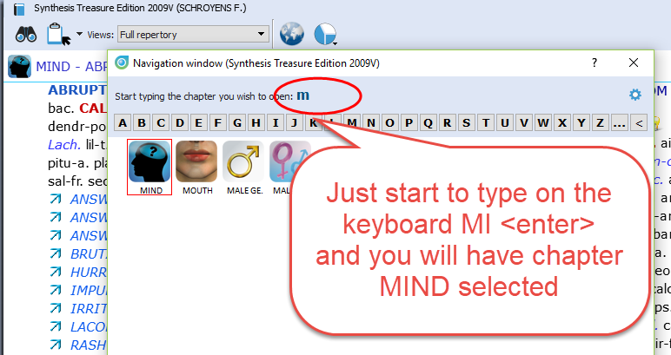

Find: Just start to type on the keyboard
You can just start to type any character of a chapter on the keyboard and the CHAPTER icons window will open.

In the repertory window Synthesis:
Start typing MI <enter> and you will select the chapter MIND

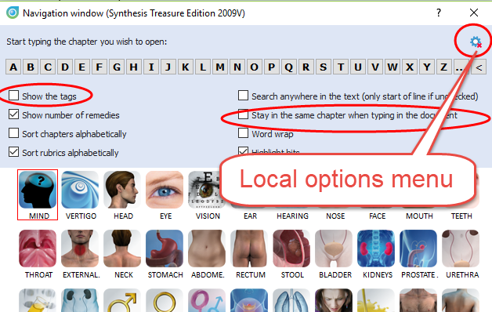
Tip: Stay in the same chapter
The Find window also has a local options menu.
- Here you can select “to stay in the same chapter when you start to type”. Then when you start to type a character it will open the Main-Rubric (symptom) level of the chapter you are currently in. This might be interesting for ex-Mac Repertory users.
- You can also select to show/hide the tags in this Navigation window.
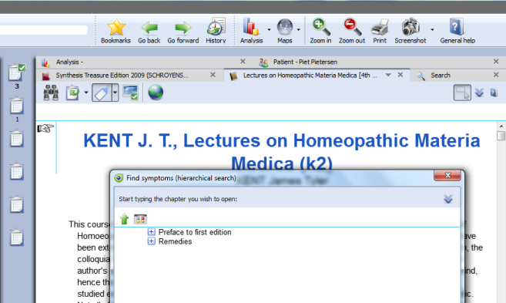

Find: Use the F2 function key
Just press the F2 to open the chapters window.

Note: The Hierarchical Find (F2) works in a similar way when you are in a Reference document. For example, in Kent Lectures on Homeopathic Materia Medica, it opens the Table of Content of this book and shows the available chapters: ‘Preface’ and ‘Remedies’. The structure may vary per document.

Note: The key F3 will open the Find window from the current location the hand indicator is pointing to.
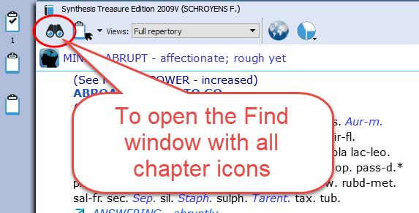

Find: use the local Find button in the toolbar of the document window
In each document window in the left upper corner there is a ‘Find button’ (also called the Navigation window).
It will open a window with all Chapters.
In a repertory it will show the icons of all chapters. In a materia medica it will show the chapters of that document.

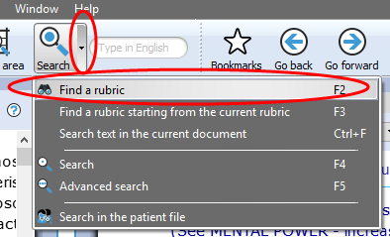

Find: from the main toolbar Search button
From the Search sub-button, you can also select the hierarchical find (F2) function.
It will open the “Navigation window”.

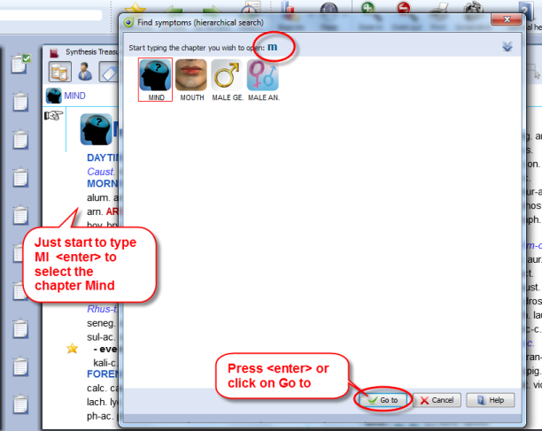
Tip: The quickest way is to just start
typing on the keyboard …
The only limitation with the hierarchical search is that you need to know the exact structure of that document, e.g. in a repertory you need to know exactly where you can find the symptom (rubric) you are looking for.

If you do not know exactly where to look, then you can use the Word-search.
From the Search button sub-menu, or you can press the (?) [question mark key] on the keyboard, or the (F4) or (F5) key.
There is a Simple search (F4), and Advanced search (F5).
See more explanation about Search elsewhere.

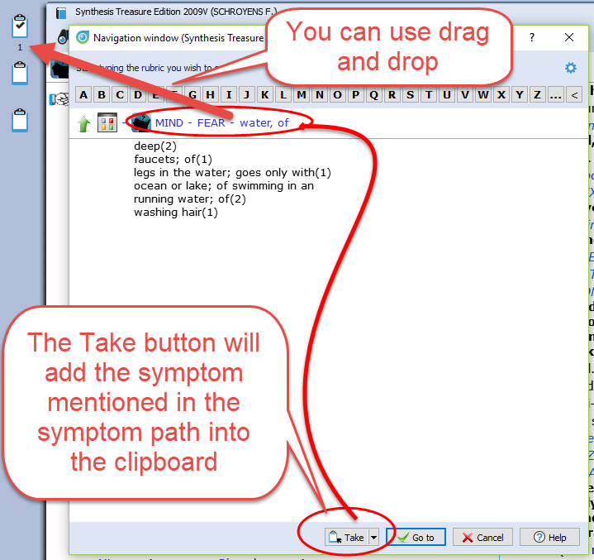
Tip: Take a symptom from the Find window
It is possible to take a symptom into a clipboard while staying in the Find window.
You can use one of the following methods:
- Drag and drop.
- The Keyboard: + <enter>
- The local Take button
- Press the F6 key (take with options)
- Press the = key (take immediately)

Or you can first continue and go to the repertory window with the “Go to” button, and then take the symptom from there.

Finding symptoms from the current symptom (F3)
It is also possible to start your search from the location you are currently at.
For example, if you are in the repertory at: General - Food and drinks - Milk, agg.
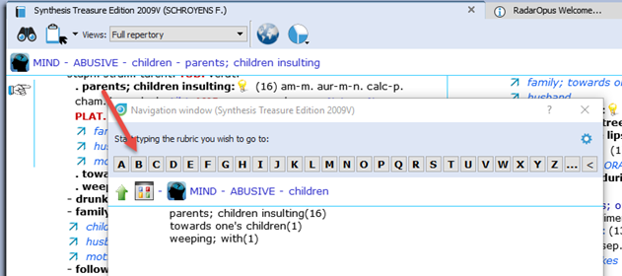
Then pressing the function key F3 will open the Find window with the current symptom already selected.

Or click on the symptom path to open the Find window. It will open at the symptom level you clicked on.

Then you can navigate one or more levels upwards by:
- Clicking on the level you want to go to.
- On the keyboard press backspace one or more times.
- On the keyboard press the Arrow left key one or more times.

To change the way a click on the symptom path functions, read more in the chapter: The Symptom Path

Find from current: Fast Find tutorial - using Backspace
See video: Fast Find and Take (2:07 min)
See this ‘fast find’ tutorial video with an overview how you can use the Backspace key on the keyboard to open the Find window and very quickly find several symptoms
See video: Using the backspace (4:48 min)
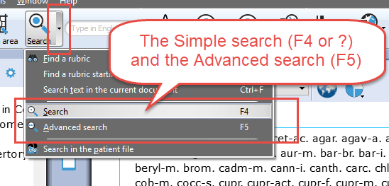

Difficulty finding your symptom?
If you do not know exactly where the symptom is located in the Repertory, then you can “Search on Words” using the Simple or Advanced search.
Remember these hotkeys:
- ? or F4 Opens to the Simple search
- F5 Opens to the Advanced search

Although only the F4 hotkey is mentioned for the Simple search, also pressing on the keyboard the ? will open it also.

More will be explained elsewhere. First, we will continue to explain the Take function.

Take

Taking symptoms into a clipboard
Above you have learned how to look up symptoms, if you know where they are located in the repertory, with the Find (F2) and Find from current (F3) functions.
See video: Taking symptoms
When you have reached the symptom (rubric) you want to use, you can take that symptom into a symptom clipboard in several ways:
- By using drag and drop
- With the keyboard, press: + <enter> (Or: +1 <enter>, +2 <enter>, +3 <enter> etc.)
- With the keyboard, press the: = key, or press the F6 key.
- With the Local Take button
- From the menu bar Take

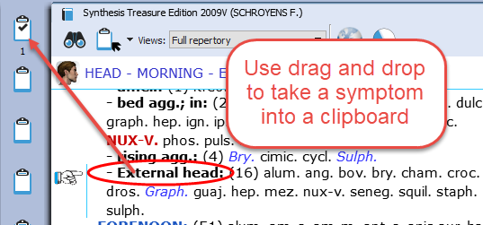
Take with Drag and Drop
You can simply drag a symptom to one of the symptom clipboards to take it.

Note: By using drag and drop the symptom strength (intensity) of a symptom will be 1.

Tip: Working with more clipboards
Normally you can take all symptoms of your case into one clipboard (the first clipboard).
You can also use several clipboards, for example if you want to divide them into categories:
You can for example use clipboard No 1 for the acute symptoms (e.g. acute bladder infection), while clipboard No 2 you can use to add all the chronic symptoms.
With other methods like the Boenninghausen method or with the Ewald Stöteler - Disease Classification of Hahnemann, several clipboards are used (e.g. 8 clipboards according to the flower leaves).

Note: The set of clipboards is for only one patient at the same time
When you save your clipboards, all clipboards are automatically saved as one set. Even if you use only one or only two clipboards, the whole set of clipboards will be saved.
In RadarOpus a set of clipboards is referred to as an ‘Analysis’.
- You should use a set of symptoms for only one patient.
- Before you start with a new patient, save them. Then select clear all clipboards
(Right mouse click on one of the clipboards)

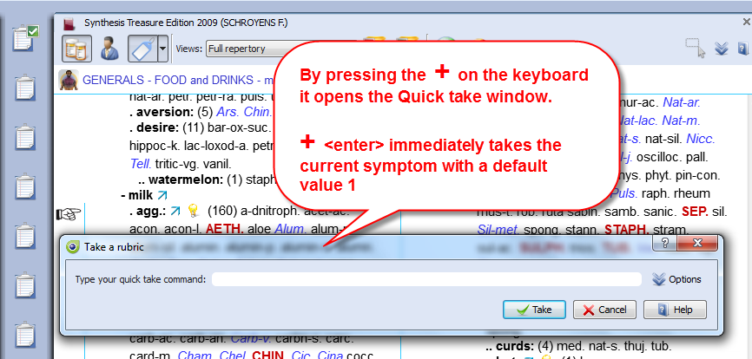
Take with the keyboard using the + key
On the keyboard you can press the + key to open the Quick Take window.

If you do not type any specific option and just press + <enter> that symptom will be taken with the default intensity 1, and it will be placed into clipboard no 1.

A quick way to apply extra symptom strength (intensity) to the symptoms you take can be done by typing: +2 <enter> or +3 <enter>.

Extra Take Options
See the local Option icon in the Quick Take window in the right upper corner - when you open it there will be extra options available:
If you press the F6 function key it will immediately open the “Take with options” window

Take with the Local Take button
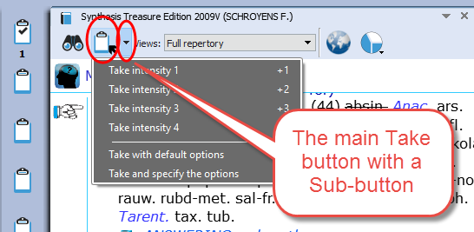
A Local Take button is available at the top of each repertory window (this is also available in a Reference documents).

The Main Take button takes the current symptom with intensity 1.
By default, it will be placed in clipboard No 1.

The Sub-button menu of the Take icon offers more options like for example ‘take with an extra intensity’.

Tip: Take from a materia medica document
You can also Take a symptom from anywhere in a materia medica document into a clipboard. In a materia medica document a symptom is of course connected to only one remedy. If you take several symptoms from a materia medica it might be useful to combine them. Read more under ‘Combine symptoms’.

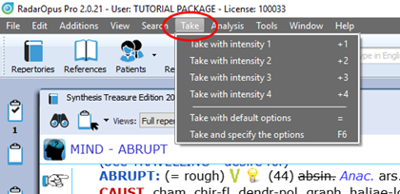
Tip: Take any Reference text as links into a clipboard
You can take text from any reference document, even if no remedy is connected to that text. Such “sentences” are then best added in a separate clipboard. Such a clipboard can be used as ‘links’ to the locations in these documents where you found this interesting text. A double click on such a ‘symptom’ will jump to the original location in the materia medica.

Take via the Menu bar
In the main menubar you can also find a Take menu. Here you can select to take with intensities 1 to 4.
You can also open the Take with options menu (F6).

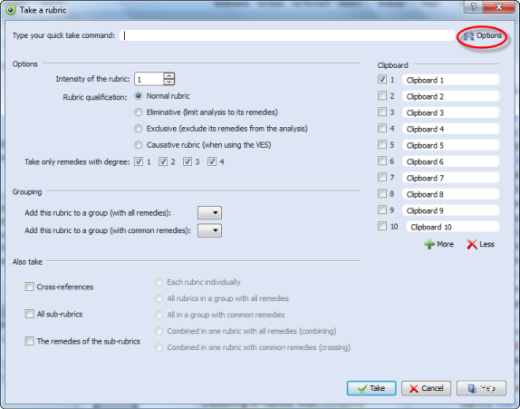
Take with extra options (F6)
When you use the F6 key it will show the Quick Take window with the extra options available:
- Take with an Intensity
- Take as an Eliminative symptom
- Take as an Excluding symptom
- Take only remedies with certain Degrees
- Group symptoms together
- Take also Cross-references, Sub-rubrics
- Select into which clipboard it must be added

Tip: For some of the take options special quick keyboard combinations are available. See below.

More ‘Hotkeys’ to Take a symptom
Below are a few other keyboard commands. You can learn about more keyboard commands in the Help on line. You can take symptoms with the keyboard also as eliminative or causative (for VES).

Here a few examples:

Keys | Function
Intensity 1
+1  or  +1>1 | Takes the symptom with intensity 1, into clipboard 1  This can be done with “+ <enter>”, or +1 <enter>, both give the same result. Or you can also press the = key, or the F6 key.
+1>2 | Takes the symptom with intensity 1, into clipboard 2
+1>3 | Takes the symptom with intensity 1, into clipboard 3
+1>4 | Takes the symptom with intensity 1, into clipboard 4
Intensity 2
+2  +2>1 | Takes the symptom with intensity 2, into clipboard 1.  Both give the same result.
+2>2 | Takes the symptom with intensity 2, into clipboard 2
+2>3 | Takes the symptom with intensity 2, into clipboard 3
+2>4 | Takes the symptom with intensity 2, into clipboard 4
Etc. | (Taking with other intensities works in the same way)
Eliminative
+!  or  +1! | Takes the symptom with intensity 1 as eliminative symptom  (you do not need to type the 1. So, you can also type +!)
+2! | Takes the symptom with intensity 2 as eliminative symptom
Group
+a  or  +1a | Takes the symptom and will place it in a group “a” together with all other symptoms taken with the same character “a”.  For a second group you can use “b” etc.  (you do not need to type the 1. So, you can also type +a)
With sub rubrics
+1/s  +/s | Takes the symptom and also all its sub-rubrics (as a group)  (you do not need to type the 1. So, you can also type +/s)
With cross ref
+1/x  +/x | Takes the symptom including the cross-reference rubrics (as separate symptoms)  (you do not need to type the 1. So, you can also type +/x)

For more keyboard commands, see the Help On Line.

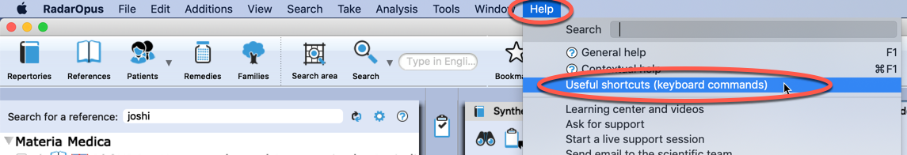

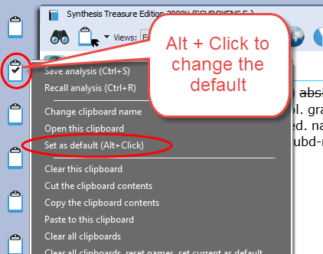
Change the ‘Default’ clipboard
If you take symptoms with the keyboard + <enter> or with the = key, the symptoms will be placed in the default clipboard which is clipboard number 1.

Use Alt+Click on a different clipboard to make that clipboard the default.
Or right mouse click on a clipboard, then Set as default.

From that moment on the symptoms will be placed in this new default clipboard if you use + <enter> or the = key.

Take a symptom with one or more Cross-Reference(s)
It is possible to take a symptom and automatically also include one or more of the mentioned cross-reference rubrics.
See video: Take with cross references
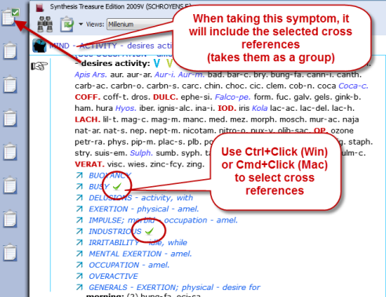
First use Ctrl+Click (Windows) or Cmd+Click (Mac) to select one or more cross references.

If you then take the rubric, it will automatically also take the selected cross-references.
All symptoms will be taken as a group.

Search

The Simple search window: (?) or (F4)
When you are in the repertory you can also press on the keyboard the ? key, or the function key F4 to open the Simple search window.
See video: Simple search part 1
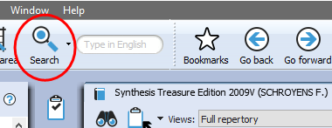
The Main button Search, can open the Simple search, or the Advanced search, depending on what is selected in the local options in the Search window.

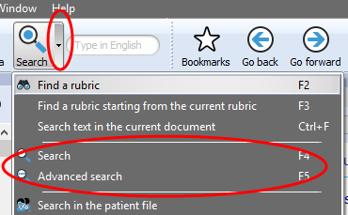
Via the Search sub-button you can select the simple Search or the Advanced search,

You can open the Search window in several ways:
- With a click on the main Search button.
- With the Sub-button menu, then select Search (F4) or Advanced search (F5).
- Directly with the Keyboard F4 or F5 function key.

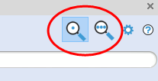

Switch between: Simple or Advanced Search
- You can also switch between the Simple search and the Advanced search with these two buttons in the search window.

- Then check the correct search location (which documents you want to search in).
The three most used search locations are:
- The current document only,
- All documents,
- the Search Area.

Tip: Tutorial how to set the Default Search Location
See video: Default search area
This tutorial shows you how to set the default search location to “search in the current document only” (which is most often the repertory).

- Make sure you select the default the search location to what you prefer.
The two most often used possibilities are:
- Search in the current document only
- Search in all documents

If you set the default search location to Search in the current document only, then you will always first search in the repertory, if you open the search from the repertory window

The language flag indicates in which language documents you want to search: e.g. only in English documents, or in French or in the German ones.

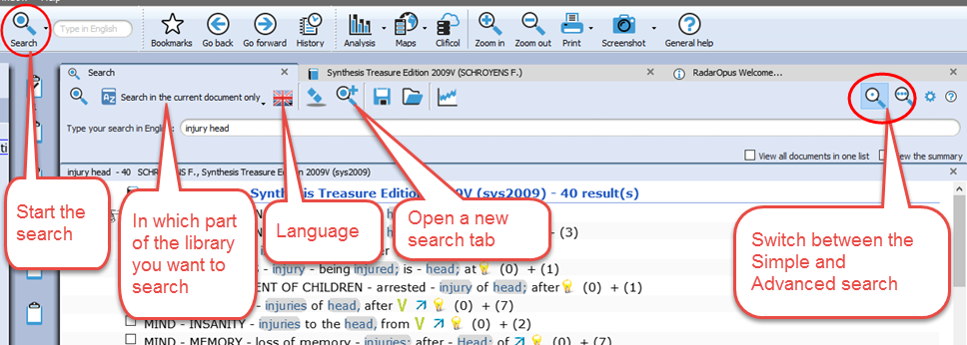

Most icons will be clear, but below a few things explained:

Language flag: This selects the language you want to search in. It will only search in documents of that language. Note that if you have a bi-lingual Synthesis, you will search in the First language.
Search location: You can select in which area of your library you want to search. The most often used are: Search in the current document only. Search in all documents. Search in the search area.
Open a new search tab: After you have done a search, it is possible to keep that search result and open a new search tab (window) and do a new search.

Search example: ‘Ball Head’ (with the Simple search window)
Let’s say you want to find all symptoms in the repertory with the words ‘ball’ and ‘head’. You should do the following steps:
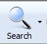
- Open the Simple search window by using: ? or F4, Or click on the Search button in the main toolbar.

- For the search location button select for example:
Search in the current document

- Then just start to type on the keyboard BALL <enter>, then type HEAD <enter>.

- If you press <enter> again, you will start the search (or click on the Search button).

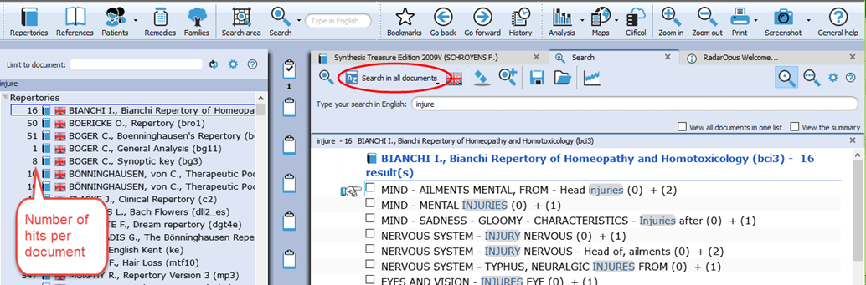
If you search through more than one document a list of titles opens with the number of hits
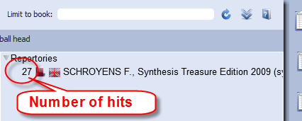
If you search in one document only, the window with the list of document titles does not open automatically. This only opens if you search in several documents

Take a symptom from the search result
See video: Simple search part 2 “Take”
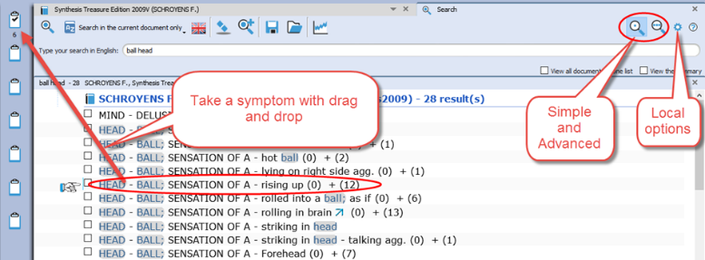
From the search result list you can take symptoms into a clipboard in several ways:

- You can Take symptoms from the search result list with Drag and Drop
- With the = key or the F6 function key
- From the main menu bar Take

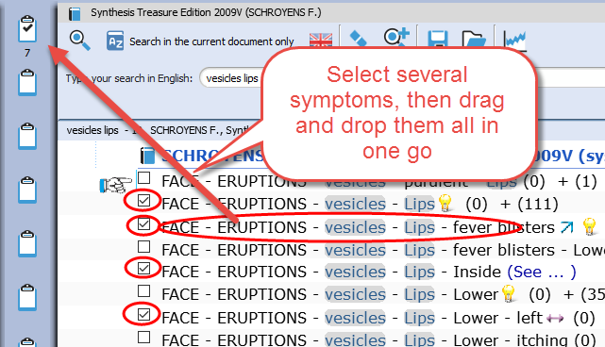
Take multiple symptoms
You can take more than one symptom at the same time by first selecting them with the checkboxes.
If you then use Drag and Drop one of the selected symptoms, you will take all at once.
You can also use Take from the menu bar or use F6.

New: Take all rubrics and create a new combined rubric
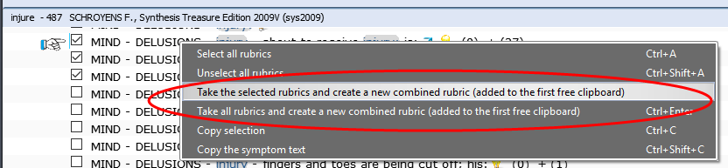
It is possible to right mouse click on a symptom in the search result and select:
- Take the selected rubrics and create a new combined rubric
- Take all rubrics and create a new combined rubric

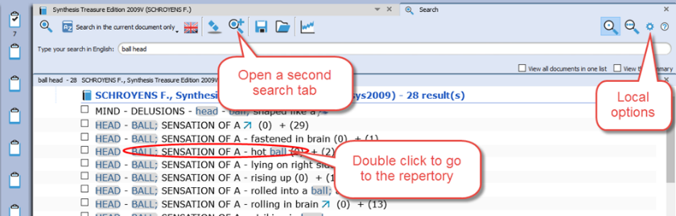
Go to a document (the repertory)
With a Double click on one of the symptoms in the search result list you will go to that symptom in the repertory.

Tip: Local Options
The Local Options window offers several possible settings to adapt the layout of the search result to your preferences. In the beginning it is best to keep the default option.

The Simple search window (Overview Tutorial)
Watch this tutorial video with a quick overview over the following searches:
See video: Simple search overview (part 1)
- One or two words search (In current document)
- Open the existing search result again (Click on the Search tab again)
- Remedy search, Word + Remedy search
- Remedy search in a certain degree or rubric size (Right mouse click on a remedy name)
- Family search, Family search with maximum rubric size

The Simple search window: AND, OR, NOT (Operators)
This tutorial video shows how to use the Operators: AND, OR, NOT.
See video: Simple search using Operators

Key | Function
& | = AND
| | = OR
! | = NOT
By using these operators you can make combinations of: Words / Remedies / Families with AND, OR, NOT between them.

But you do not need to type the AND function.
Two words automatically will be with AND: For example typing “head injury” is is the same as typing “head & injury”

Some examples of combinations:
Word 1 AND Word 2 AND Remedy 1
Word 1 AND Word 2 NOT Remedy 1
Word 1 AND Word 2 OR Word 3
Word 1 AND Word 2 NOT Remedy 1

For example: dream cats ! dogs
This will find all “dream of cats” and there may not be the word “dogs” present.

The Simple search window: Using more Search Tabs
See video: Simple Search: using Search Tabs
If you did a search and want to do a second search, it is possible to keep the previous search result, so you can compare them.
The tutorial video will show you how to work with multiple search tabs and also some of the other functions of the simple search function.
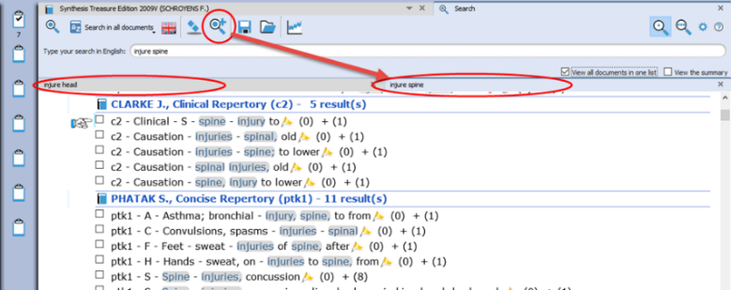
Opening a second or third search tab allows you to compare search results:

- With (slightly) different search words or
- In a different set of documents.

This enables you to compare a search done in the repertory Synthesis to the same search done in all the Reference documents or in your Whole Homeopathic Library.

Search in a (temporary) document selection (mix)

You can search not only in one of the standard search locations like “Current document”, “Open documents”, “All documents” etc., you can also indicate exactly which combination of documents to search in. In RadarOpus this is called a Document mix.
See video: Search in a specific document selection

- Step 1: Select the documents you want to search in the Table of Contents of Repertories or References.
- Step 2: From the Search location drop down menu in the Search window (F4) use the item called The current document mix. “The current document mix” is a temporarily selection of documents. You can select several repertories and/or references with the checkboxes in front of them.
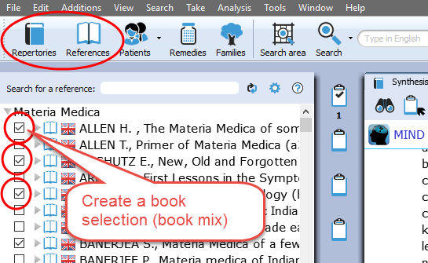
Tip: Create a Document selections (mix)
If you want to use a certain document selection more often, then you should save it under a “Document mix” name.

This can be done via File, Save selection as a document mix

Then you can use this document mix again easily when you search.

Search in a “Search Area” (a part of the repertory)
Often you like to search only in a certain limited area in the repertory. For example you want to find all symptoms of a remedy in a specific chapter or main rubric.
See video: Search in a Search Area
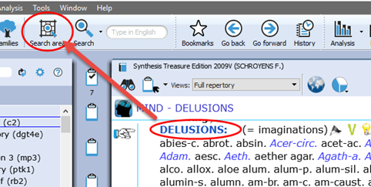
- Step 1: You can drag and drop only one specific area, or several areas, from the repertory to the Search Area button in the main toolbar.
- Step 2: In the search window (F4) select the option to search in a specific search area.

You can use this “Search area” both in the Simple search (F4) and the Advanced search (F5)

Fast Search tutorial
See this very short tutorial video with a summary how to use the “?” key on the keyboard, to do a Word, Remedy or Families search.
See video: Fast Search

Quick Search box

Search for a word
See video: Quick Search Box
You can also use the Quick search box to search on words.
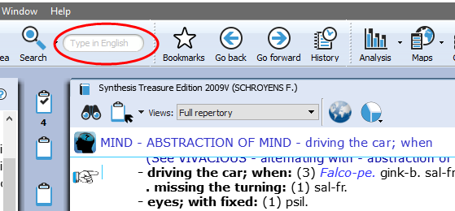
The Quick search box will search in the default location which is set in the search options: e.g. The current document or all documents.

But it probably better to always use the Simple (? or F3) or Advanced search window (F4).

Advice: For novice users it is best to set the default search location to: Search in the current document only.
You will search in the (first) language of the current document.

Search for a remedy
It is also possible to use the Quick search box to search for a remedy. But it is probably better to use the Simple search or the Advanced search window.

Search & Languages

Synthesis languages
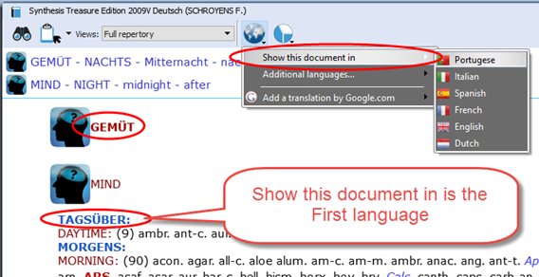
Show Synthesis in a language (= First language)
If you have this option in your package, you can select to show in the repertory Synthesis a second language.

Click on the World icon, Show this document in, selects the language the repertory is shown in.

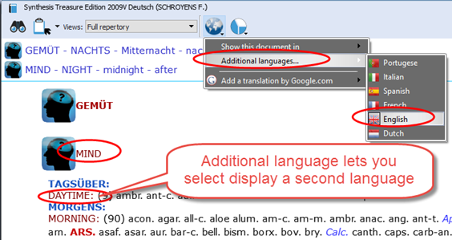
Show a Second language*
Via the World icon, Additional language you can show a second language.

(*) It depends on your package which additional languages you have. Ask your representative if you want to add another language.

Switch the first and second language
If you have 2 languages shown, you can switch the first and second language as follows: via the option Show this language in select the language which you would like to be shown as first language and they will switch.
See the paragraph about Search in a language, how you can search on one of the shown languages.

New: In RadarOpus version 2.0.35 Synthesis has come available also in Dutch. In version 2.1 Synthesis is also available in Turkish.
Other available in languages are: English, French, German, Portuguese and Spanish.

Search in a language

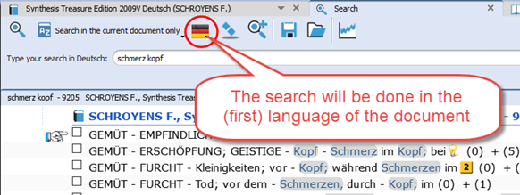
Search in current document
New: When you open the simple search (? or F4) or advanced search (F5), the language flag will show the language of the current document.

You can only search in the first language.

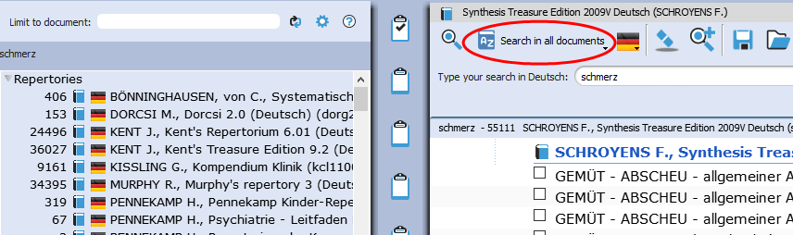
Search in All documents
A Search in all documents will search in all documents of that language (only in the first language of a double language document).

Materia medica & languages

Searching in all References takes the language into consideration in a similar way as with Repertories.
Most documents are only in one language, but there are also reference documents which are in two languages.
Use the World icon to switch the language in that reference document.

Attention: a Word search will only search in the (first) language of all these reference documents (also only in the first language of all repertory documents).

Root & Branches
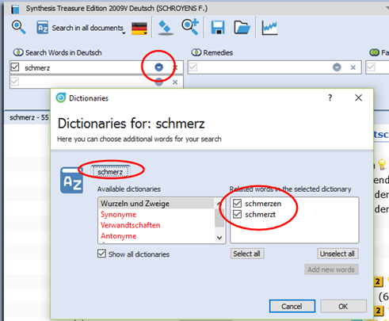
In the Advanced search click on the blue icon to see all Branch words which will be included in the search.

Attention: You can also use the asterix (*) behind or in front of a word.

This can be most useful in all languages where often words are written connected:
See below Dutch examples, but this can be applied in all languages.

For example in Dutch: *kramp
Will find all these words:
- maagkramp
- buikkramp
- menstruatiekramp

you can also use: *kramp* to find all words beginning or ending with your search word
It will find:
- maagkramp
- buikkramp
- menstruatiekramp
- krampend
- krampachtig
- maagkrampachtig
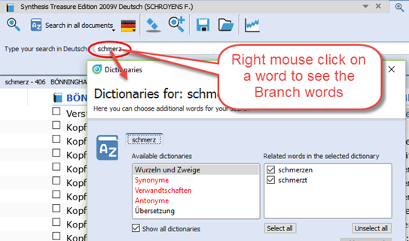
In the Simple search, Right mouse click on a word to see all Branch words.

Concepts & Families languages
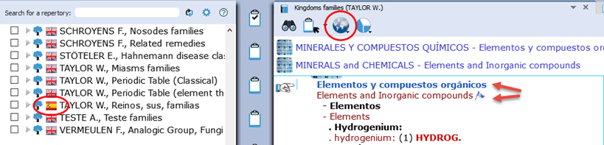
Many Concepts and Families are also available in several languages*.
You can also use the World icon to select the desired first language, and optionally show a second language.

Note that the language flag in the Table of content shows the first language shown in the document.

(*) Ask you representative which repertories are available in your language.

Boenninghausen Pocketbook & other repertories
There are other repertories which also have translations available*.
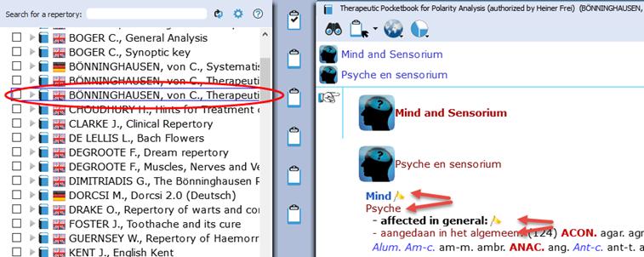
For example the Boenninghausen Pocketbook repertory, Kent repertory, Foster repertory, etc.

(*) Ask you representative which repertories are available in your language. In version 2.0 it was available already in: Dutch, English, French, German, Italian, Portuguese, Spanish

In the below example Boenninghaussen Pocketbook is shown in English as first language and French as second language:

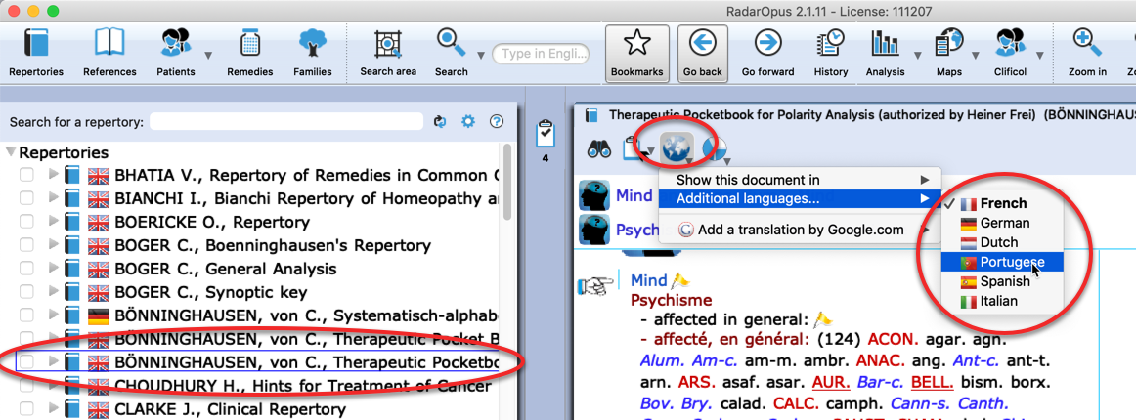
Remedy Info & Remedy Search

Quick Remedy info: Open a MM or Remedy Search

This Quick Tour video will give an overview of many Remedy searches and how you can open a MM to read about a remedy. It is very quick!!
See video: Quick Overview of Remedy searches and how to Open Remedy MM:
Overview Part 1 Overview Part2

Overview Part 1 shows:
- Double click on a remedy abbreviation: Opens reedy information window.
- Drag and Drop a remedy to the TOC
Overview Part 2 shows:
- (A summary of all shown in Part 1)

Example Remedy-search with the ‘Simple search’ window (?) or (F4)
See video: Remedy Search part 2 “Simple search”
You can press on the keyboard the ? or the F4 key to open the simple search window.
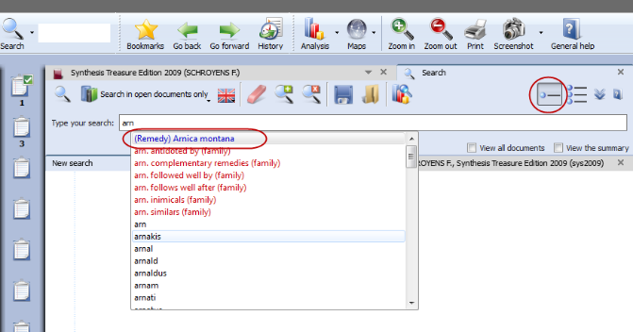
Then start to type the remedy name and from the auto complete box select the item indicated with (Remedy).

Press <enter> to start the search.

Remedy search: Limit to the “Degree” or “Rubric size”
It is also possible to limit your remedy search to a certain degree in the Repertory, or to a certain maximum rubric size.
See video: Remedy search Degree & Rubric size
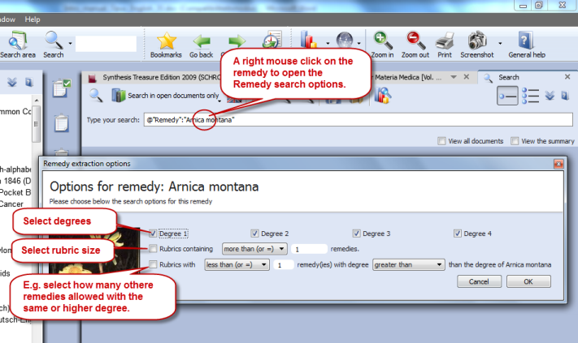
Step 1: First type the remedy you want to search for.
Select from the auto-complete list the item with the indication (Remedy).

Step 2: Right mouse click on the remedy name and the Remedy search options window will open.

From this window you can select the following:
- The degrees of the remedy in the repertory, e.g. you can search for only degrees 3 and 4.
- The Minimum Rubric size (other options possible also).
- The Maximum number of other remedies also allowed with the same degree (other options are also).

Remedy Search via “Drag and Drop”
Elsewhere it has already been explained how to search for a remedy from the Quick search box or the Simple search window (?) or (F4). Here are a few other ways to do a remedy search:

Drag and Drop Remedy search in the Repertory
See video: Remedy Search 1 “Drag and Drop”
In a similar way you can do a quick repertory search for a remedy. Just Drag and Drop a remedy abbreviation to the TOC of repertories.
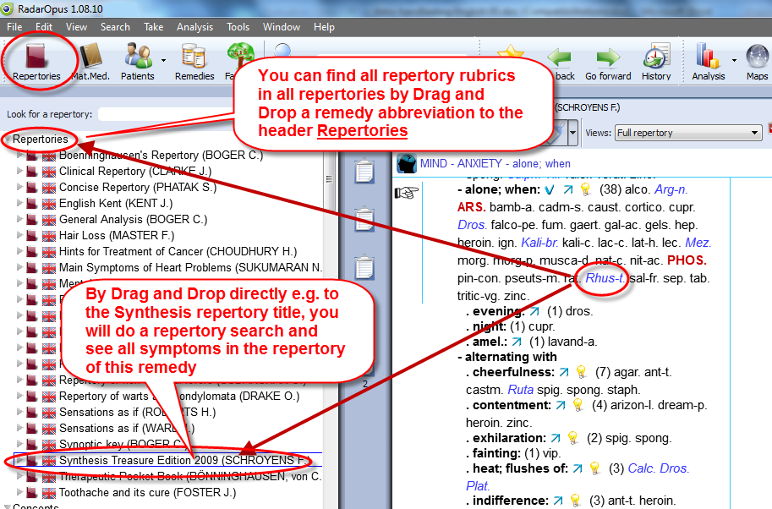
You can drag it to the header ‘Repertories’ or to one specific title.
It will show you: …
- All symptoms in all repertories, or
- All symptoms in the Synthesis repertory only

More information about a Remedy search in the repertory will be given elsewhere.

Drag and Drop Remedy search in a Materia Medica
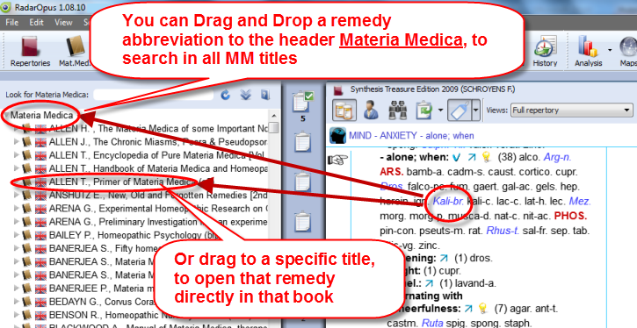
A unique feature in RadarOpus is that you can consult the materia medica inside the same program.
If you switch to the TOC of materia medica, you can then use Drag and Drop to quickly search for a remedy in for example: …
- All materia medica books, or
- Only one specific book

You can drag a remedy abbreviation from the repertory window to the left to the TOC list and drop it on a specific MM title or drop it on the header ‘Materia Medica’.
More information about a remedy search in the materia medica will be given elsewhere.

Advanced Search
Search for: Words, Remedies, Families, Cases

Advanced Search (F5): Words, Remedies, Families
Introduction
See video: Advanced search introduction
With the advanced search window (F5) you can do the same searches as you can do with the simple search window (F4 or ‘?’) but in a different, more guided way.
- It allows more easy use of “Proximity”. Proximity is the “distance between your search words”.
- You also can do easily a Remedy Comparison. (this is explained in a separate chapter below).

Select your default startup: Simple or Advanced search
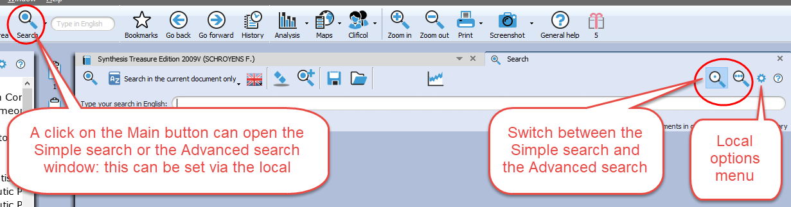
With a click on the Main button search in the main toolbar, can open the Simple search, or the Advanced search window.
Via the local options button in the search window you can set your preference.

Tutorial video
See this tutorial video for an introduction how to use the advanced search window. You can do several types of searches, search for:
- Words
- Remedies
- Families
(or a combination of them)
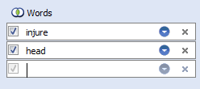
Attention
In the advanced search window enter only one word per field, so if you need to search for two or more words, you need to enter from top downwards only one word per box.

In the example below a search is done for all symptoms with “injure” and “head” if at least one of the “solanaceae” remedies is present. Please see also the Chapter Families & Maps.
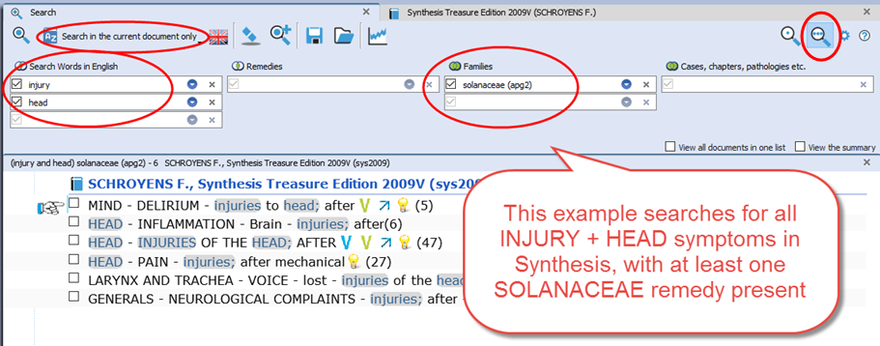

An example of a: Remedy search in a ‘Search area’
Simple search:
This example shows how to do a search for:
All Delusions rubrics for Arsenicum album, where the Rubric size is not more than 20.
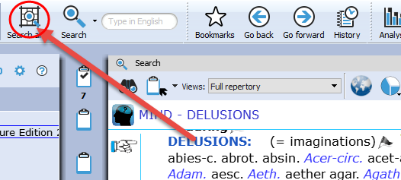
- In Synthesis drag the rubric MIND – DELUSIONS to the Search area clipboard.

- Open the simple search (? or F4), and select remedy Arsenicum album.
- Right mouse click and select the option: Rubrics containing “less than or = 20”.
- Select for location of the search: “Search in the current search area”.
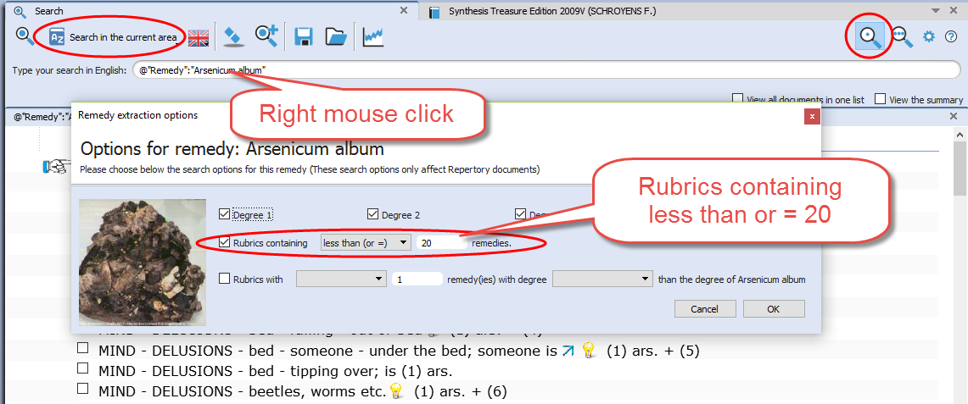
- Start the search: Click in the left upper corner, or press <enter> again.

Advanced search: The same search done with the Advanced search:
- In Synthesis drag the rubric MIND – DELUSIONS to the Search area clipboard.
- Open the advanced search (F5), and select remedy Arsenicum album, press enter to open a next search field.
- Click on the small blue circle and select the option: Rubrics containing “less than or = 20”
- Select for location of the search: “Search in the current search area”.
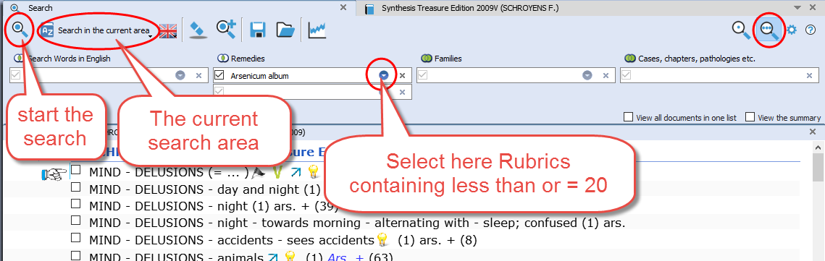
- Start the search.

Search in a: Search Area (a part of the repertory)
This topic “search area” has been mentioned already above. But because it can be used in combination with the advanced search (word search, or remedy search) it is repeated here again.
See video: Search in a Search Area
Often you like to search only in a certain limited area in the repertory. For example you want to find all symptoms of a remedy in a specific chapter or main rubric.
- Step 1: You can drag and drop specific areas from the repertory to the Search Area button in the main toolbar.
- Step 2: In the search window (F4) select the options to search in a specific search area.

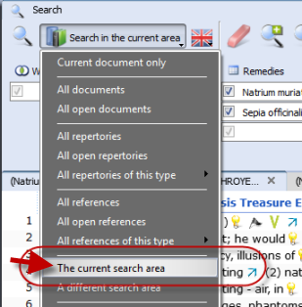
You can use this “Search area” both in the Simple search (F4) and the Advanced search (F5)

After you have dragged one or more repertory sections (main rubrics or chapters) to the search area button, you can perform your search through “the current search area”.

Take from the Search result window
You can also take symptoms from the search result in several ways:
- From the Menu bar Take
- With Drag and Drop
- New: With a Right mouse click there are two special take options available:
Take the selected rubrics and create a new Combined rubric
Take all rubrics and create a new combined rubric

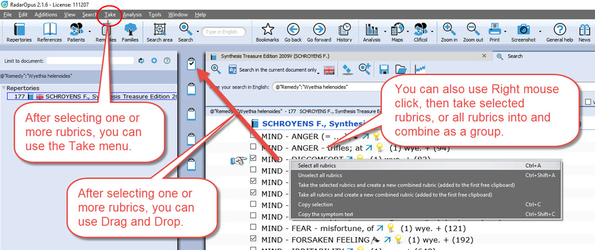

Advanced Search (F5): Case remedy
See video: Search for a Case Remedy
It is also possible to search in the Opus Library all cases for a certain remedy. So all cases where a certain remedy was prescribed. For example all cases where Ignatia was prescribed.
- Open the Advanced search, and type the first characters of the name of the remedy: Igna…
- Select: Ignatia amara “Case Remedy”
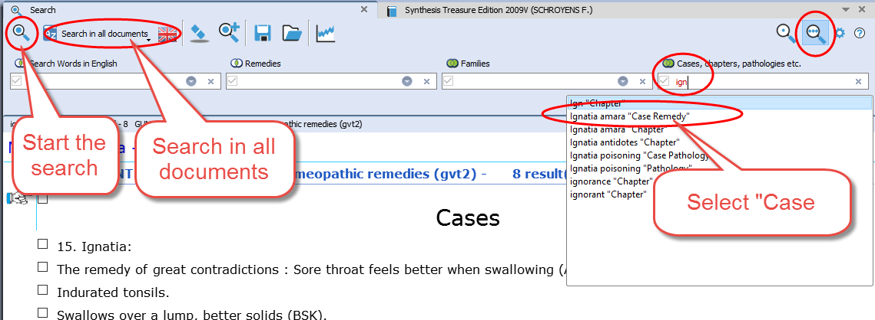
- Then press two times Enter to start the search, or click on the Start search icon.
- In the search result window, at the left you will see a list of all document in which a case is present where the remedy Ignatia amara was prescribed. At the right a part of the text in that document.
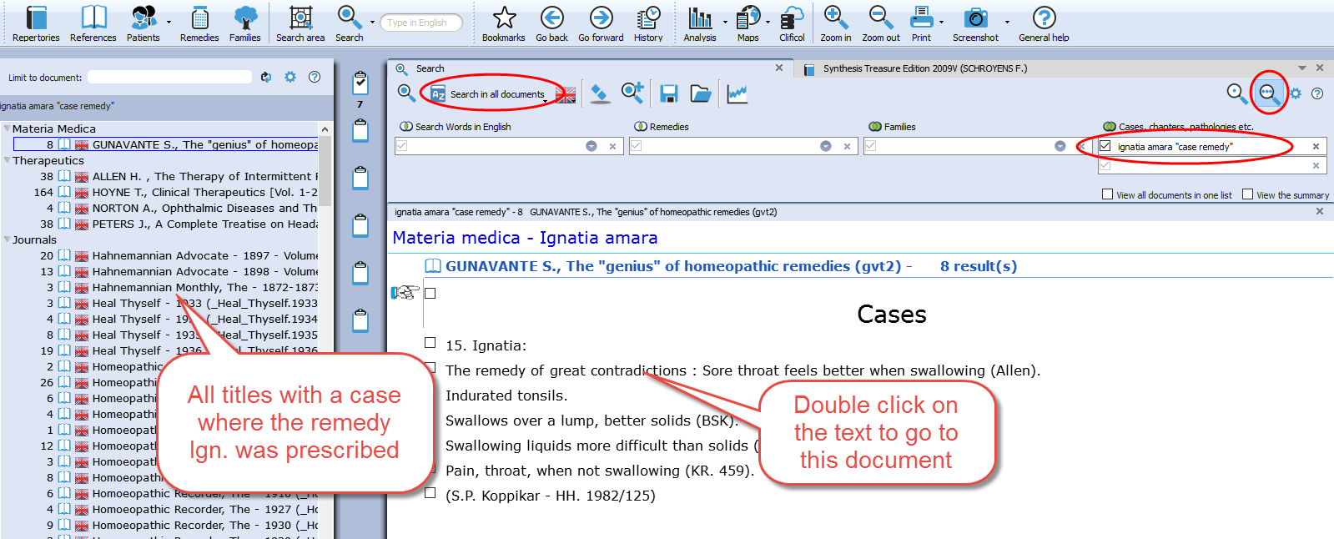
- If you want to really open that document, and see the full text of this case, double click somewhere in the text of that case.
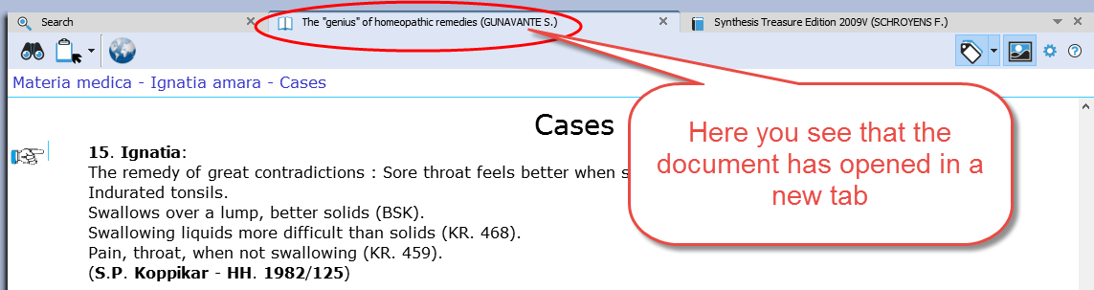
- If you look at the title mentioned in the Tab, you will see that you are now in that document.

Advanced Search (F5): Pathology, Case pathology
See video: Pathology, Case pathology
This tutorial video shows how you can search for chapters and paragraphs about a certain Pathology.
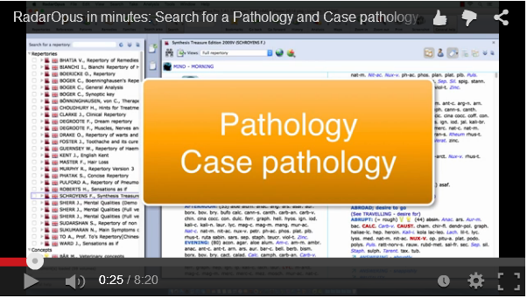
It is also possible to search for Cases of certain pathology.

Search result graphically: Open more search tabs
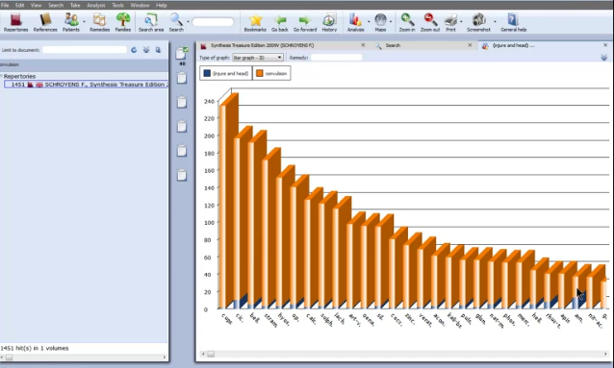
Here is a tutorial video showing in the advanced search window, with two separate word searches, and then showing which remedies has both combinations shown graphically.
See video: Search result graphically

Example used in the tutorial:
- Search 1: Word search “Injure head” (Tab 1)
- Search 2: Word search “convulsions” (Tab 2)
- Show a graph: Which remedies have both searches

Remedy Comparison

Advanced Search (F5): Remedy Comparison
To compare two or more remedies in the repertory you need to switch from the Simple Search window (F4) to the Advanced search window. Or you can open the Advanced search window directly from the main toolbar or with the F5 function key.
See video: Remedy Comparison
This instruction video shows you how to do a single remedy search and how to compare 2 or more remedies.

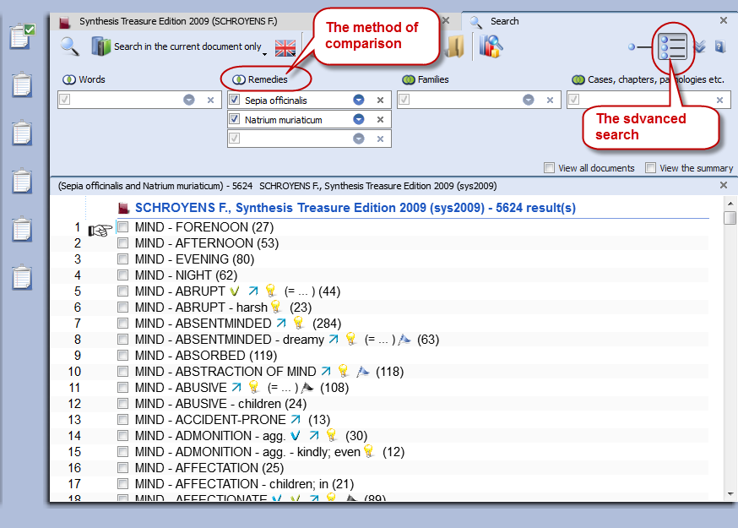
This tutorial video is a short version explaining the Remedy Comparison, and it combines it with using "Search Area", and adding a "New Search Tab"

Steps to do a remedy comparison:
- Press F4 to open the Search window
- Select the Advanced search
- First from the auto-complete list select a remedy in a box. Then press <enter> once to open a next box below it.
- Select a second remedy in Box 2, and again press <enter> once to open a next box.
- Start the search by again pressing <enter> just once or click on the search button.

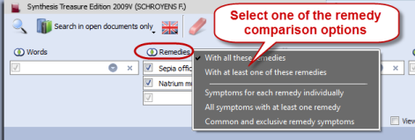
Search method
Via the button Remedies at the top, you can select one of three search methods.
See the video for more information.

A short summary video
This tutorial video is a short version explaining the Remedy Comparison, and it combines it with using "Search Area", and adding a "New Search Tab"
See video: Remedy Comparison Short

Search area
You can also perform a search through certain sections of the repertory only.
First drag one or more 'Chapters' or 'Main rubrics' to the search area button in the main toolbar.
Then when you open the Advanced search window, you can select to do the search in the 'Search area'.

Adding a second search tab
After you have done a search it is possible to keep this search result, and open a second search tab to do a new search. In this way you can easily compare results.

Overview video
See video: Example search Dr Subrata Banerjea
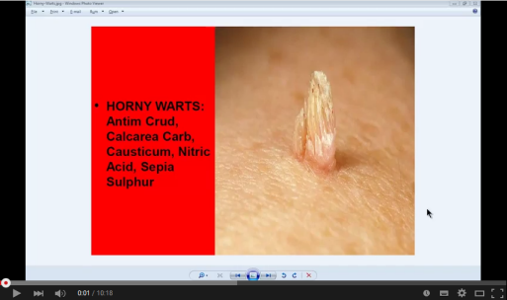
This video shows some practical possibilities of the Remedy Comparison function using the topic “Warts” from a seminar of Dr Subrata Banerjea.

Advanced Search (F5): Combine Words & Remedies
Often you need to differentiate two or more remedies specifically in regard to a certain symptom.
In the below screenshot you see a search with a combination of the word Discharge and two remedies All-c and Euphr.

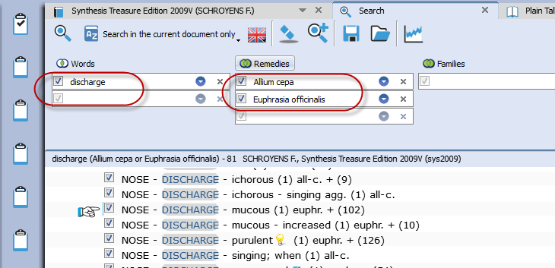
- The document-location to search is set to: Search in the current document only.
This will search in the repertory only (if you open the search while you are in the repertory).

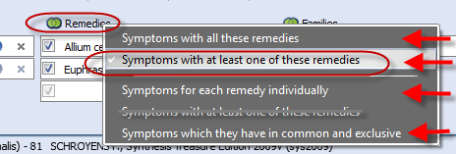
- Click on the Remedy search-options button which is located above the search fields, to select how the remedies should be compared.

* one search-option is double and hidden in the screenshot. This option will be removed from the list in a next live update.

If you select “Symptoms with at least one of these remedies” you can still see in the result list, if only one or both remedies are present, and in which degree.

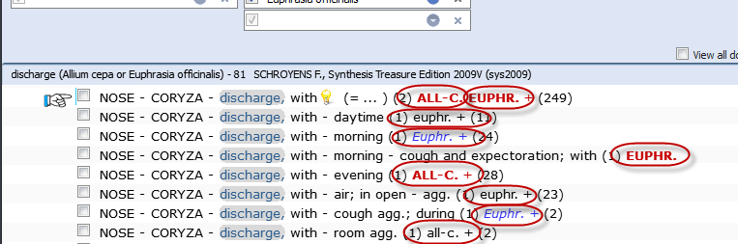

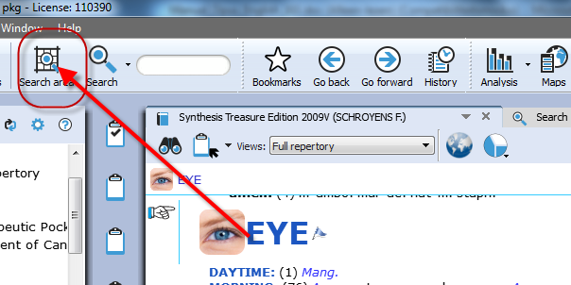
Using Search Area
- To do the same search only in a specific Search Area, e.g. the Chapter Nose and Eyes., you need to do the following steps:

Step 1: Drag from the repertory the two chapters Nose and Eyes to the Search Area icon.

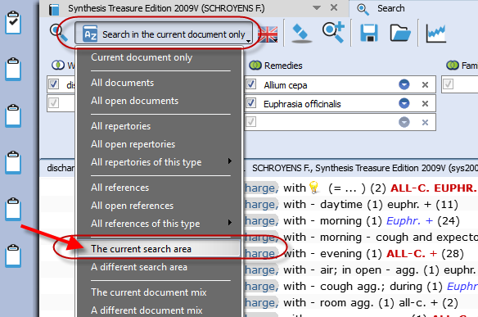

Step 2: Open the search window, and then select as search location: The current search area.

Your search will then be limited to only those sections (chapters) which you have dragged into this search area clipboard.

Combine Words & a Remedy, only in a certain Materia Medica
RadarOpus also allows to do a search though only one Reference document (e.g. in one Materia Medica document), just like you would search only in the Repertory.
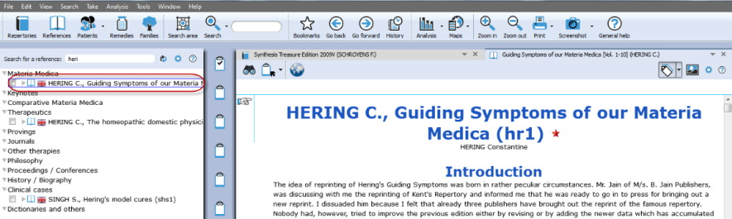
Step 1: Click to open for example the: Hering C., Guiding Symptoms

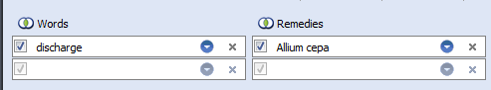
Step 2: Open the simple (F4) or advanced search (F5).
Type the word Discharge, and the remedy All-c.

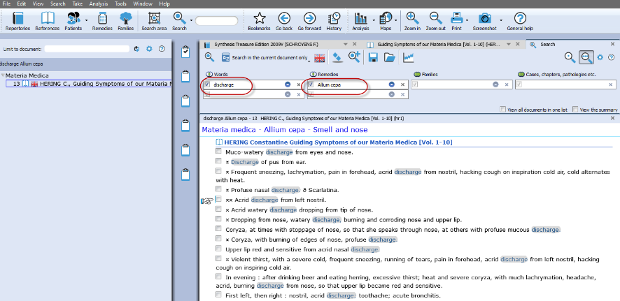
This will bring up all discharge symptoms in the Hering only for this remedy All-c.

Tip: If you want to keep this search result, but want to do the same for another remedy, then click on the button to open a new search tab.
Clipboards & Analysis

The Symptom Clipboards (F7) - The Analysis window (F8)

How to take symptoms in a clipboard, please see the chapter Take for more information.

Two new tutorial videos
See video: Using clipboards 1
View these two new tutorial videos explaining several functions of the symptom clipboards.
See video: Using clipboards 2

Using Symptom Clipboards (Video Part 1)
See video: Symptom clipboards part 1
In this instruction video, some basic functions are discussed:

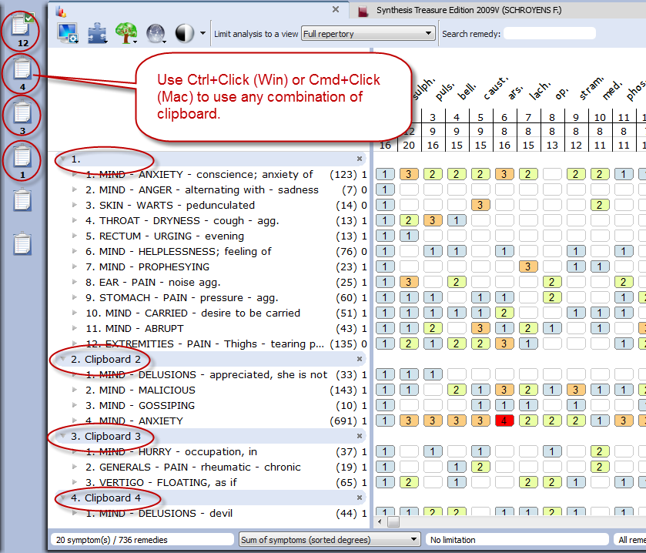
- Using One or More clipboards
If you click on a clipboard it will only analyze using the symptoms in that particular clipboard.

If several clipboards have been used to take symptoms on, then you can use Ctrl+Click (Win) or Cmd+Click (Mac) on the other clipboard icons to select more than one clipboard.

You can select any combination of clipboard to use in your analysis.

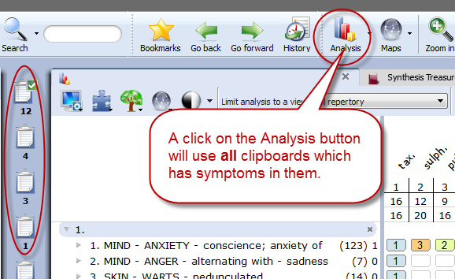

By clicking on the Analysis icon in the main toolbar, all clipboards that contain symptoms will be used.

If you want to use again only 1 clipboard, then single click at the left on one of the clipboard icons.

- Move symptoms within the same clipboard
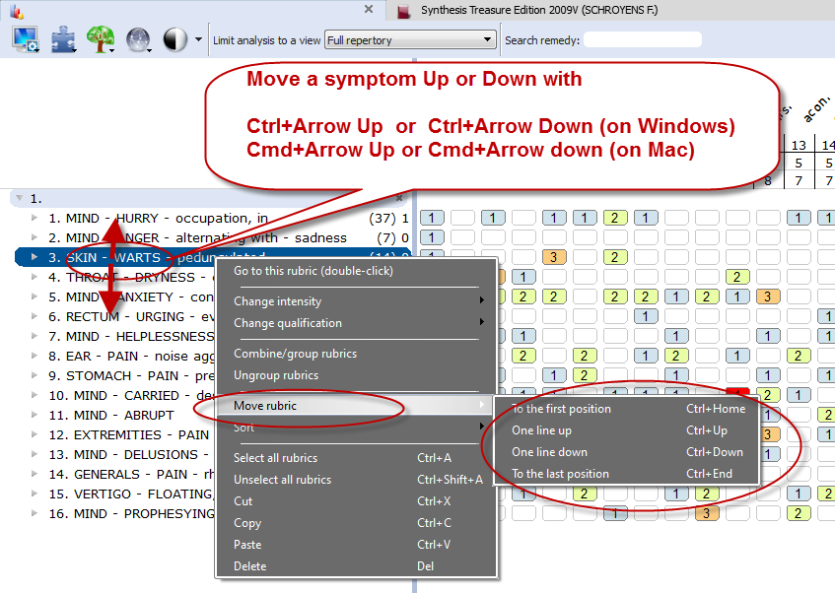
First you click on a symptom in the clipboard to select it, and then you can move it in several ways:

- With a Right mouse click and from the context menus use the Move options Up / Down.

- (On Windows) use Ctrl+Arrow up, or Ctrl+Arrow down to move the symptom one line up or down.

- (On Mac) use Cmd+Arrow up, or Cmd+Arrow down to move the symptom one line up or down.

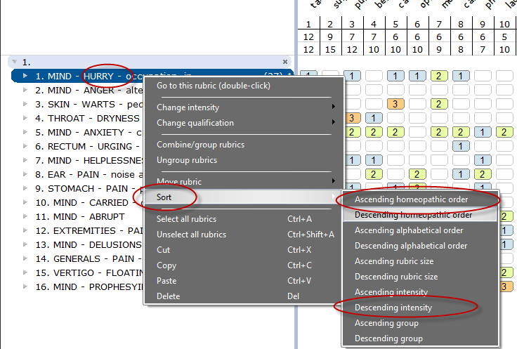
- Sorting symptoms
You can automatically sort the symptoms which are in a clipboard via a Right mouse click on one of the symptoms, then select Sort.

Most often is used: “Ascending homeopathic order” (From Mind to Generals), and also “Descending intensity” (From intensity 4 to 1)

Sorting will only work correctly for symptoms taken in RdarOpus from Synthesis. Converted/imported files from older Radar version will not sort correctly

- Change intensity of symptoms
It is possible to change the intensity of symptoms after they have been taken into a clipboard already.
You can do this for an individual symptom or several symptoms at the same time.
- You can do that via the Right mouse menu, then from the menu select Change intensity.
- Or with the keyboard: You first select a symptom with a single click (it becomes highlighted). Then on the keyboard press one of the number keys: the 1, 2, 3, or 4 key.

- Select several symptoms and apply a change to them in one action.
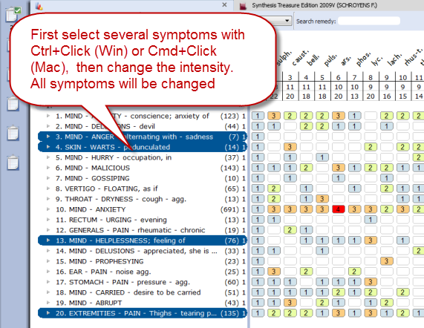
If you first select more than one symptom by using the Ctrl+Click (Win) or Cmd+Click (Mac), then you can apply a change to all selected symptoms in one action.

- In the screen several symptoms have been selected with Ctrl+Click (Win) or Cmd+Click (Mac)

- Then press on the keyboard one of the keys 1, 2, 3 or 4 to change the intensity for all selected rubrics.

Tip: By selecting the intensity 0, you can remove that symptom from the analysis score.
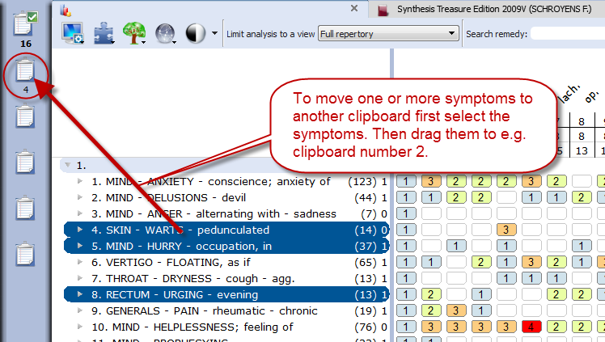

- Moving symptoms from one clipboard to another clipboard

You can move one or more symptom from one clipboard to another clipboard.
First click on the symptom(s) to select them, then you can drag them to another clipboard on the left.

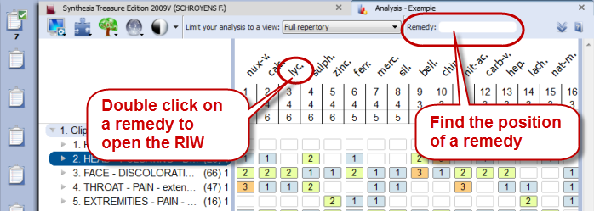
- Find the position of a remedy, and open the remedy information window.
See the screenshot for these two more functions:

Using Symptom Clipboards – more functions
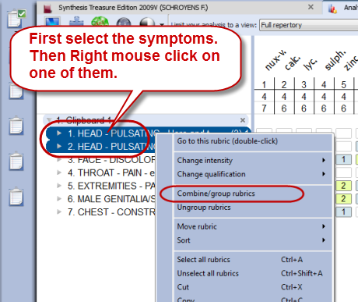
- Combine (group) symptoms
You can use combine symptoms if you have several smaller repertory rubrics all expressing the same problem. You can avoid overemphasizing these separate rubrics by grouping them into one group.

- First select all the symptoms you want to combine or group with Ctrl+Click (Win) or Cmd+Click (Mac)

- Then Right mouse click on one of the selected symptoms and select Combine/group rubrics.

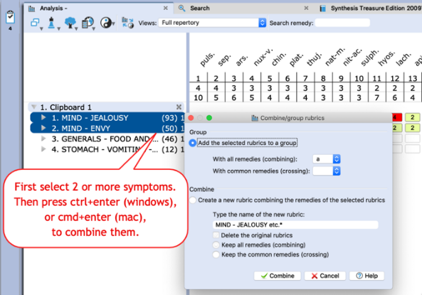
Or use the keyboard combination: Ctrl+enter (windows) or Cmd+enter (mac) to open the combine-dialogue window.

- Making a group
This method is used most often.
When you create a group, the original symptoms remain in the clipboard, but they are calculated as one symptom (rubric). You do this by giving them all the same letter, for example: “a”.

- Combine into one new symptom
If you really combine several symptoms into one new symptom, then only one new rubric will be created. This new symptom will then contain all remedies of the original symptoms.
If a Remedy has a different degree in the original grouped or combined rubrics, then the highest degree will be used for remedies which occur in more than one symptom.

- Use an Eliminative or Exclusive symptom
To make a symptom Eliminative means that only remedies which are in that symptom will remain in the analysis.
- To make a symptom Exclusive is the opposite. Then all remedies which are in that symptom are removed from the analysis.
Right mouse click on the symptom, then from the menu select Change Qualification.

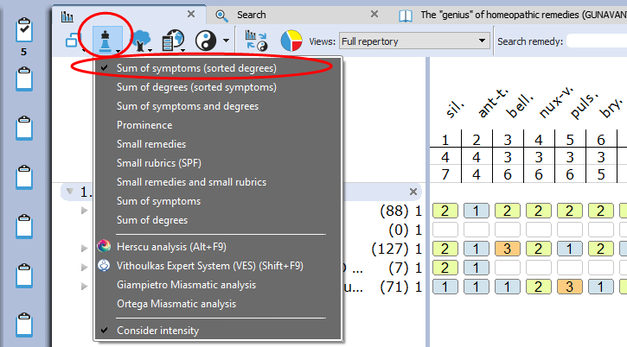
- The Analysis method
There are several methods of analyzing. Most often when you analyze by hand you use the method “Sum of symptoms (sort degrees)”.

With this method you first count in how many symptoms a remedy is present. If remedies have the same number of symptoms, then the program looks how high the total number of degrees is.
If remedies, then still have the same score they are placed alphabetically.

- Find the position of a remedy
You can use the Remedy box to find the position of a remedy in the analysis. The auto complete box will only contain remedies present in the analysis.
Mind that you have selected the correct Repertory View selected which you want to use.
(See the screenshot on a previous page)

- Default clipboard
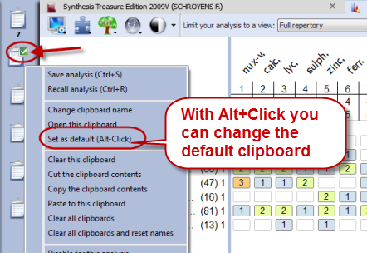
When you take symptoms via drag and drop you can decide into which clipboard they go. The only disadvantage is that the intensity will always be 1.

But when you take symptoms into a clipboard via the take button or with the keyboard
commands + <enter> (or with = <enter>) they go into clipboard number 1 by default.

Sometimes however you may want symptoms to go into another clipboard.
If you change the Default clipboard with Alt+Click (or via the right mouse click menu) then the symptoms will go into that clipboard.
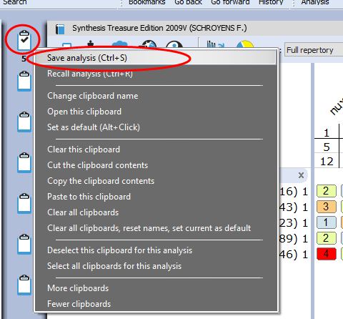

- Right mouse click on a clipboard for more options

If you click with the Right mouse button on a clipboard icon there are more options available, for example:

- Save analysis
- Recall analysis
- Clear this clipboard
- Clear all clipboards.
Etc.

Attention: Save and recall the clipboards (Analyses)
There are two ways to save the clipboard (Analysis).

- You can save them connected to a patient file (a consultation).
Please view the tutorial video.
If you use the patient file, then you do not need to save the analysis yourself. It will be saved automatically to the consultation which is open.

- You can also save the clipboards as a separate file (not connected to the patient file). This is called: “Save analysis to a folder”.
Please view the tutorial video.

Read more on how to save and recall the clipboards in the next chapter.

Save and recall the analysis (separately from the Patient file)

You can Save and Recall an Analysis (the symptom clipboards) in two ways:

- Separately (outside the patient file) (similar like in RadarClassic)
- Connected to a consultation in the Patient file

Save separately (outside of the patient file)
See video: Save the analyses separately
There are two main approaches: you can save the analysis together with a patient when you work with the patient file or you can save an analysis separately (this is called: Save to a Folder).

You can save an analysis (the whole set of clipboards) separately with:
A Right mouse click on one of the clipboards
- Via the sub-button of the Analysis button
- With the keyboard [Windows] Ctrl+S or [Mac] Cmd+S.

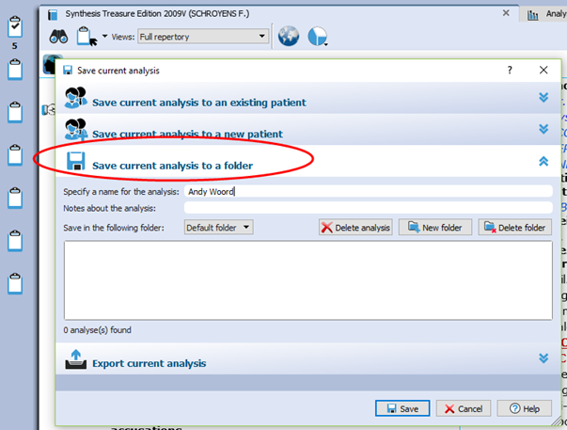
In the Save analysis window select the option to Save the Current analysis to a folder
(this is not connected to a patient file).

Note: This is similar to the function in Radar 10.5 which was called “Save the case”.

Give the analysis a Name, then click on the button Save
You can also enter a short Description if you like.

By default all are stored in the Default folder.
To Recall an analysis can be done in a similar way to the Recall analysis window. Right mouse click on one of the clipboards, then Recall analysis.

Save the analysis to a Patient (in the Patient File)
The second method to save the analysis is by using the patient file.
If you use the patient file, then the symptom clipboards are saved automatically when you save the patient

For more information see the chapter about the “The Patient File”

But here are already two tutorial videos to view:

Video: Save analysis to the patient file, manually
See video: Save to patient file (manually)

Video: How to use the patient file (Basics)
See video: Using the patient file (basics)

The Analysis (F8)
A click on a clipboard or pressing F8 shows the symptoms plus the remedies score (the analysis).
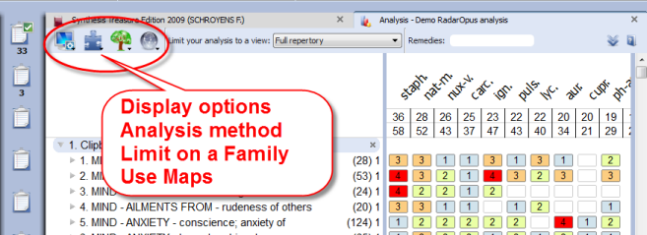
Tools
In the left upper corner you can find icons with which you can select Display options, Analysis method, Families selection window and (families) Maps.
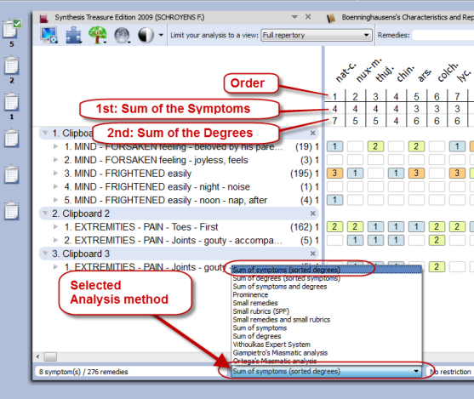

Methods
You can also select the analysis method via the ‘method button’ at the bottom of the analysis window.

The most common used method is:
Sum of Symptoms (Sort degrees)
This means that the score of the remedies is first calculated using the remedies which have the most symptoms. In case some remedies have the same score, the number of degrees is taken into consideration next.

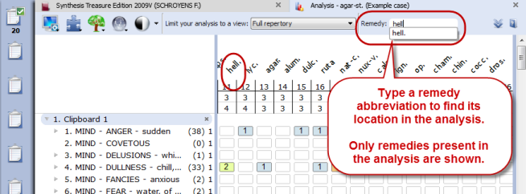
Find the position of a remedy
With the remedy search box you can find the position of a remedy in the analysis.
Only remedies that are present in the analysis are shown in the selection box.

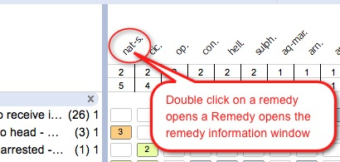
Tip: Quick Remedy search from the Analysis window

In the analysis window a double click on a remedy opens the Remedy Information window (RIW). Here you can find all sorts of information about this remedy.

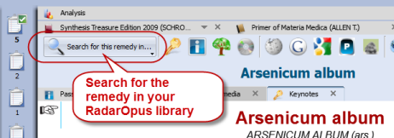
From this RIW you can also do a Search on this Remedy in the repertory or in the other search locations (Open documents, All documents etc.).
For more information see also the chapter Remedy Information Window.

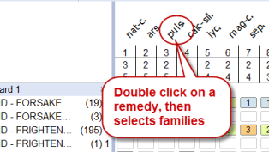
Family information: ‘Limit To’ or ‘Highlight’ a Family
You can show all family members of a certain remedy you see in your analysis in the following way: …

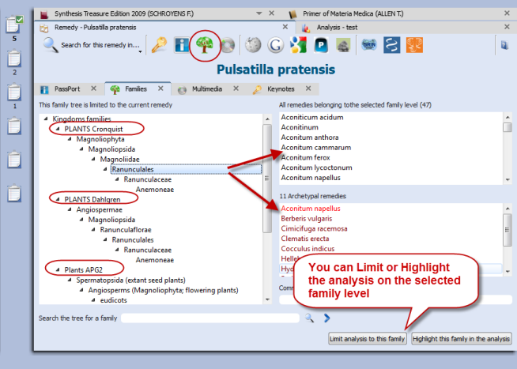
Step one: Double click on a remedy to open the remedy information window.

Step two: In the Remedy Information Window select the button Families.

If the remedy is a Plant, you can see where that remedy is located in the three main classification systems.
The APG2 classification system is the most modern.

In the lower right corner there are two buttons, one to limit the analysis, the other to highlight that family in the analysis.

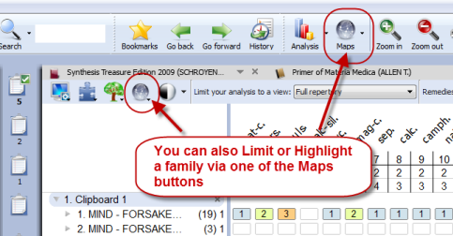
Select a family via the Maps
You can also select a family level from one of the Maps to limit or highlight the analysis on.

For more information about Families also see the chapter: The Remedy Information Window RIW

Repertory View
In the analysis window you can also select one of the Repertory Views.
Read more about using Repertory Views in the chapter on “Repertory Views”.

Local Options
Have a look at the Local Options window, to see all possible settings for the analysis window.

Show remedies excluded from the analysis (eliminative, families)
If you apply a limitation to the analysis, for example if you make a rubric eliminative or limit to a family, the remedies which are then excluded are then remove (hidden) from the analysis.
See video: Show excluded remedies from the analysis

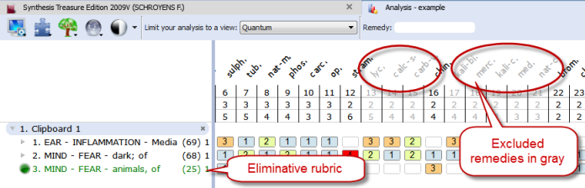
There is also a great feature to have the remedies which are excluded from the analysis still visible in gray.

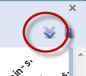
This feature to show excluded remedies in gray can be set via the local options button.
Select: Show in their position

Copy and paste the analysis (the symptom clipboards)

A text copy of the analysis
If you are in the analysis window, make sure there is not any symptom selected.
- On the keyboard press: (Windows) Ctrl+C, (Mac) Cmd+C.
- The open your Email or Text editor and press (Windows) Ctrl+V, or (Mac) Cmd+V and the analysis will be pasted.

Attention: If there are one or more symptoms selected in a clipboard, then only these selected symptoms will be copied.

1 | 1234 |  | 1 | THROAT - CONSTRICTION - Esophagus |  |  |  |  |  |  | 32
2 | 1234 |  | 1 | HEAD - HAIR - falling - grief; from |  |  |  |  |  |  | 9
3 | 1234 |  | 1 | CHEST - CONSTRICTION - Heart - grief; from |  |  |  |  |  |  | 1
4 | 1234 |  | 1 | STOMACH - PAIN - grief; from |  |  |  |  |  |  | 8
ign. |  | coloc. |  | staph. | ant-c. | ars. | asaf. | bell. | caj. | lyss. | ph-ac.
1 |  | 2 |  | 3 | 4 | 5 | 6 | 7 | 8 | 9 | 10
4 |  | 2 |  | 2 | 1 | 1 | 1 | 1 | 1 | 1 | 1
5 |  | 2 |  | 2 | 2 | 2 | 2 | 2 | 2 | 2 | 2
1 |  |  |  |  |  | 2 | 2 | 2 | 2 | 2
1 |  | 1 |  | 1 |  |  |  |  |  |  | 2
2
1 |  | 1 |  | 1 | 2

Screenshot
You can also use the Screenshot icon in the toolbar to make a screenshot of the local window. But this will result in a graphical image. Keep in mind that on Windows and Mac there is also general hotkeys available to copy the screen. Read more in the section about hotkeys
Repertory Additions

Add a remedy with a MM text to a symptom in Synthesis.
You can make the following additions:
See video: Making repertory additions, part 1
- Add a remedy
- Add a remedy + link to the original materia medica text
- Add an author reference to an existing remedy
- Add an author reference + the original materia medica text to an existing remedy.

Note: When you make an addition the Synthesis will switch to the Full Synthesis View, and will show the authors references.

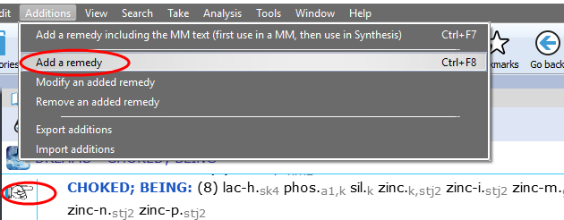
Add a remedy (or family)
From the menu bar Additions select Add a remedy.
You then will need to select:
- the remedy (or family*)
- the degree
- if a human or veterinary addition
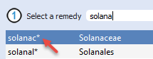
- the author name, or the author + exact publication

(*You can also select a “family-name” in stead of a remedy-name as an addition.)

Add a remedy + the materia medica text
From the menu bar Additions there is an option Add a remedy including the MM text.
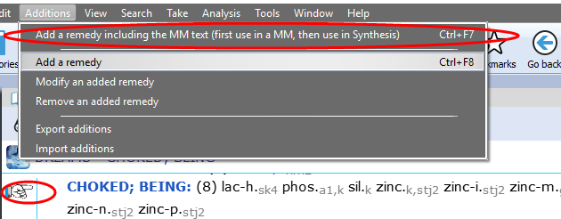
This can be used for two situations:
- Add a remedy not yet in the rubric + the MM symptom link.
- If the remedy is already present, you can add only an (additional) MM link.

In both situations you need to do the same steps,

Example:
You read in the Hering Guiding Symptoms the following symptom in the remedy Zincum:
Dreams - as if she were strangled, in morning, fear lest the man who strangled her would return
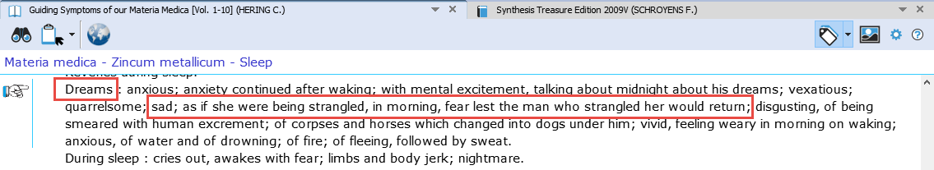
Step 1.
When in the materia medica text the hand is pointing to this symptom text, use Additions, Add a remedy including the MM text (on Windows Ctrl+F7), (on Mac Cmd+F7)

Step 2:
Switch to Synthesis, and place the hand in front of the correct symptom (rubric), and use again Additions, Add a remedy including the MM text (on Windows Ctrl+F7), (on Mac Cmd+F7)

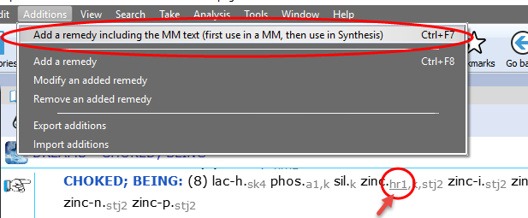
You will see that a new author abbreviation has been added, which is also underlined.

Double click on the underlined author abbreviation to see the materia medica text which has been added.

To add only the MM text to an already existing remedy:
If you use this option for a remedy which is already present in a Synthesis rubric, then only the materia medica text will be added (to an existing author, or the new author reference will be added)

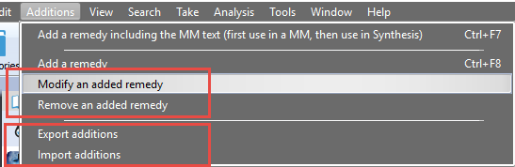
Modify or Remove
You can modify a remedy which you have added.

Or you can remove again an added remedy.

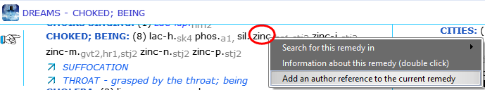
Add an author reference to an existing remedy
Right mouse click on a remedy, then select Add an author reference to the current remedy

Remove an author reference from a remedy
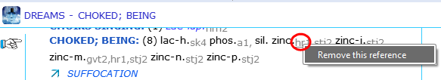
Right mouse click on the reference you like to remove.
In version 2.0 for the moment you can only remove personal added author references.

Export additions to share them
Your additions are included in the general RadarOpus backup.
But if you want to get more insight into your additions or want to share your additions with someone else, you can use this option Additions, Export additions.
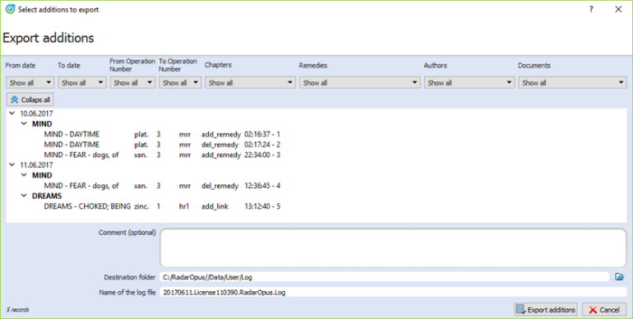
Select from the menu bar: Additions, Export additions

In this window you can see an overview of your additions.

It is possible to make a selection and show only certain additions:
- for a certain remedy
- for a certain author reference,
- etc.

Before you export the additions, select a location (destination folder) to save the Log-file.
Then click on the button Export additions.

Import additions
See video: Import additions
You can import repertory additions from another RadarOpus user, or additions sent to you by the Synthesis team.

- Automatically: Additions can be received automatically, via the “Content updater” (Live updates). Please read more in he chapter Content updater.

- Manually: Or maybe someone sends you a Log file.
Then place this log file in a location which you can easily find back. (e.g. RadarOpus\Data\Users\Log)

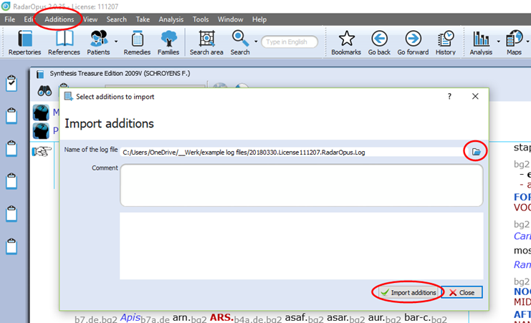
- Then select from the menu bar Additions, Import additions.
- Select the location where you placed the Log file.
- Start the import with Import additions

The importation process may take a while depending on how many additions the log file contains.

- When ready a message will show: Import completed.

- Then you may Close the window

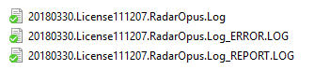
After importation a Log file, you can find that two additional files which have been placed in the same location of the Log file:

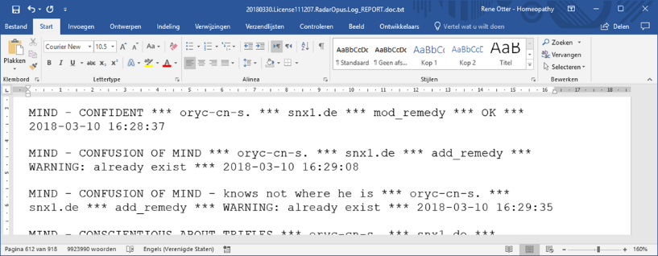
- date.licensenumber_REPORT.log file
This file can be opened with a text editor, and contains an overview of the importation result.

- date.licensenumber__ERROR.log file
Only useful for technical support staff only. Yoy may delete it.

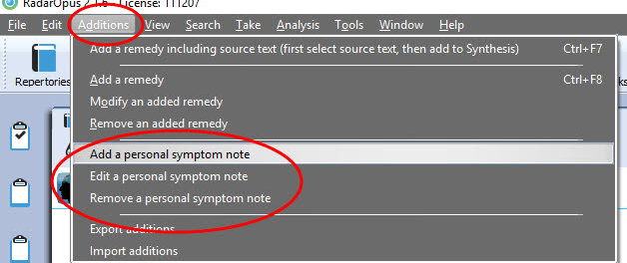
Add a personal symptom note
New: In version 2.1 you can add Personal Notes to symptoms in the repertory Synthesis.

Content Updater
Freenote and Library (repertory and references) updates

New: Version 2.1 comes with a new automatic check if there is new content available.
These can be:
See video: Content updater (Long version)
- Free RadarOpus documents or additions
- Payable RadarOpus documents or additions
- Freenotes
See video: Content updater (Short version)
- Synthesis additions updates (Log files)

You can set how often RadarOpus should check if there are content updates available.
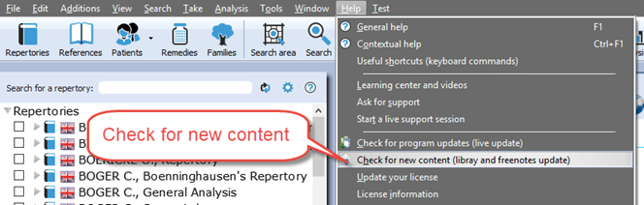
But you can also check for new documents manually via the menu bar Help, then Check for new content.

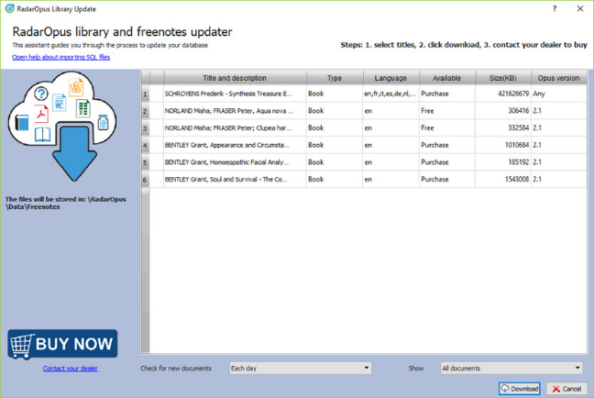
The Content updater window gives an overview of all available new files, and if they are Free or Payable documents.

Next time you open the Content updater, make sure you select to see in the list only those items “Which can still be installed”

Free reference documents: new free proving documents
After you installed Radar Opus 2.1 the Content updater will open automatically (it might come only after you have started Radar Opus a few times).
In the list of available items, you can find three free proving documents from Mischa Norland:
- Aqua nova
- Clupea hagengus
- Monotropia uniflora

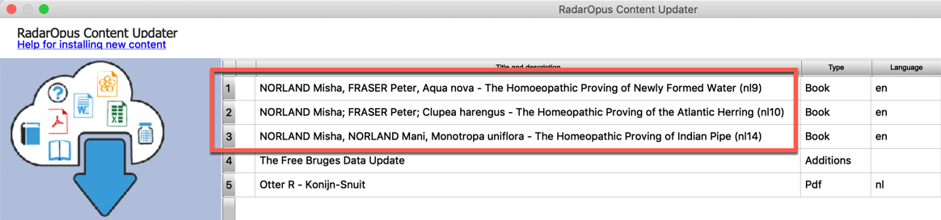

Select these three items, and then click on the Download button.
Then restart Radar Opus to view these new documents in RadarOpus in the list of References.

Added to the list of References
After installation and restarting Radar Opus you can find these new proving documents of Miasha Norland in the list of References:
This is just an example, and other documents will come available.
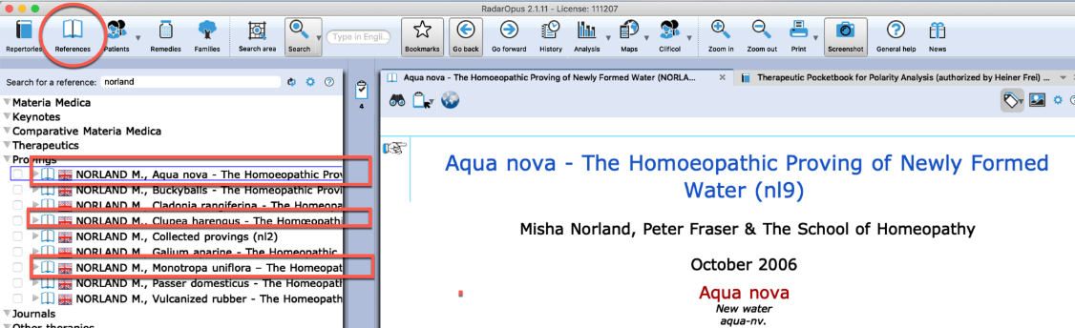

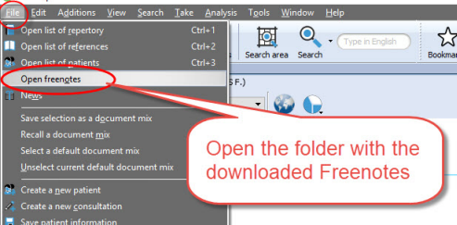

Freenote files
When you download Freenote files, you can access them via the menu File, Open freenotes

These files are stored in the folder:
\RadarOpus\Data\Freenotes

Share freenotes
If you like to share interesting information with other RadarOpus user, please send them to: synthesis@zeus-soft.com.
The information you like to share can be Repertory additions, Proving documents, Text documents, Links to interesting videos, etc.
Attention: Make sure to only send information of which you are the copyright owner !

Repertory additions, e.g. “Bruges additions”
Attention: only download and install such Repertory Additions if you have sufficient time to install them.
They will be installed in two steps:
  - 1st: Download,
  - 2nd: Import into Synthesis

In the list of available items in the Content updater, you will find an item called “The Free Bruges data Update”.
This is just an example, and other documents will come available.

This log file contains repertory additions of the following remedies:
- Carbo-f. Carbo fullerenum
- Ran-a. Ranunculus acris
- Cuph. Cuphea viscosissima
- Brass-r. Brassica rapa rapa
- Dcact-f. Disocactus flagelliformis

Attention: After you download this additions file, it will need to be inserted into the repertory, this may take up to 1 hour if your drive and computer is not very fast. On a i5 processor with a SSD it will only take 10 minutes.

Payable documents

If you download Payable documents, you need to contact you local representitive to receive access to them.
You will receive a ‘activation key’ and the installation will happen automatically.

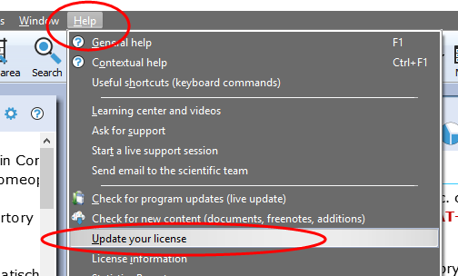
How to enter a new activation key

Go to the menubar Help, then select Update your license

Then typ the Activation key, and click to register it and restart RadarOpus.

Families & Maps

A Family search in the repertory
Families is everything that has to do with “groups of remedies” or “relationships of remedies”.
These groups (families) can be based on many different criteria.
Family-information can be consulted via the:
- Maps
- Remedy Information Window (RIW) (a double click on a remedy abbreviation)
- Table of Contents of Families
See video: Family Classification - introduction

See this introduction video about Families:
It is possible to search for a “family of remedies” in the repertory. You can search for all symptoms (rubrics) in the repertory which contain a family member of a certain remedy.

You can do such a family search from: the Quick Search box (Ctrl+F5), or from the Simple search window (?) or (F4), or from the Advanced (guided) search window (F5).

- ? Opens the Simple search window
- F4 Opens the Simple search window
- F5 Opens the Advanced (guided) search window

Search for a “Family” in the repertory
The video shows you how to search for a family in the repertory. You can search for all symptoms (rubrics) which have at least one remedy belonging to a certain family.
See video: Families search part 1
You can do such a search both from the Simple search window and from the Advanced (guided) search window.
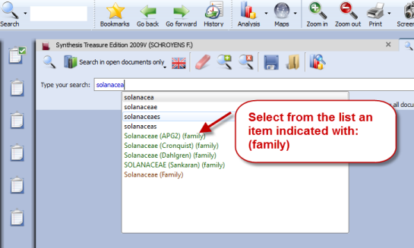
- Start from the Synthesis repertory window.
- Press F4 to open the simple search window.
- Start to type the name of the family and select from the auto-complete list an item indicated with (family)
- Start the search by pressing <enter> or by a click on the search button.

Note that you select the correct location (document) to search in: Search in the current document will search in the Synthesis only.

Family search options (maximum rubric size etc.)
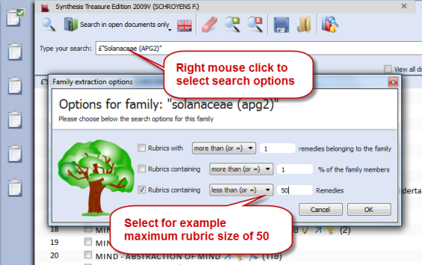
You can also specify the following extra search criteria:…

- The minimum number of remedies of a family
- A minimum percentage of remedies from a family
- A maximum rubric size
Other options and combinations are also possible.

- Right mouse click on the family name in the simple search box and it opens a window with extra search option.

Search for a “Family” and a “Word”
See video: Families search part 2
You can combine a family search in combination with a word search. You can also combine it with a “search area” in case you want to search only in a particular section of the repertory.
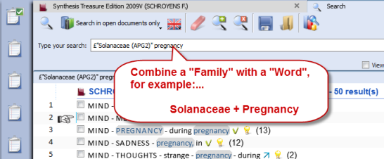
In this example a family “Solanaceae” is combined with the word “pregnancy”.

It will find all symptoms in the repertory of Pregnancy if at least one of the Solanaceae remedies is present in that symptom (rubric).

- You can also select Search options with a Right mouse click on the family name in the search box. For example limit the search to rubrics not larger than 50 remedies.
- Or you can limit the search to a specific search area. You can drag and drop a chapter or a main rubric to the search area box. Then select “Search in the current search area”

Advanced Search
The advanced search window can also be used to search for a family in the repertory.
- Use the fields for Families.
- Open the Options to enter additional search options (Minimum rubric size, Minimum number of remedies from a family, etc.)

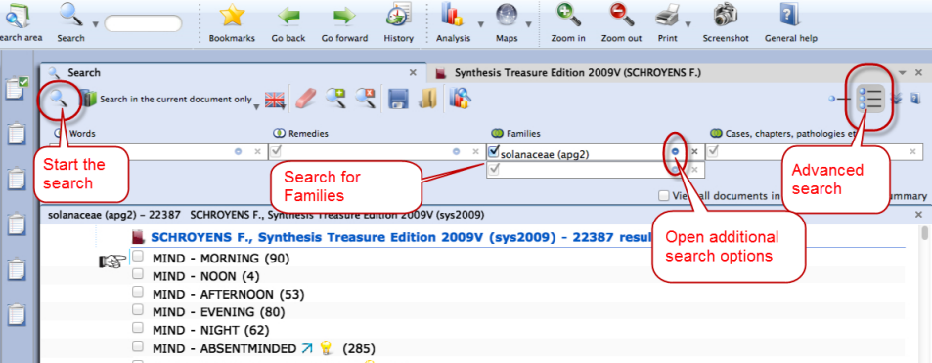

See also the chapter Advanced search for more explanation and a tutorial video.

Maps
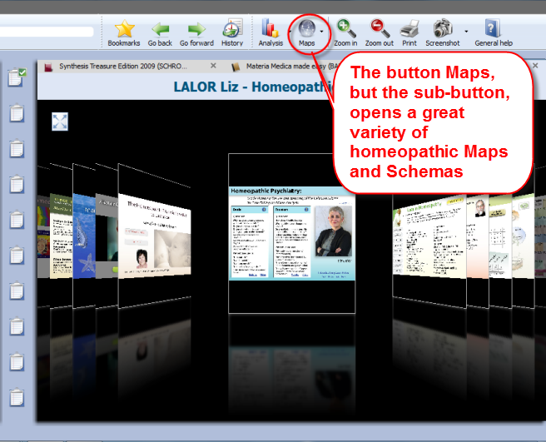
The button Maps offers a great variety of homeopathic maps or schemas of different teachers and approaches.

Maps can give access to specific information and allows you to limit or highlight a certain remedy- group (a family) in your analysis window.

For example the Maps of Liz Lalor help to analyze your case by offering information about Delusion rubrics and helping to find the correct rubrics for your case.

Will Taylor: Highlight or Limit to a Family
Maps and families are very related topics. Most of the Maps have to do with ‘Groups’ of remedies.
See video: Use Maps (Kingdoms Will Taylor)

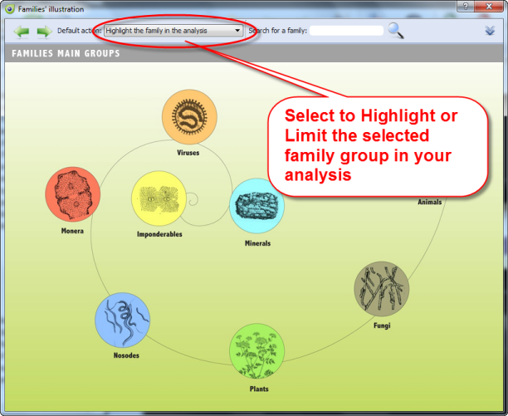
For example the Map of the Families Main Groups offers a graphical way to select the family group you like to Highlight or Limit your analysis to.

Navigate to the family group you need.
- Right mouse click on it and select Highlight or Limit the analysis
- When you have reached a last level it will automatically execute the option you have selected at the top.

Learn more about using Maps in the Help on Line or see the chapter Families.

Jan Scholten: Highlight or Limit to a Stage or Series
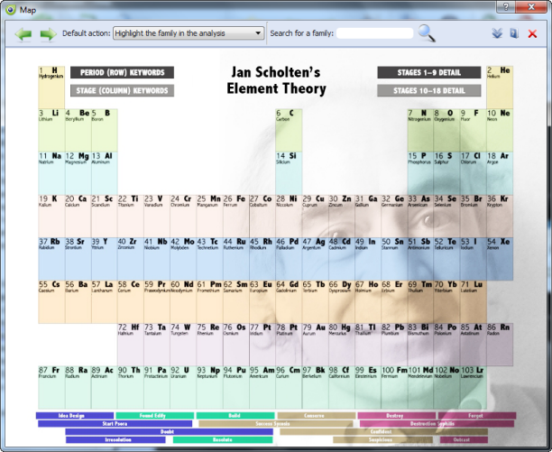
The video shows you how you can use the Maps to select one or more family-levels in the Periodic table to limit or highlight the analysis to.
See video: Use Maps (Jan Scholten)

In the periodic table you can select a ‘family/group’ to highlight or limit your analysis to.

You can also select several items via the Right mouse click or with the keyboard Ctrl+Click (Windows) or Cmd+Click (MAC).

Tools
The Remedy Information Window
Language & Translation
Backup & Restore

The Remedy Information Window
The Remedy Information window (RIW) is a quick and great source of information about a remedy.
See video: Family Classification - introduction
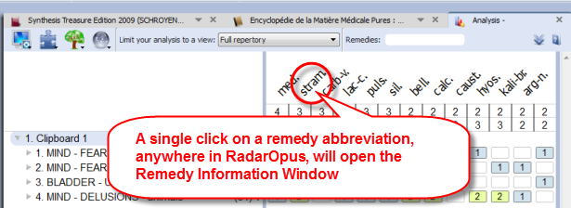
Anywhere in RadarOpus you can double click on a remedy abbreviation to open the Remedy Information Window (RIW):…
- For example in the Analysis window you can click on any of the remedies to see information about that remedy.
- You can also double click on a remedy abbreviation anywhere in the repertory window.
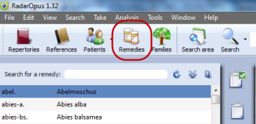
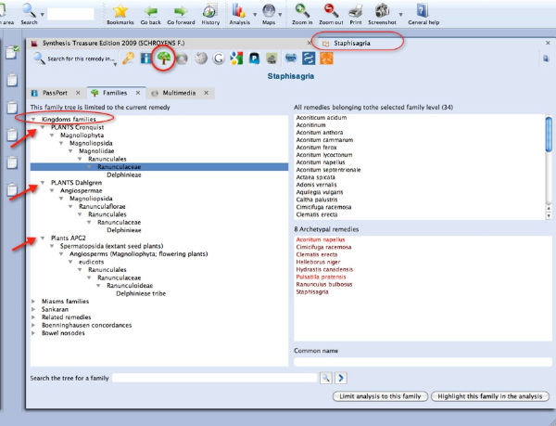
- Or you can use the Table Of Contents of the Remedies to open the RIW of any remedy which you might not see listed in the repertory or the analysis window at that moment. This TOC offers a list of all the Remedy abbreviations. A click on that remedy will open the Remedy Information Window of that remedy. From this RIW you can again do a quick search for that remedy in the repertory or in any other part of your RadarOpus Library. See more in the chapter about the Remedy Information Window.

Quickly see all family members of a remedy
As an example I like to point to the icon of the Families-tree. If you click on it you will see exactly to which family level it belongs to and also see all other members of that family. If it is a plant remedy you will see the three main classification systems. APG2 is the latest one based on DNA research.
You can Limit or Highlight the analysis on the selected family level.

Note this interesting group of the ‘Related Remedies”
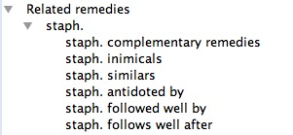

Info in the remedy information window
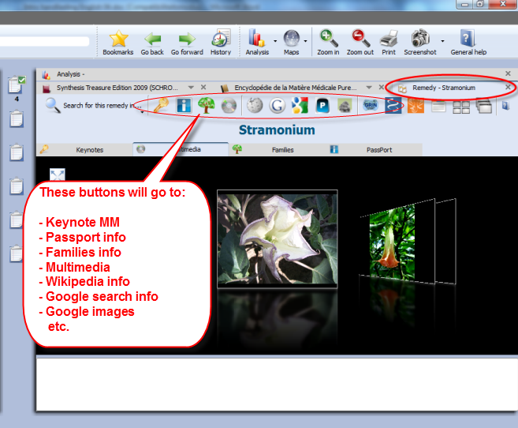
In this RIW you can find information about:…
- Keynote MM
- Passport info
- Families info
- Multimedia

And if you are connected to the internet:…
- Wikipedia info
- Google search info
- Google images
- Proving website(s) info,
Etc.

Tip: for New remedies be sure to look at the Provings.com website.
A Quick Remedy Search from the RIW
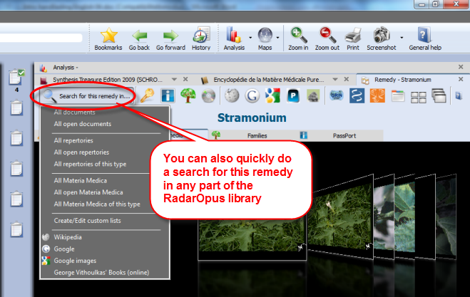
From the RIW you can quickly continue to search for more information about that remedy in any other part or in the whole RadarOpus Library with the ‘Search for this remedy in’ button.

You can search for this remedy in the whole repertory, all repertories, or e.g. in all materia medica books you have in your library.
There are several other ways to do a remedy search: e.g. via the Simple search or the Advanced search.
For information about a remedy search see elsewhere.

Languages and Translation tools
Attention:
The Google translate function does not allow anymore larger sections of text to be translated.
You can probably translate one or two times, then an error message will come, blocking further translation on that day.
See video:
Repertory in different languages
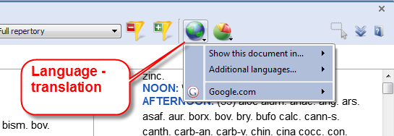
In all documents a Language icon is located at the top.

- If there is an official translation of a document, e.g. the Synthesis, available then you can use the option ‘Show this document in’ to change the language.
- You can use the option ‘Show additional language’ to add a second or third language.

- You can also use the Google translation function to have a ‘rough’ translation added. Of course there will be some errors, but often it will give a helpful first translation when you need it quickly. Even if the translation is not perfect, if will often give you a good idea about its meaning.
Note: These translation tools can be used both in a repertory and in a materia medica document.
Select a specific word or sentence to translate (ALT + ‘select text’)
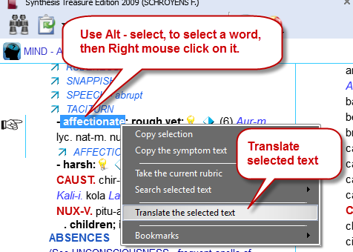
It is possible to select only one word or a sentence for translation.
First select a word or sentence by holding down the Alt key on the keyboard and then drag over the word or sentence to select it.

After you have selected a word or sentence then Right mouse click on it and select: Translate the selected text. In the next step you can select the language to translate to.

A special “text selection” button will be added in one of the next live updates.

Backup and Restore: Using the RadarOpus backup”
It is important that you make regular backups of your additions and patient information stored in the RadarOpus database.
You can choose to make a backup when you close the program and are prompted to do so. But you can also start the backup yourself.
See video: Backup and Restore
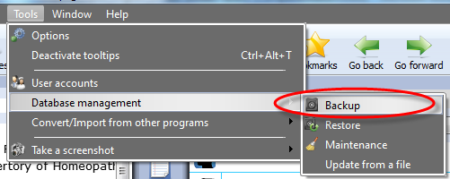
To start a Backup manually:

Go to Tools, Database management then select Backup

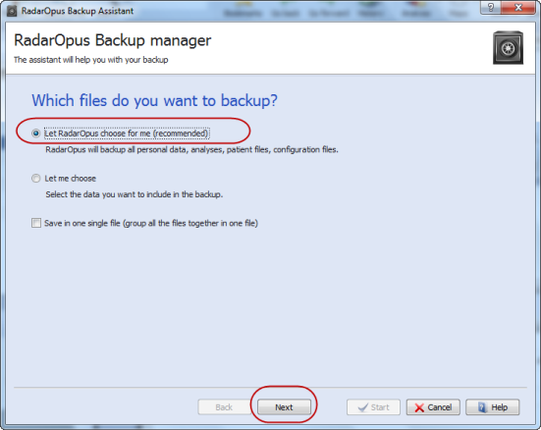

Then: Select the recommended setting:
Let RadarOpus choose for me

Then click on Next to continue.

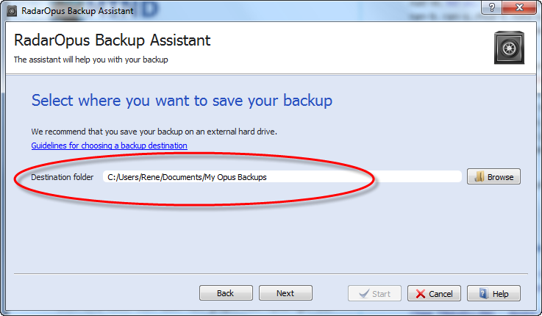
Click on Browse and select a folder where the backup will be saved.

Attention: make sure you select a correct folder on your hard drive to save the backup.

For example on windows:
C:\Users\Name of user\Documents\Opus-backups

After selected, you should see the complete path of that folder in the “Destination folder” box.

Click on Next to continue, and then click on Start

The Backup Name
The name of the RadarOpus backup folder will contain the Year_Month_Day_Time when it was created.

External media
Make sure that you also copy your backup to an external media, or you can also save the RadarOpus backups directly to the external media: Memory stick, External Hard drive.

Keep several backups
It is always best to keep at least three of the previously made backup copies. From time to time you can delete some of the older backups if you start to have too many.

Restore a backup

Attention: if you restore a full backup then all existing information in your RadarOpus will be overwritten. This is not a “merge” function!

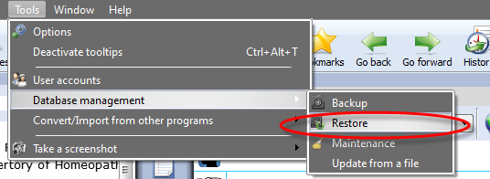
Go to Tools, Database management then select Restore

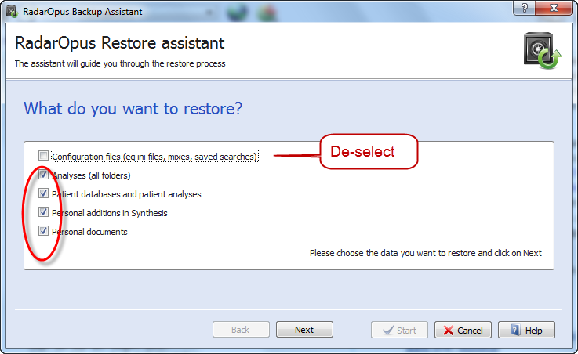
It is best to de-select the item: Configuration files, if you are moving from an older to a newer RadarOpus version.
You should also de-select this item if you want to see the original default program settings again.
Keep all the other options selected.

Click on Next, then on Start.

Exchange between Mac and Windows
A RadarOpus backup made on a MAC can be restored to a Windows version and vice versa, but only if both are running the same RadarOpus version. You can restore a backup made on an older version to a newer version, but not the other way around.

Using a Cloud Folder (Drive) like Dropbox, OneDrive, iCloud

RadarOpus Backup
It is Not advised to use a cloud program like Dropbox to exchange files of a full RadarOpus Backup between different computers you are using.

The RadarOpus backup consists of a folder with several subfolders, and it might take some time before all is synchronized. We noticed with a few users some problems when regularly using such cloud function. Probably it is caused by not allowing sufficient time for all files to be uploaded, and then not given enough time to be again downloaded again to the other computer.

Analysis (clipboards) saved as external files
If you only need save and recall analyses, it is possible to use the option to export such analysis and save them on a NAS drive for example. Then you can always recall them from any location. You can also use a cloud drive, but be aware that officially you are not allowed to store any recognizable patient information in this way

Concepts: Veterinary – Roger Morrison – Roberto Petrucci

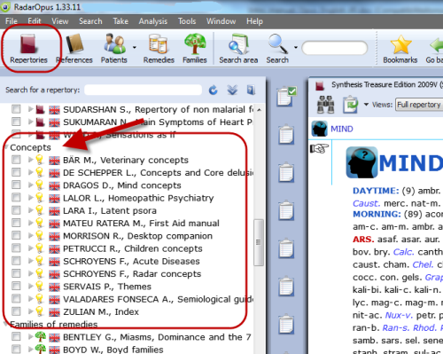
The Concepts are used to help you find the correct symptoms in the repertory. This tutorial video gives a short introduction on how to use concepts.
See video: Using Concepts

In the tutorial video these concepts are mentioned:
- Marc Bär - Veterinary concepts
- Roger Morrison - Desktop Companion
- Roberto Petrucci – Children concepts
More information about concepts will follow.

Bookmarks

In the Repertory
You can add to any rubric in the repertory a bookmark with a right mouse click on the rubric. Then select Add bookmark.
To delete or rename a bookmark, right mouse click and select from the menu Delete this bookmark

In Reference documents
You can add in the same way also a bookmark to any reference document you wish.
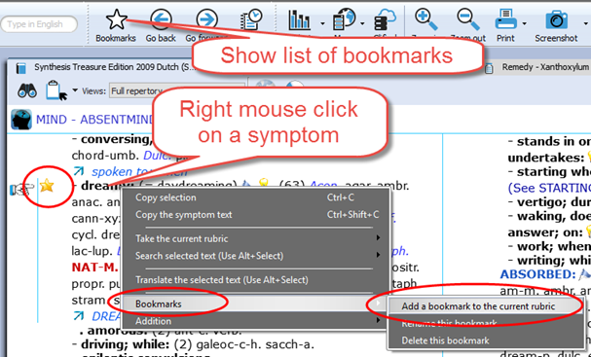
List of Bookmarks
From the main toolbar you can open an overview with all the bookmarks you have placed.

References
Materia Medica / Journals /
Therapeutics

References: Browse in Materia Medica, Journals, etc.

Because RadarOpus has everything combined in one interface, you can easily consult any of the books in the Reference Table Of Contents list. You can just look up a remedy in one of the books you like to consult, or you can use the Search (F4 or F5) function to search specifically in only one or all of the Reference books.
See video: Browse in Reference documents

Open a Materia Medica book to look up a Remedy
In the TOC go to the title you are interested in. There are several ways to navigate to the remedy you like:
(I) You can open the sub-levels and then go to the remedy name you are interested in. Click on the remedy name and it will open on the right. (II) You can also open this document first and then use the local find button to go to the remedy you want. (III) You can also use drag and drop: drag the remedy abbreviation you are looking for from the repertory and drop it on the book title you want.

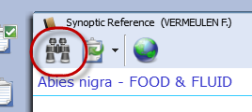
Ad I: You can open the document and use the Local Find (Chapters) icon to look up the remedy you want.
This works exactly the same as in a repertory document.

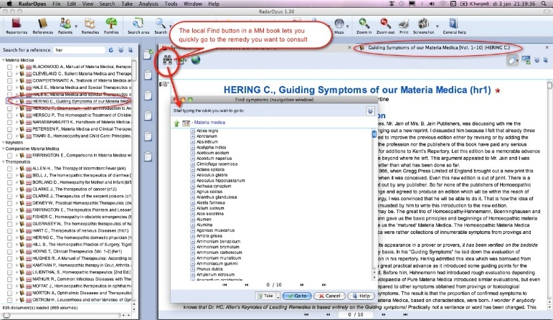
A list with the chapters open.
Depending on the structure of the document one can see all sublevels immediately (for example all remedies), or maybe you need to select first a materia medica section.

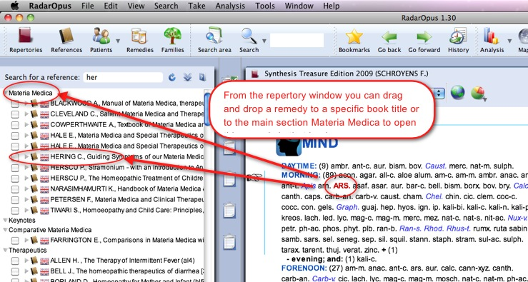
Ad II: You can drag and drop a remedy abbreviation from the repertory to the TOC of References to quickly look up a certain remedy:

- You can drag and drop to a specific book title.
- Or you can drag and drop to the main section ‘Materia Medica’ to search in all MM books*.

Ad III: With a single click on the triangle in front of a book title, the table of contents of that title will open.
Then with a click on that triangle the next level of the chapter opens.
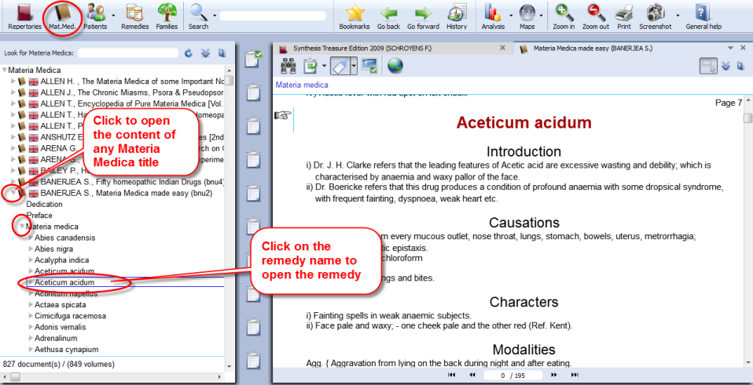
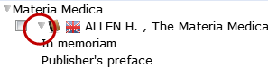
If you click once on the Remedy name it will open in the document window on the right.

Browsing & using the Symptom Path
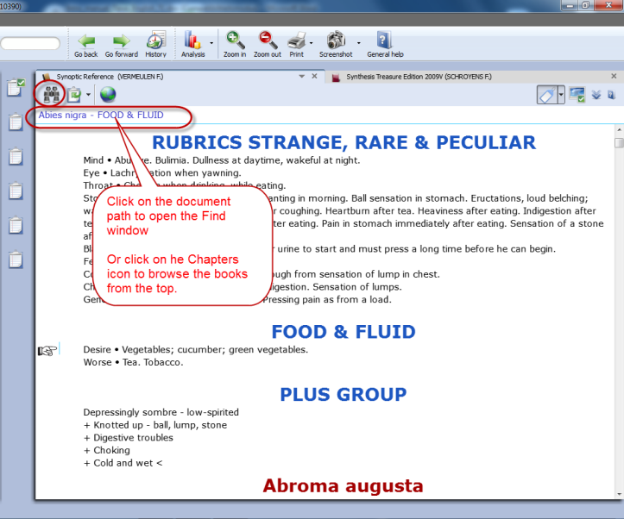
You can browse quickly through any Reference document with

- The Find icon which opens all chapters, then sub levels.

- Once you are browsing in the document, you can click also in the “Symptom path” or “Document path” to navigate upwards.

Taking symptoms from Reference (MM) books
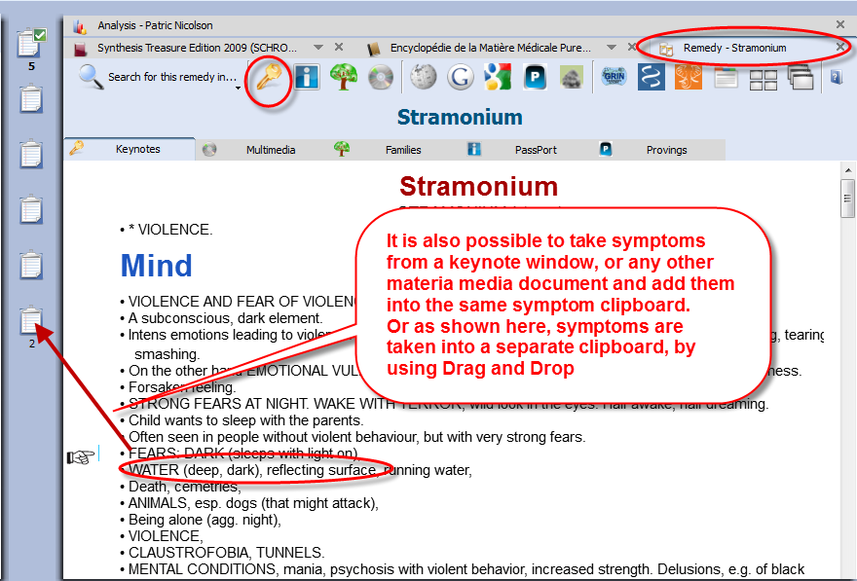
RadarOpus revolutionizes the way you can work while analyzing a case because you are now working in one large homeopathic library.

You can Take symptoms from any Materia Medica document and add them to the same (or a different) symptom clipboard, much as you do for repertory symptoms.

Note: If you take a symptom from a Materia Medica, then of course there is only one remedy connected to that symptom.
When you analyze you should be aware that it is like taking a rubric from the repertory with only one remedy in it. So you might want to use functions like combining several of such related single-remedy symptoms.

Taking “Symptoms” from any part of your library as a Reference
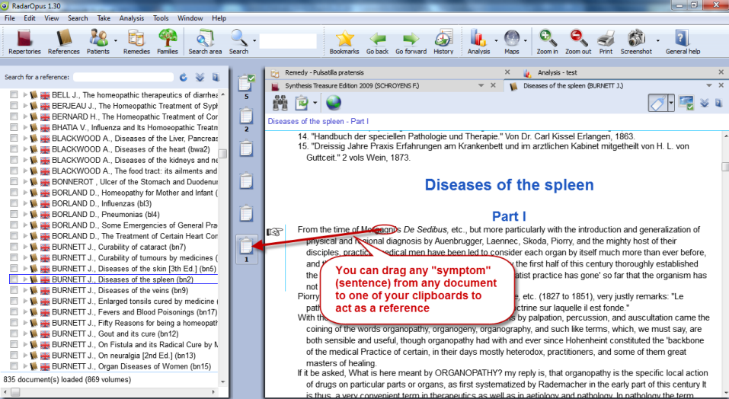
When you study a case, you can also browse through e.g. Journals or Therapeutic documents. You might come across a case which is interesting for your own patient and you may want to remember it for later reference - this is easy to do.

In RadarOpus you can also simply drag and drop such “symptoms” (sentences) to one of your clipboards and it will act as a Link (a kind of bookmark) to that location.

You could for example always use the last clipboard as a ‘reference clipboard’ to add all such links to.

When you save the Analysis (clipboards) these links will also be saved. When you recall such an analysis later on, you can use this special reference clipboard to jump to all the interesting locations that you found for this case in the library.

Patient File

The Patient file

How to import old Winchip 3.x patient information:
For instructions how to import your Radar–Winchip 3.x patient catalogue, see the Installation manual

It depends on your RadarOpus package which functions you have in your patient file.

Two ways to save the Analysis
See video: Save the analyses to patient file
There are two methods to save the Analysis in RadarOpus:
- You can save the Analysis separately (Outside of the patient file "to a folder")
- Or you can save the Analysis connected to a patient (In the patient file)
(Below you will find tutorial videos explaining the difference)

Save / Recall an analysis separately (outside of the patient file)
If you do not want to use the patient file, you can Save and Recall an Analysis (the symptom clipboards) in a quick and easy way outside of the patient file. This is called "Save current analysis to a folder".
See video: Save the analyses separately
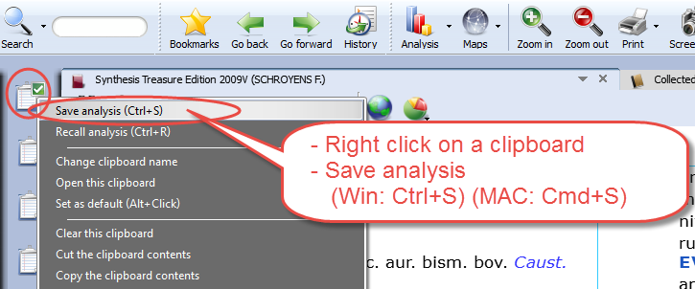
Right mouse click on a clipboard.
Then select: Save analysis

Or use keyboard shortcut:
- On Windows: Ctrl+S
- On Mac: Cmd+S

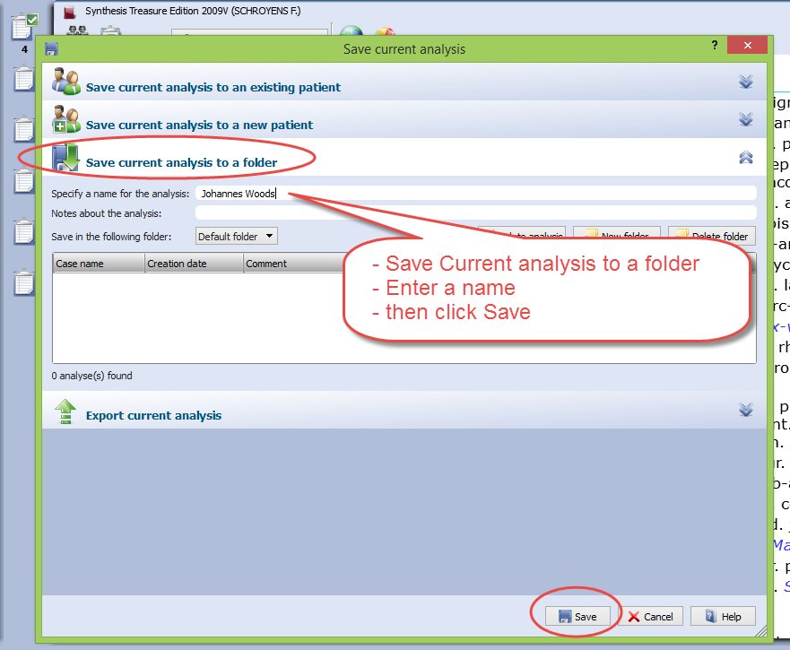
Then select: Save current analysis to a folder.

Enter a name for this analysis, then click the Save button.

You can also enter a short description.

By default the analysis are all saved in the Default folder.

Please see also the Chapter Clipboards & Analysis, for more information.

Save / Recall an analysis to the patient file
Make sure to view this tutorial video “How to save the analysis to the patient file”
See video: Save an analyses to the patient file

Workflow moving between Tabs in RadarOpus
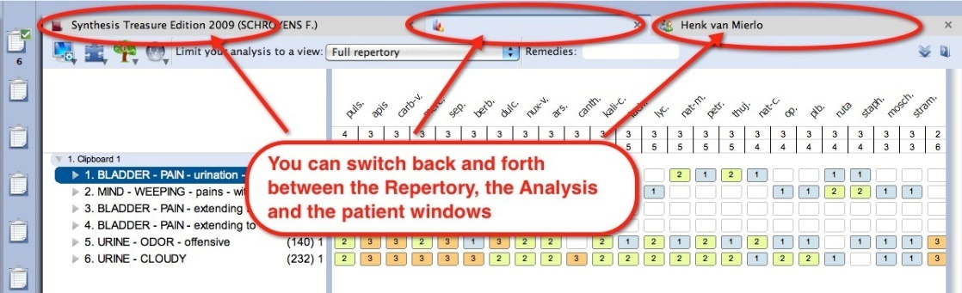
The patient file works seamlessly with the rest of the RadarOpus program. You can switch between the different tabs quickly: The patient tab, the repertory, the analysis or any other tab.
See video: The patient file workflow

In this example there are three tabs: the patient file, the repertory and the analysis window.

Taking symptoms from the repertory
After you switch to the Repertory window you can start to find and take symptoms for this patient into the clipboard(s) as you would do if you did not have a patient open. You can switch back to the patient file again to type more text of the consultation.
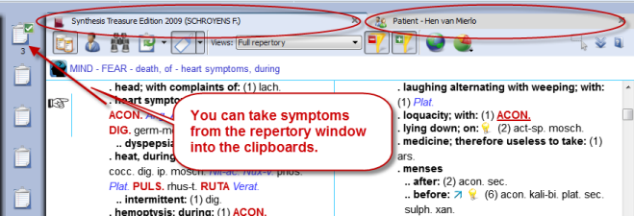

Save the Analysis and the Patient file
When you have a patient file open, the program will automatically save both the current consultation information and the analysis (symptom clipboards) with just one click on the Save button in the Consultation window.
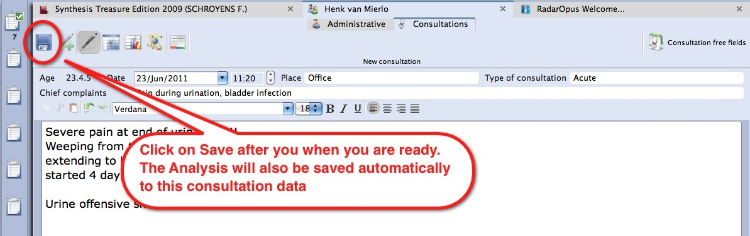

Save only one or several analyses
When you are working with the patient file you can switch back and forth between the tab of the patient file and the tab of the repertory. If you have taken symptoms for this patient into the clipboard(s), go back to the patient tab and click on the Save button to save both (the consultation window and the analysis). The analysis is saved to the patient file, connected to the current consultation date.

If you continue to work on the same analysis and save the patient file again, you will be asked if you want to overwrite the existing analysis or to save as a new one.
In this way you can save only one analysis per consultation or save several different ones.
See also: Recall, Edit and Save an analysis.

Introduction
The patient file is fully integrated in RadarOpus. There are four versions available: Mini, Silver, Gold, Diamond (see the Help On Line for an overview of the different functions).
See video: Patientfile part 1

The patient file allows you to keep track of the administrative data, the full consultation text, your diagnosis and other medical details, therapy evaluation and much more.
You are not obliged to use all the fields, but you can use the patient file exactly as it suits you! You can even hide groups of fields which you are not interested in.
The RadarOpus patient file (Winchip) is a great tool to store your patients’ information and do advanced research. The advanced patient research function (in the professional version) will help you to gain valuable insight into your practice.

Overview of the consultation text editor window
The text editor version 2.1 has improved functions to work with your method of case analysis.
You can not only indicate the Intensity, Family symptom, Personal history symptom, Personal observation note of the homeopath, but also add Tags like: “the Hahnemann Disease Classification”.

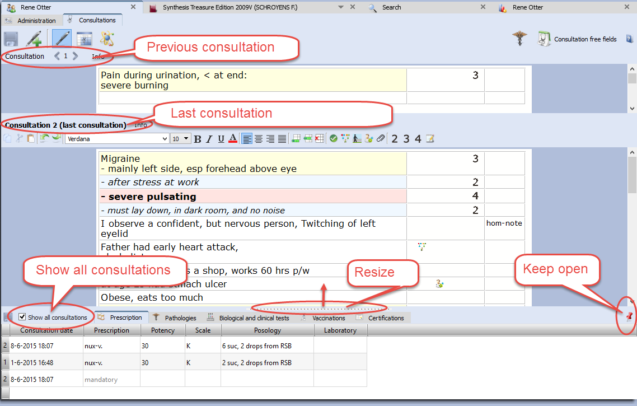

Below we will discuss all functions and steps in detail.

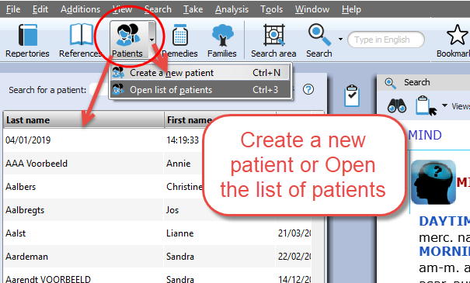

Create a new patient
With the Patient button you can open the list of existing patients in the Table Of Content.

Step 1:
With the sub-button you can select Create a new patient. Or use on the keyboard Ctrl+N (Windows) or Cmd+N (Mac).

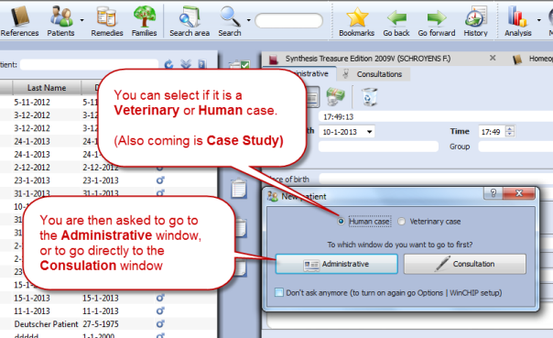
Step 2:
A window appears where you can select to go to the Administrative window first or to go immediately to the Consultation window.
You can also select if it is a Human or Veterinary case. (Coming is an option ‘Case Study’)

Tip: Acute Consultation
If you are in a hurry (with an acute telephone consultation) where you do not have the time to first fill in all the administrative details, you can immediately go to the consultation window and start to type the symptom from the patient. Then for the patient first and last name the current time and date will be used. Then later you can change it to the correct first and last name of the patient.
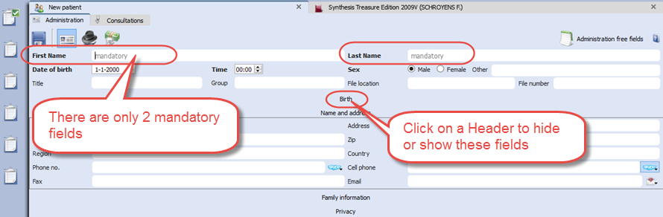
Step 3:
When you select the Administrative window first, there are only 2 mandatory fields: First Name, Last Name

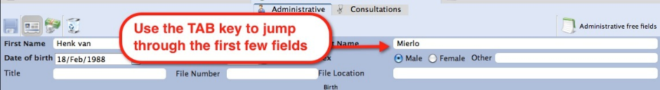
Tip: Use the TAB key on the keyboard, to jump through the first few fields.
Shift+Tab goes back one field.

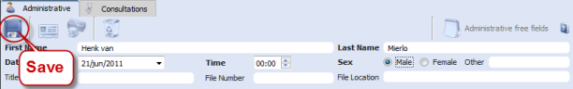
Step 4:
When you are ready filling in the (two mandatory) fields you can click on the Save icon.

Then click on the Tab Consultations to switch to the consult window, and a "new consultation" will be created automatically, with the current date and time.

Note: Automatic Save
It is not necessary to click on the Save icon because the Administrative window will be saved automatically when you move to a different window. So when you move from the Administrative window to the Consultation tab the entered information will be saved automatically.

Step 5:
In the Consultation Tab you find several icons which open different sections.
From left to right the following buttons are listed:
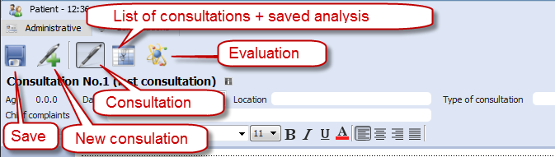
- Save: to save the current consultation tab and the analysis, (But also note the automatic Save function).
- New consultation: to add a new consultation.
- Consultation text: The consultation text editor window.
- List of consultations (dates + analysis): for an overview of consultation dates with the saved analyses.
- Therapy evaluation: to note the reaction to you prescription / therapy.

If I write the consultation on paper, can I then still use the patient file?
If you like to keep on writing the consultation text on paper, it is still useful to use the patient file a in the following limited way:

- In the administrative window, note down the patient name and address details
- Go to the Consultation window, where you can only press the Save button, to save the new consultation date.
- After you have taken symptoms from the repertory into a clipboard, you can switch to the Patient Tab, and press Save. Then the analysis will be saved to that consultation (you can see them in the List of consultations).
- Use the prescription tab, to note the remedy and potency you prescribed.
- At the follow up consultation, you note down the general evaluation in the Evaluation window.

Even with this limited use of the patient file, it will still allow you to do research and get valuable insight in your practice: Which remedies you prescribe most frequently, which repertory symptoms you use most often, what percentage of cured patients you have etc.
You can adapt the use of the patient file exactly to how you work: you can use only those fields you want.

Tip: Change the default Font Size of the text editor
If you find the text to small or too large, then you change the default font size via the General RadarOpus settings. You can find the general Options:..
- On Windows: via the menu Tools, then Options
- On Mac: via the menu RadarOpus, then Preferences (in some versions also via Tools, then Options)

Consultation text editor
After you filled in the patient name and address details, you click on the Tab Consultation and come to the consultation text window:
- The Pen-icon shows the consultation text editor
- The "Info" shows/hides the consultation summary info fields
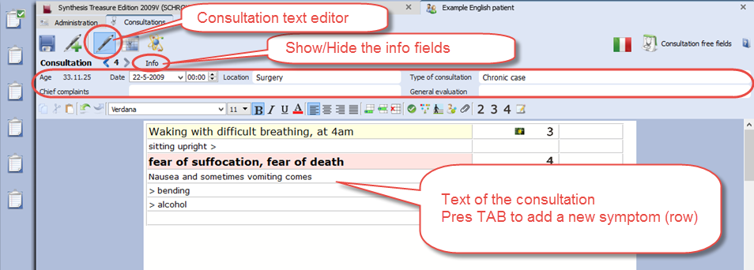
- In the text editor you can press on the keyboard the Tab key to add a new row for each new symptom. The Enter key adds a new line within the same row.

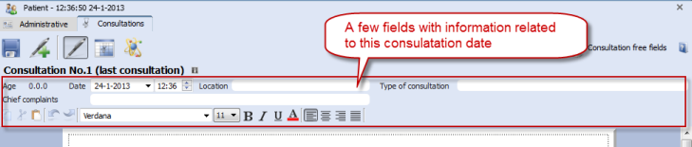
Consult summary details
This area has the following information:
- The age of the patient (given in: years, months and days).
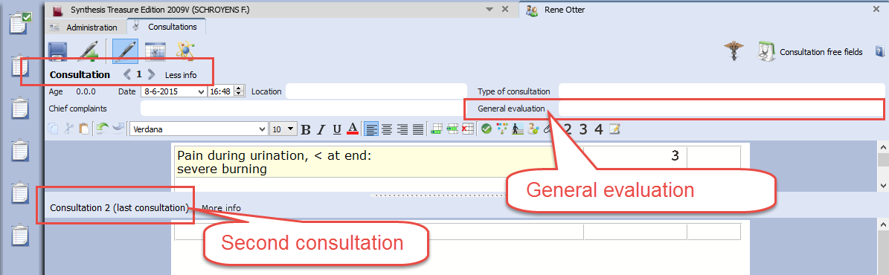
- The consultation date and time.
- The Place field is to note where the consultation takes place.
- In the Type of consultation field you can indicate e.g. acute, chronic, follow up.
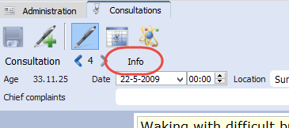
- The field General evaluation will only be displayed after a second consultation has been created.

Show/Hide the consult summary fields
Click on Info to open or close the consultation summary fields.

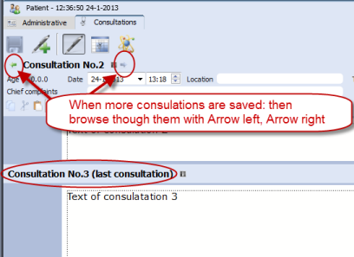
Browsing through consultations
After several consultations have been created for a patient, you can browse through them with the Arrow left and Arrow right buttons.

The split screen will show the last (or current) consultation at the lower part, and the previous consultation(s) in the upper part.

You can resize the upper and lower parts as you prefer.

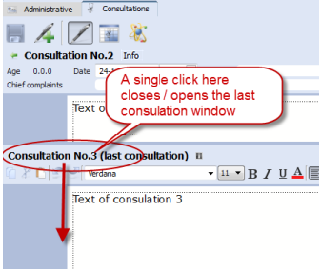
A click on the header Consultation No. will open, or close that consultation text.

Using the TAB or ENTER key in the text editor
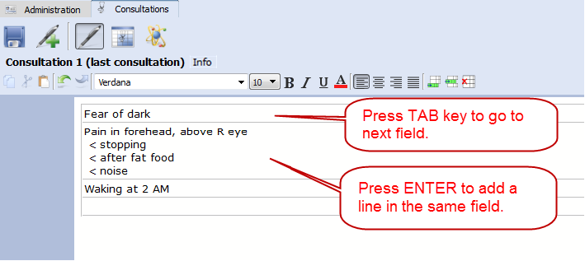
When you type the symptoms of your patient you can use the TAB and ENTER keys:

- TAB key on the keyboard adds a new field.

- ENTER key on the keyboard adds a new line within the same field.

The text editor toolbar
At the top of the text editor you find icons for many functions:

- (A): Text layout: font style, bold/italics/underlined, font size, alignment.
- (B): Insert, Append, Delete a line (row)
- (C): Icon to add Tags: Important symptom, family anamneses, past medical history, physiological anamnesis, add an attachment (image, video, pdf, word, etc.).
- (D): Indicate symptom intensity 2, 3, 4. By default a sentence (line) has an intensity 1. (To remove an intensity again, click again on the intensity button.)
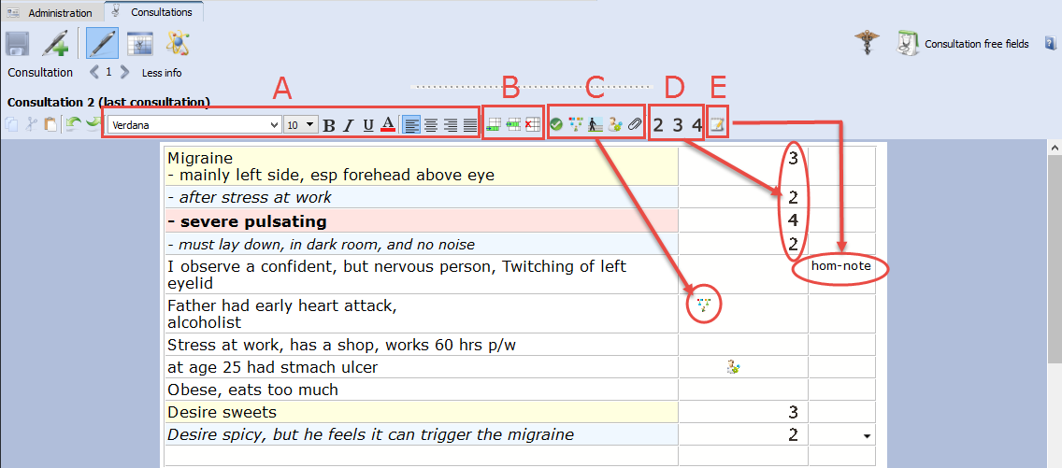
- (E): To indicate a sentence as a "remark by the homeopath" (hom-note)

Show all sentences with a similar quality (Tag)
All information (C, D, E) which you can add to sentences in the last two columns are called tags.

You can easily show a selection of all sentences with a particular tag in the following two ways
- Click on a tag icon to open a separate window, with all symptoms with that tag.
- Or, Right mouse click on a sentence to open a context menu.

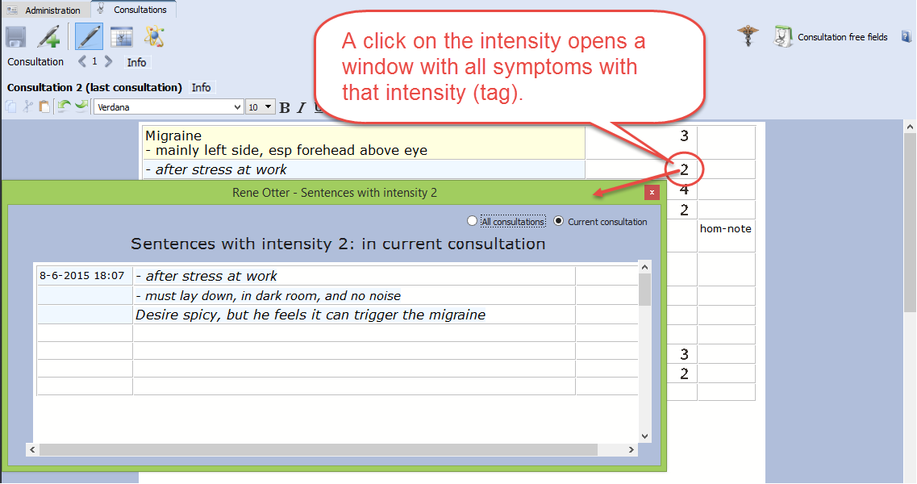
In this example below: a single click on the intensity 2 opens a window with only all sentences intensity 2.

A right mouse click on a sentence opens a contextual menu with several options:
- Tag a current sentence with a certain quality (family history, past medical history, etc.)
- Show a window with all sentences tagged with a certain quality
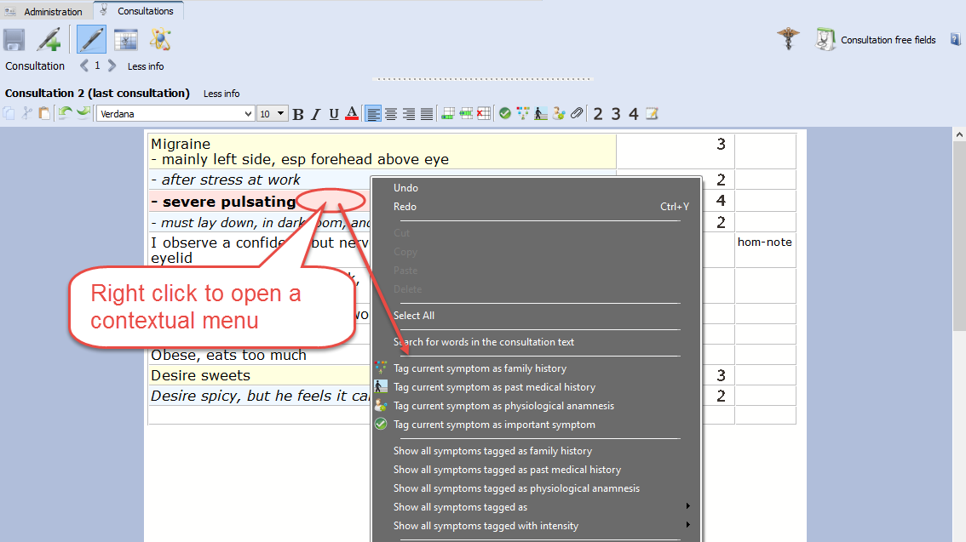
- Limit the text editor to show only symptoms with a certain quality

Word search in the consultation text
The contextual menu also has an option to do a 'word search', in the current consultation only, or in all consultations of that patient. In this way you can find all sentences with a certain word in only the current consultation or all consolations of that patient.
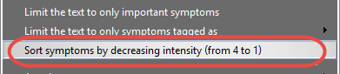
Sort symptoms according to decreasing intensity (4, 3, 2, 1)
The contextual menu also has an option to sort all sentences according to degreasing intensity.
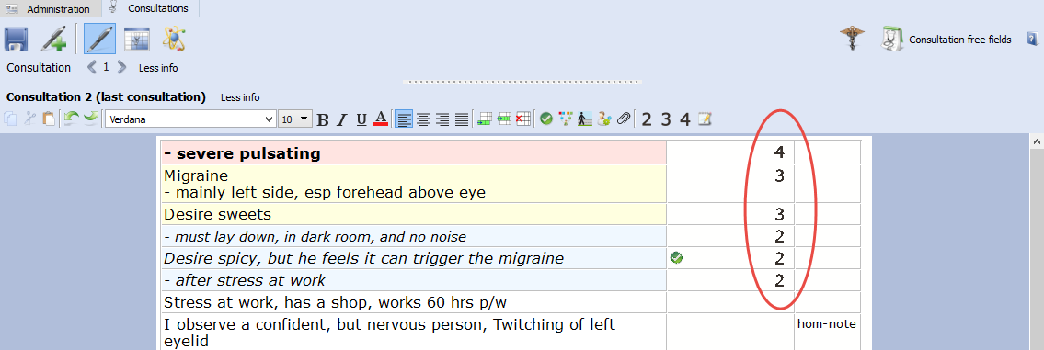
Add other tags & personal defined tags
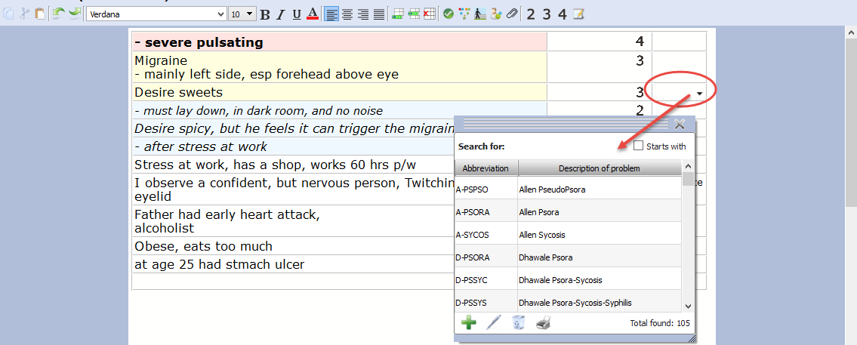
A click on the triangle icon in the 3rd column opens a pick list with tags.
It is possible to limit, or show a list of all symptoms with any of the tags added in the 3rd column.

Ewald Stöteler: The Disease Classification of Hahnemann
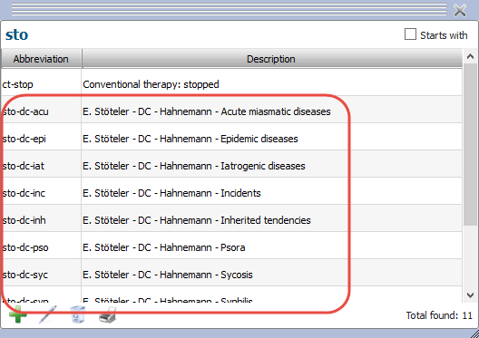
The "add other tags" function allows you to select predefined tags from the disease classification.

- Sto-dc-acu = Acute miasmatic diseases
- Sto-dc-epi = Epidemic diseases
- Sto-dc-iat = Iatrogenic diseases
- Sto-dc-inc = Incidents
- Sto-dc-inh = Inherited tendencies
- Sto-dc-pso = Psora
- Sto-dc-syc = Sycosis
- Sto-dc-syp = Syphilis

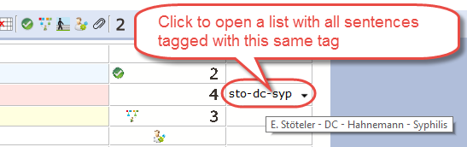
Show all symptoms with a certain text-tag
To show a list with only all symptoms with a certain text-tag just click on that tag

You can show all symptoms with this tag only within the current consultation, or in all consultations.

Important symptoms
The green checkmark icon can be used to indicate important symptoms. You could use this tag for example for those symptoms you prescribe on, or at least the remedy you select should cover these important symptoms as best as possible.
A single click on such an icon will show you for the current consultation only or for all consultations a list of these important symptoms.
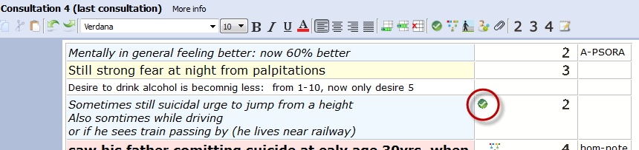

Prescription and Pathologies fields:
This Prescription and Pathology fields are located at the bottom of the window. The Professional version will have more Tabs: Biological and clinical tests, Vaccinations, Certifications.

- Move the mouse to the bottom, to open the Prescription and Pathology fields.
Note there are also hotkeys: Ctrl+L (on Windows), and Cmd+L (on Mac).
- Click on the Pin icon, to keep the Prescription and Pathology fields open.
- Function key F9 opens the Picklist.
- Function key F10 inserts the Default value (only if you have assigned one to that field)
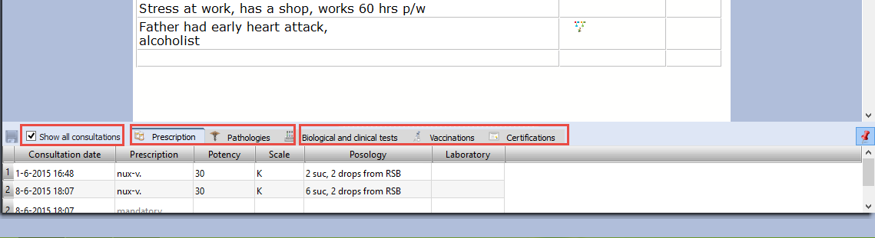
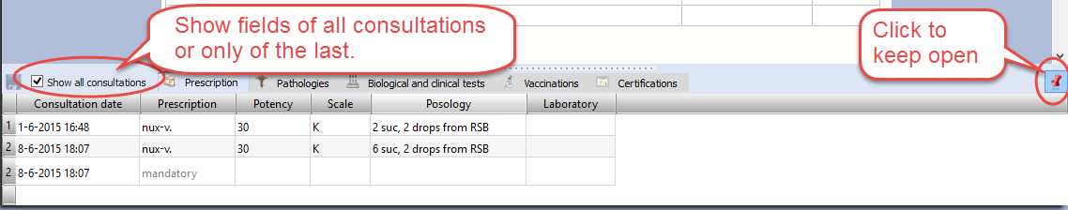
With the checkbox "Show all consultation" you can switch between showing only the prescription fields of the current consultation or to show the prescriptions for all consultations.

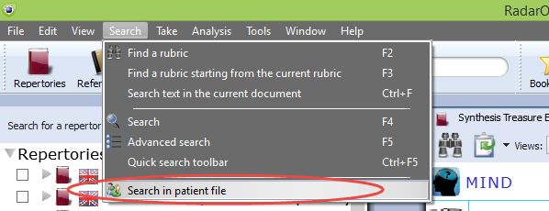
Patient search
With the function Search in the patient file, you can do advanced patient research, show statistics, and export any query result.
See more in the chapter Patient search elsewhere in this manual.

Manually Save / Recall an Analysis to the patient file
As explained already above, the analysis (the clipboards) is saved automatically when you save the patient file. There is a way to save manually the symptom clipboards to the patient file, but the automatic method is easier.

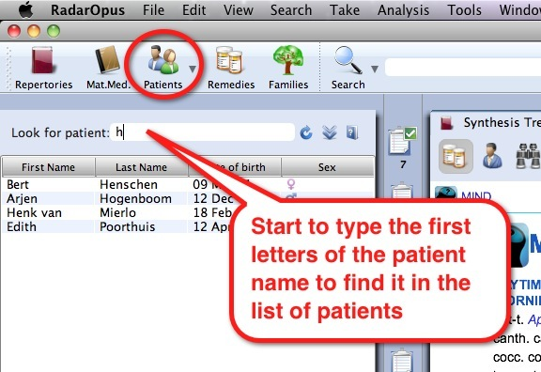
Follow up consultation
How to Create a Second or Follow up Consultation

Step 1:
When the patient returns for a follow up consultation you should start by selecting the patient from the List of patients to open it.
A single click on the patient name will open that patient file.

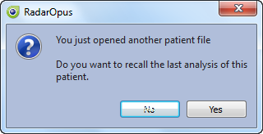
Tip: If you have a long list of patients type part of the patient name in the search box. It will search in the all three fields: First name, Last name, and Birth date.

Automatically open the last Analysis
The program will ask if you would like to open the last saved analysis of this patient automatically. If you select yes, the symptoms of that analysis will be loaded in the clipboard(s).

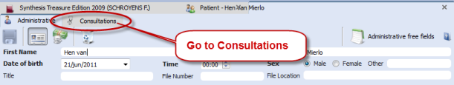
Note: After recalling an analysis, and saving the patient file again, it will be saved to the current new consultation.

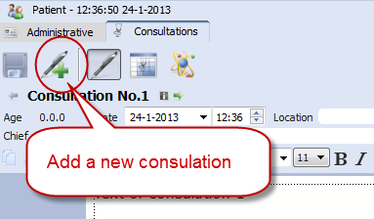
Step 2:
Then go to the Consultation tab.

Step 3:
Then click on the button Add a new consultation.

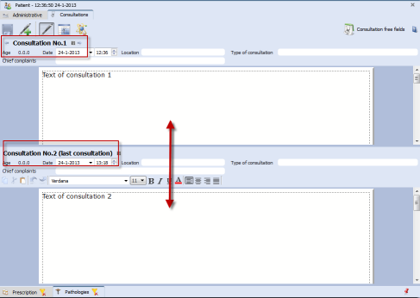
Compare a New consultation with a Previous consultation
When you create a second or third consultation for a patient, you can easily compare this new consultation window with one of the previous consultation windows.

The upper part shows a previous consultation, the lower part shows the current (last) consultation.

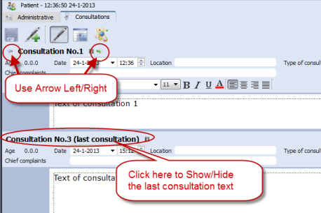
Browse through consultations
The consultations will be numbered “No.”
Use the Arrow left and Arrow right buttons to move through the list of consultations

Open / Close consultation text
You can close/ open the previous consultation text area or the last consultation text with a single click on the header.

List of patients: ‘Groups of patients’

Assigning a patient to a group
It is possible to define several categories (groups) of patients.
After you assign patients belonging to a certain group, you can use this in the List of patients.

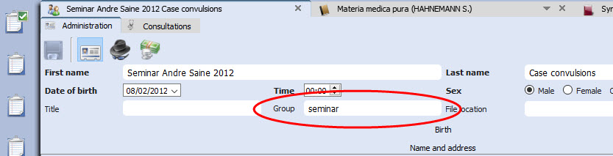
In the Administration window there is a field called Group.

You can define your own groups (also called tags).
For example: Family, or Teaching or any other ‘group’ you want.

List of patients: show only a certain group
In the list of patients you can then select to show only patients belonging to a certain group.
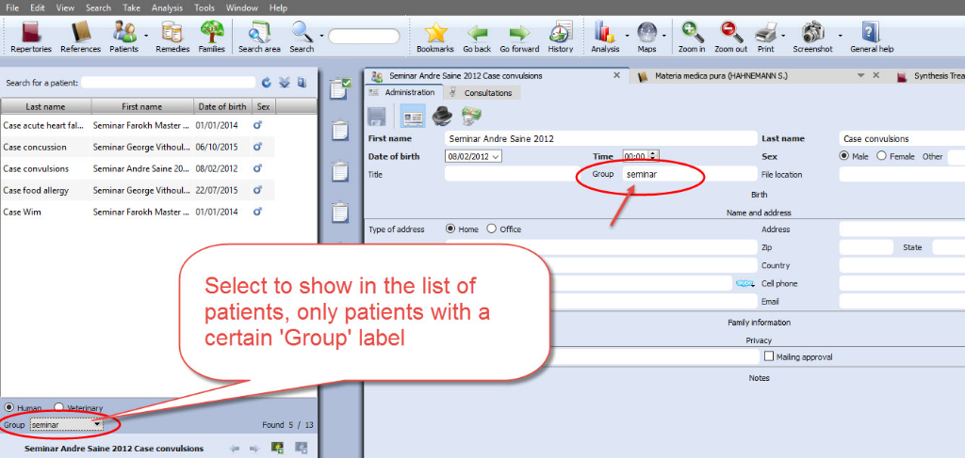

See at the bottom of the List of patients.

By default is selected “All” patients

You can select here on of your own groups.

Keep in mind that there are already two main types of patients: Human and Veterinary
So you can show the following combinations:.
Human:
  - All
  - A personal defined group

Veterinary
  - All
  - A personal defined group

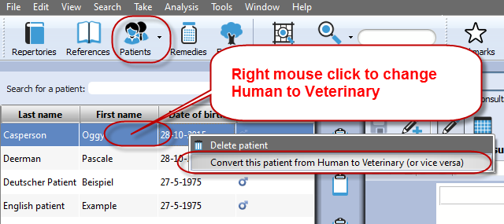
Change “Human” to “Veterinary” or vice versa
If you made a mistake initially when creating the patient in “human” and “veterinary”, you can change it via a right mouse click on the name of the patient in, in the List of patients: then select:
Concert this patient from Human to Veterinary (or vice versa)

The Veterinary Patient File
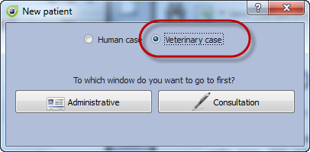
When you create a new patient you can select Veterinary patient.

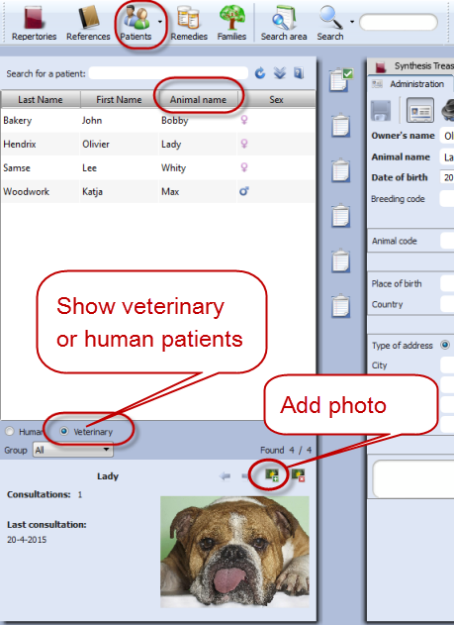
In the Table of Content (List of patients) you can switch to show only human patients or veterinary patients

The veterinary patient file has some additional fields for the animal name and animal details:
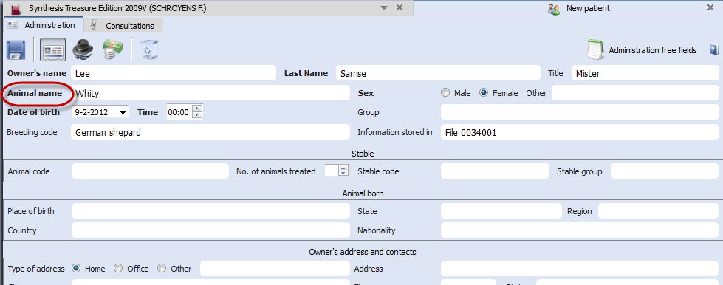

Change “Human” to “Veterinary” or vice versa

If you made a mistake initially when creating the patient in “human” and “veterinary”, you can change it via a right mouse click on the name of the patient in, in the List of patients: then select:
Concert this patient from Human to Veterinary (or vice versa)

List of consultations & saved Analyses
The list of consultations gives an overview of all consultation dates, with the prescribed remedies, and the repertory symptoms used in the saved analyses.

Recall, Delete, Show symptoms:
- Show repertory symptoms: Hold the mouse in the column Analyses to see the symptoms used in the analysis.
- Recall an analysis: Single click on the analysis to recall it in the clipboards.
- Delete an analysis: Right click in the column Analysis.
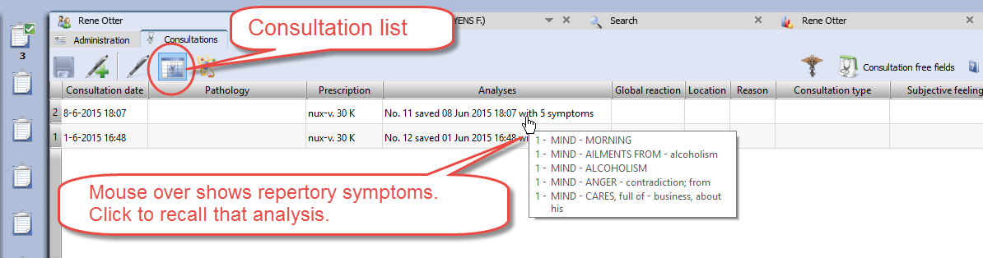

Import an analysis and save to a consultation
- You can import a separately saved analysis in RadarOpus (saved separately to a folder) to a consultation.
- It is also possible to import an analysis coming from the Synthesis App (xml file) or an analysis exported from a different RadarOpus program (xml file).
- You can also import a CAS file, which is saved (or exported) from RadarClassic 10.5.

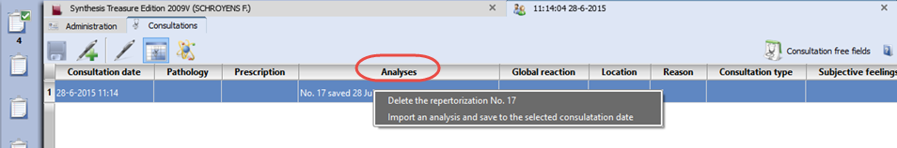
To import, Right mouse click in the column Analysis, then select Import an analysis (which was saved separately, or recalled from a RadarClassic 10.5) and save to the selected consultation date.

Attention: Delete a consultation date
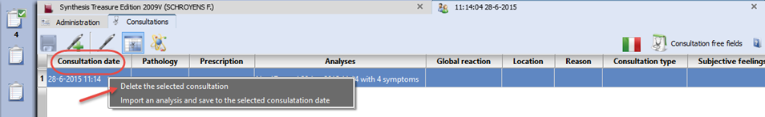
If you Right mouse click in the column Consultation date you can delete the complete consultation date. Be careful you will delete all information of that consultation.

Prescriptions and Pathologies
The fields for the Prescription and Pathologies are located at the lower part of the screen.
The Professional version has more fields for: Biological and clinical tests, Vaccinations, Certifications.

- The prescription tab allows you to note the remedy you have given, the potency, the type of dilution scale, the posology (amount, frequency, method of taking), the Laboratory (Pharmacy).

- You can click on the small Pin icon to keep these fields open (Right lower corner).
- You can resize the window.
- You can select to show only in the table only the fields for the current (last) consultation or for all consultations.

Tip: There is a hotkey to show/hide the prescription-pathology fields: Ctrl+L (on Windows), and Cmd+L (on Mac).

Show only the fields of: the current consultation or all consultations
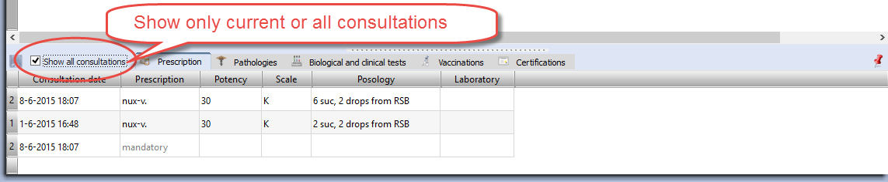
In the table you can select to show only the current consultation or all consultations.

Insert a prescription afterwards to a previous consultation
In case you forgot to enter the prescription during the interview, or if you want to add a second prescription line to a previous consultation, you need to do the following:
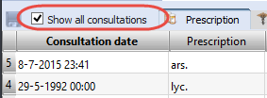
Step 1: Select to Show all consultations.

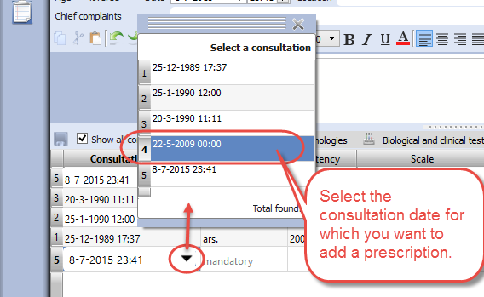
Step 2: Click on the (arrow down icon) to open the pick list with consultation dates. Then select the date of a previous consultation date, and enter the prescription.

The entry (new row) will be sorted automatically correctly in the list.

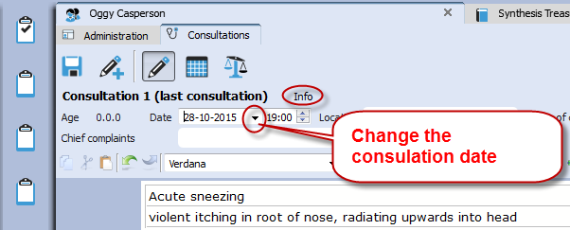
Correct a consultation date
If you might want to add later a consultation to a patient, after the original consult took please, you need to change the consult date.

For example you were traveling and had a telephonic consultation and prescribed a remedy.

When you open this patient, and create a new consultation by default the current date will be used.
To change the date, open the Info box. Then correct the date.

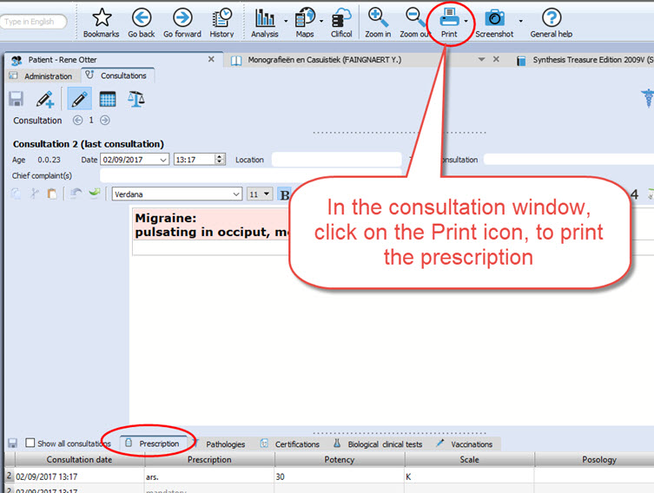
Print the prescription
If you are in the consolation window, click on the print icon to print the prescription.

Note that via the general option menu, you can select a few settings for this prescription: Go to Tools, Options, Patient setup.

For example: Print prescription:
On/Off Do not print the header
On/off Do not print the footer

Invoices

From the Administration Tab, you can click on the button Invoices (financial information):
- You can copy the name and address information of the patient from the Administrative window with a click on the Copy Name& Address button.
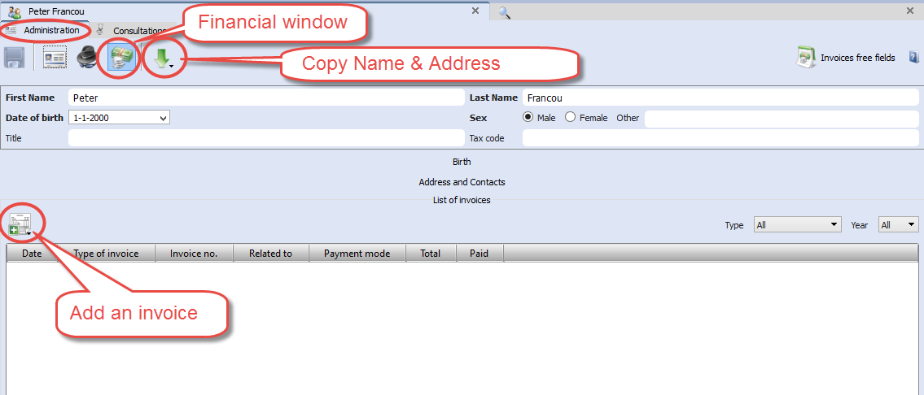
- Click on the Add an invoice button, to create an invoice.

Create an invoice
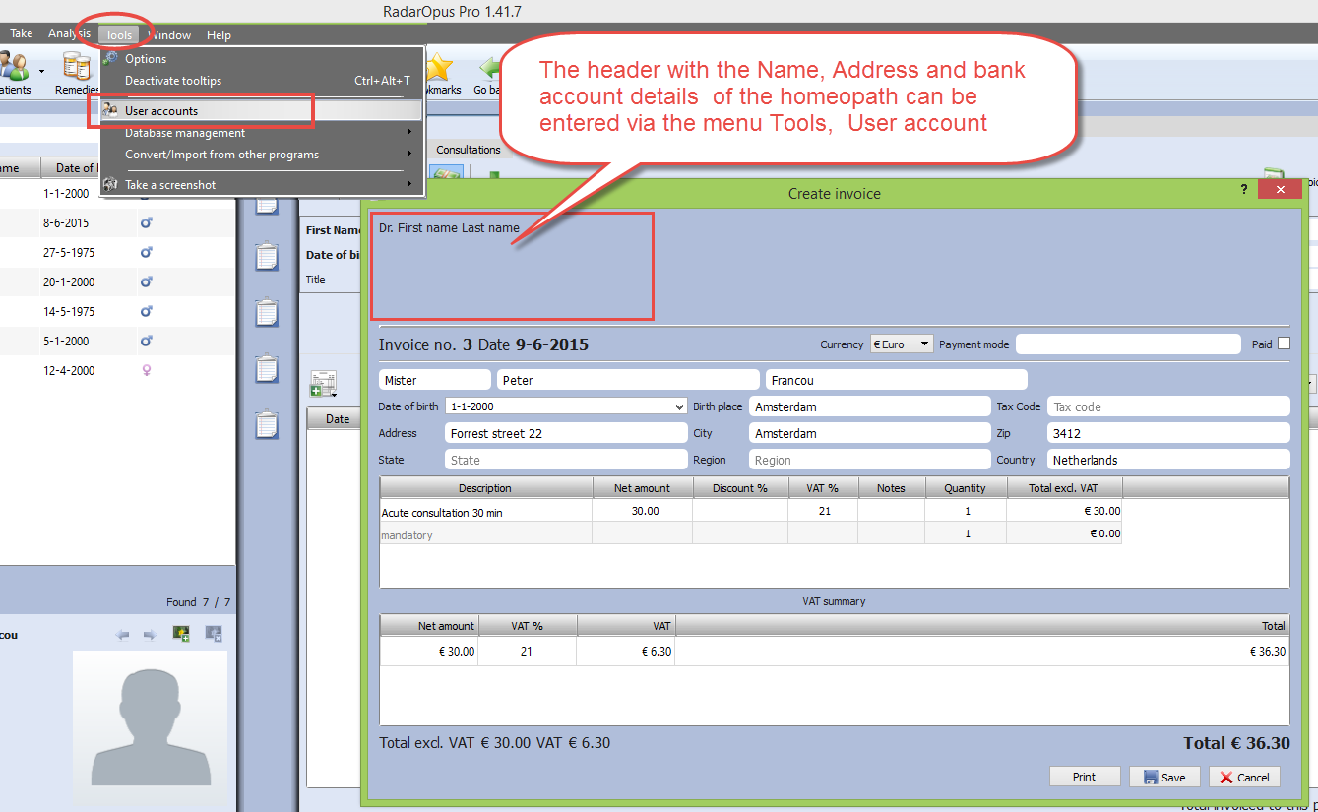
The invoice will contain as header also the Name, Address, Bank account details of the homeopath. This information should be set only once, via the menu Tools, then User account

Tip: You can use the Patient search function, to search for all unpaid invoices.
For more information see the chapter Patient search.

Attention: The name and address details of the homeopath is printed in the header of the invoice. You can insert these address details via Account settings.

Therapy Evaluation
When the patient visits for a follow up, you can record the effect of your treatment in a more general way, or in great detail.
If you enter for all your patients a therapy evaluation, you will be able to get reliable statistics via the Patient Search functions.

Example: 5 consulations and 2 prescriptions
In this example you can see that there where a total of 5 consulations, and that the remedy Ars. 200 K was prescribed at consult 1, and again at consult 4.

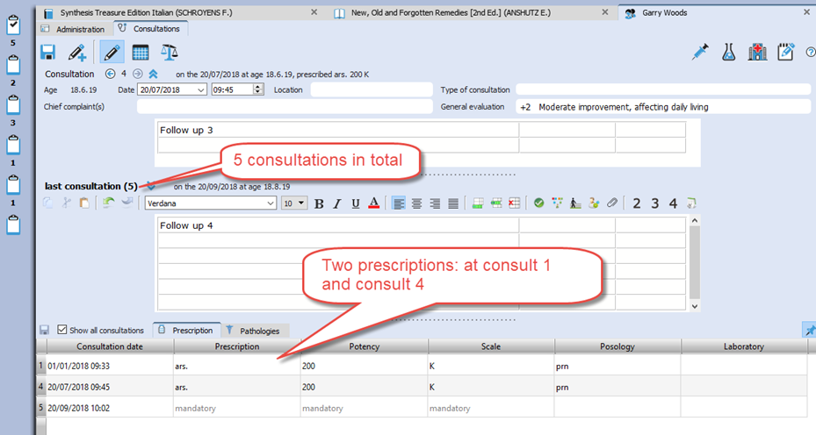

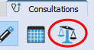 Evaluation
Click on the button Prescription Evaluation to open the evaluation window with the following options:

- At the left is shown a list of Consultation dates & when a prescription was made
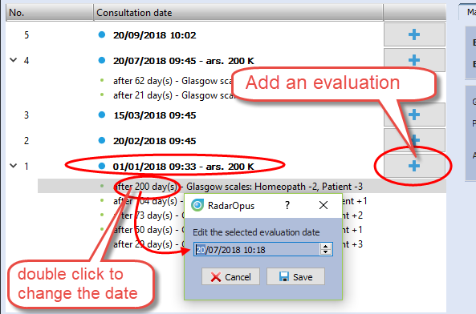
- Click on the + button, to add an evaluation.
You should enter your evaluations connected to the consultation date of the prescription.
You can add several evaluations about that prescription, as long as you do not make again a new prescription.

To change the date of an evaluation, double click on “after xxx days”.

For each evaluation moment you can record one or more criteria:
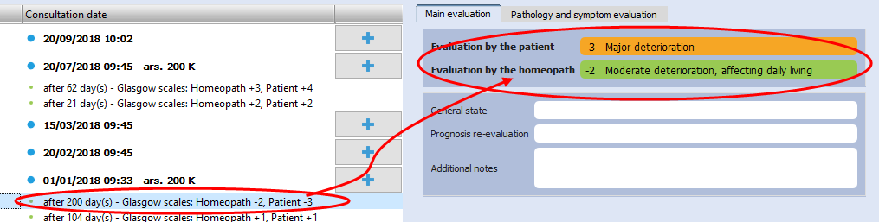
- The evaluation by the homeopath: This field you should always fill in.

- There is also an evaluation by the patient: this is optional

- You can also evaluate the pathology, or even evaluate each used repertory symptom from the analysis.

The evaluation graph
In the below example you see in the graph the two blue dots when a prescription was made. In this example only two prescriptions where made during 5 consulations.

In the graph you also see an orange line indicating the evaluation by the patient, and a green line indicating the evaluation by the homeopath.
The smaller orange and green dots indicate the evaluation dates.

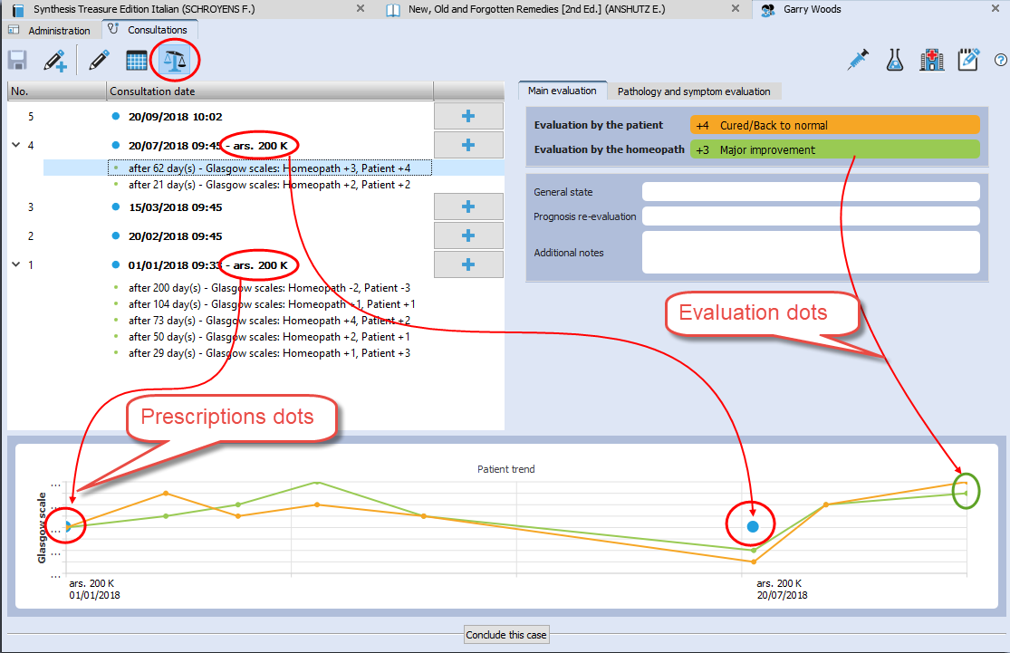

Conclude a case
With the button “Conclude this case” you can write a general description about this case, and you can also upload it to the Clificol database.
Click on the button Conclude this case

You can share the case in a secure and anonymous way, by sending it to the Clificol database.

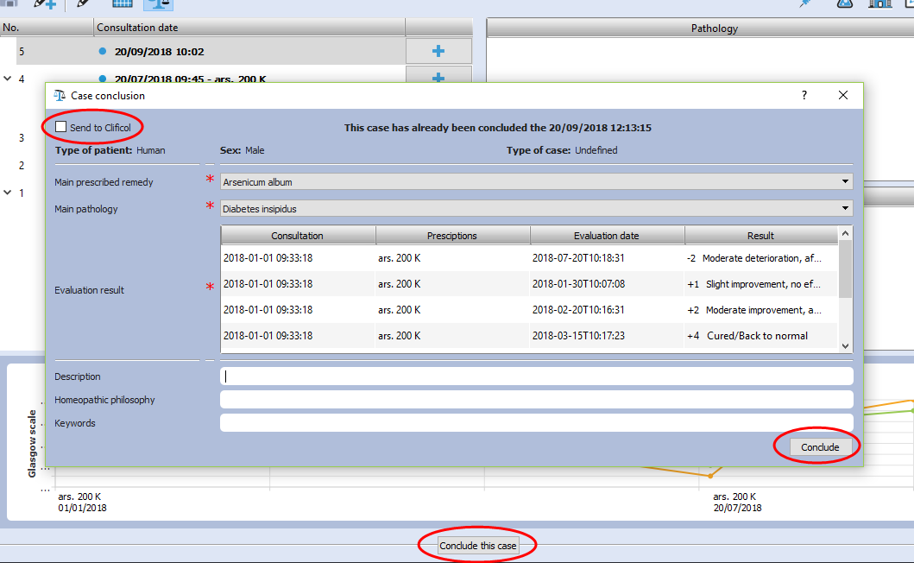

Patient Search

New: Using the Patient Search function will allow you to gain valuable insight into your practice.
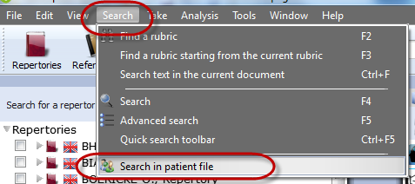
The Light version of the patient file allows you to do basic searches. With the Professional version you will have the most powerful research tool for homeopathy excising to date, with a wide range of research possibilities.

From the menu bar select Search, then Search in the patient file.

To do a search, you need to decide the following:
- In which main category you want to search
- Which fields should be shown in the search result list
- You can enter criteria in one of the fields, or leave them empty
- Search in your Human or Veterinary cases
- Then click on the Start Search button, to see the result

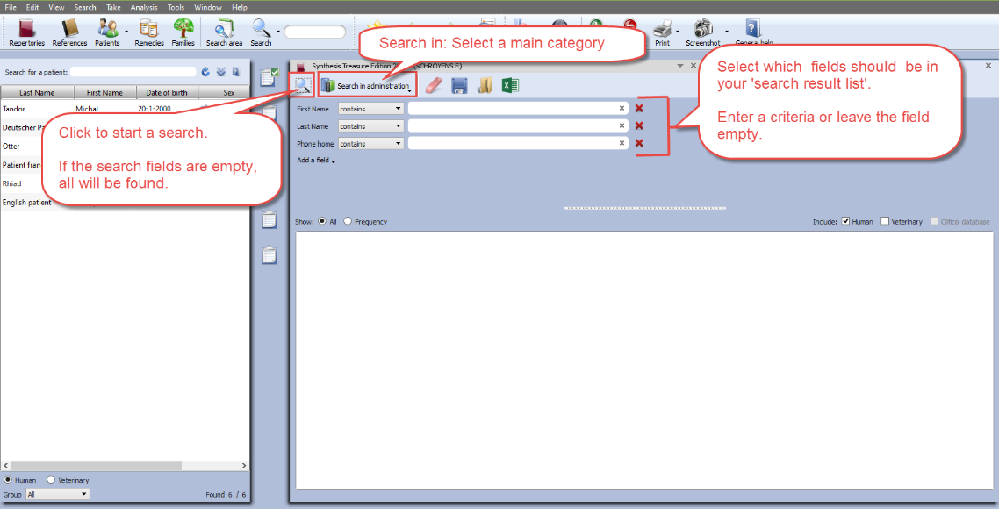

If you leave all fields empty, you will get a search result (a report) in a table, containing all the fields you selected. You can also export this result to Excel, edit it and print your own forms.
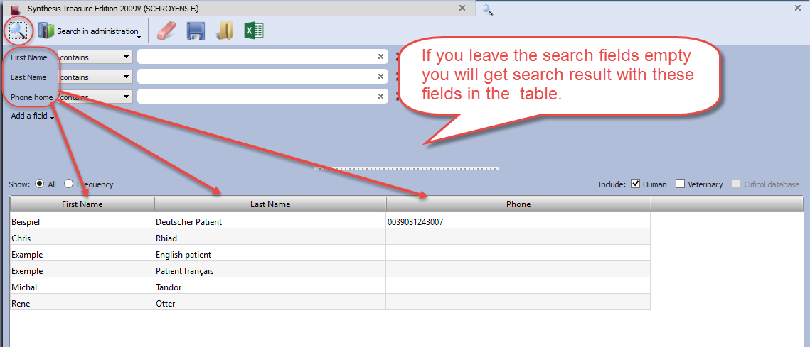

Frequency
If you select to show Frequency, it will consider all the selected fields in your list.
To explain this, see the below two examples:

- If you select only one field Prescription for the list, and enter the condition Ars., you will see how often you prescribed this remedy.

- If you use two fields e.g. Prescription with the condition Ars., but use the field Potency without entering a condition, you will see how often the remedy Ars was prescribed with each unique combination "remedy and potency".
For example:...
10 times Ars. 200
4 times Ars. 30

Example screen:
In this example below, we searched for all Prescriptions with the remedy Ars., but also the fields Potency, Scale, Posology where added.

Because when calculating the frequency, all unique conditions are considered, this will mean that all fields must have the exact same value to be counted as "the same".

You see in the screen below, that the result is not one number how often Ars was given in total, but you see a result showing three rows:
- 2 times the exact same result: "Ars. + 200 + CH + Chalazion" was found.
- 2 times: "Ars. + 200 + CH + Diabetes insipidus"
- 1 time: "Ars. + 30 + K + Diabetes insipidus"

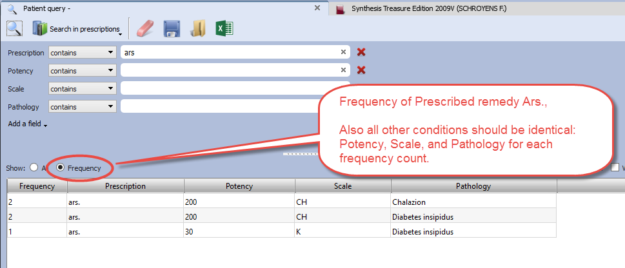

Other toolbar icons
With the other toolbar icons you can do the following:
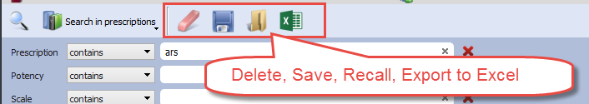
- Delete all fields (the whole query)
- Save to disc for future use the query
- Recall from disc a query
- Export the search result to an Excel file

Example:
In this example database of a RadarOpus user, the remedy Puls. in a 200 potency was prescribed most often.

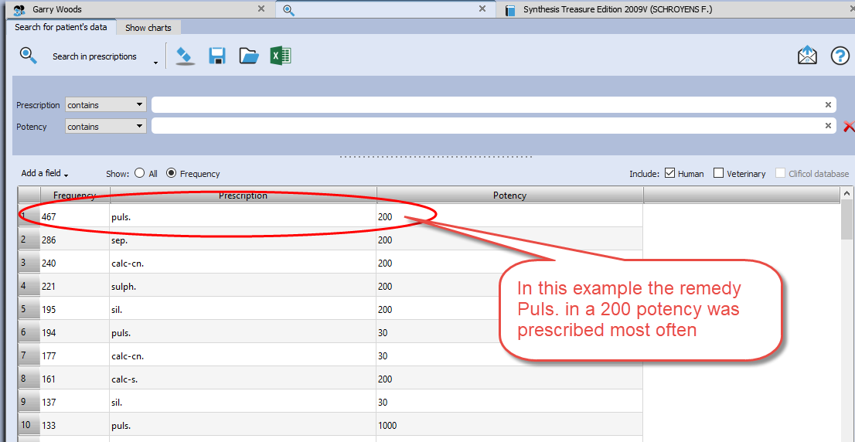

Show charts in the Patient file-Search
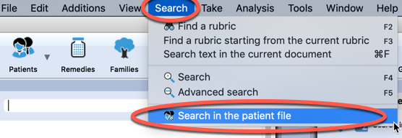
Go to the menu bar: Search, then select: Search in the patient file

Then click on the tab Show charts

You can see some details of your practice presented graphically.
- The distribution over age categories, Which remedies prescribed most often, Which pathologies are most common.
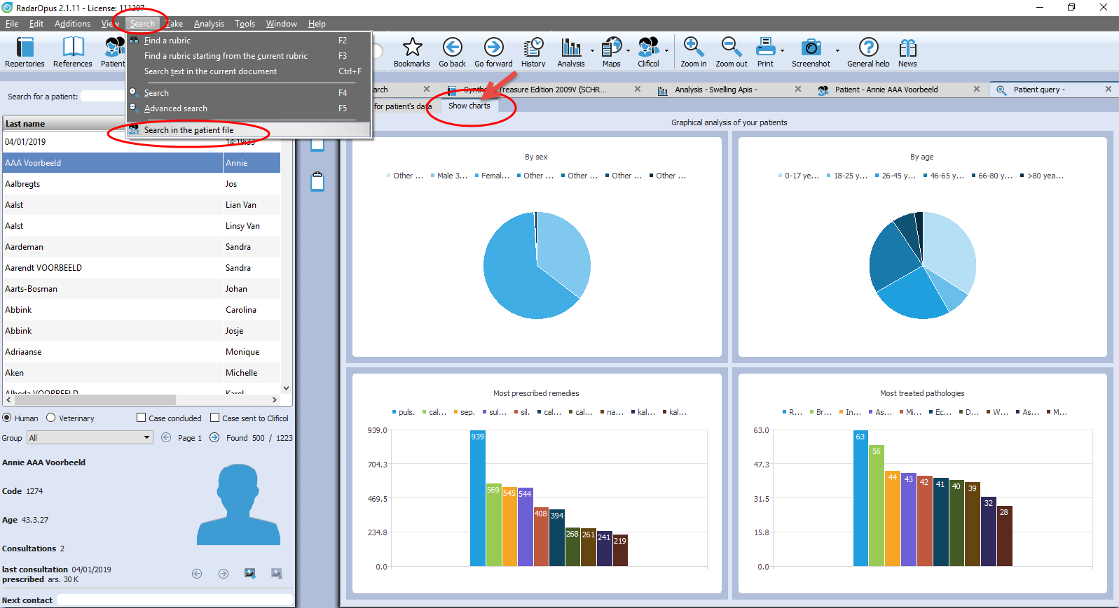

Search for words in the consultation text

It is possible to use the function from the menu bar Search, then Search in Patient file, to do searched for words. This can be done for only one patient, or all your patients.

You can find the patient name(s) and exact consolation date(s) and the sentences where a certain word is used, or you can show a general frequency count.

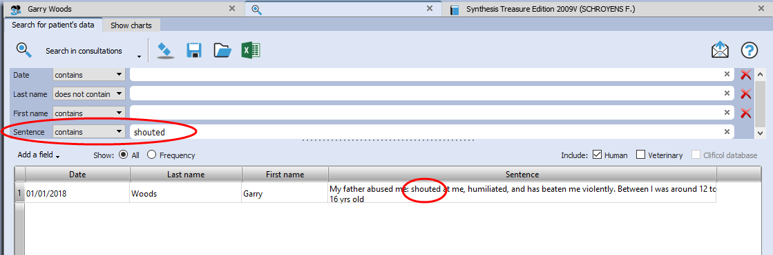

Tip: If you have a patient consultation window open, it is also possible to search for Words within that consultation, or within all consultation of that patients.

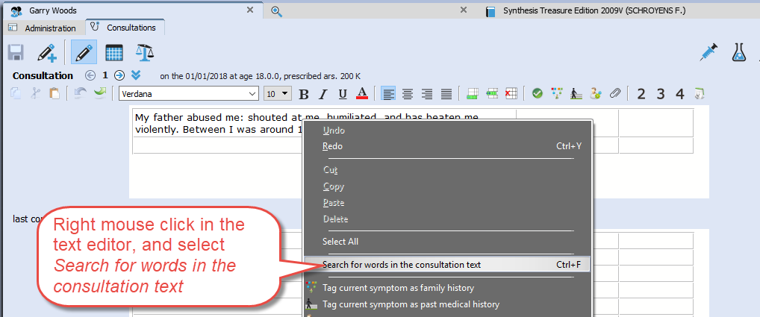

Send an Email to (all) your patients
Sometimes you want to send an email message to all or a selection of your patients.
You can send an email to:
- only one patient
- to a selection of patients
- to all your patients

How to send to all your patients an email
- Open the Patient search window: from the menu bar Search, then Search in patient file.
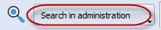
- Select Search in administration

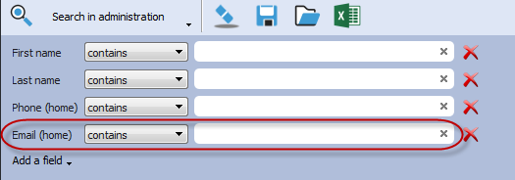
- Make sure the field Email home is selected
You do not need to enter any search criteria into the fields

- Click on the Search icon to start the search:
The result will be that all patients are in the list.
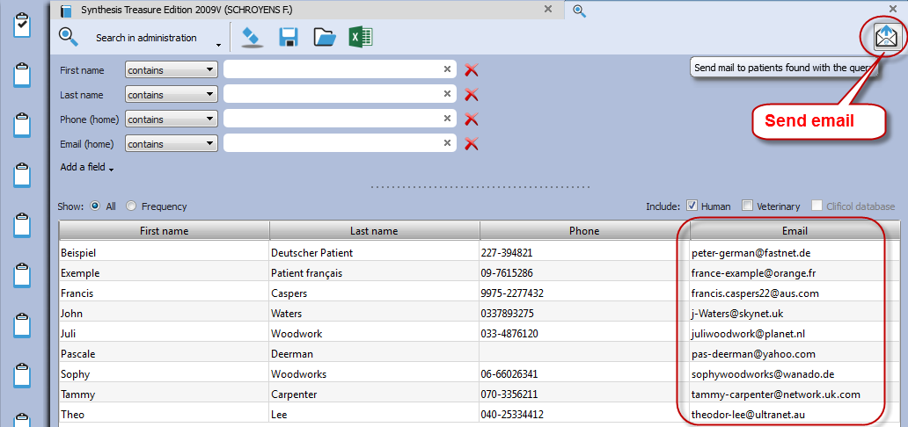

- Then click on the Send email icon (envelop) to open your email software.

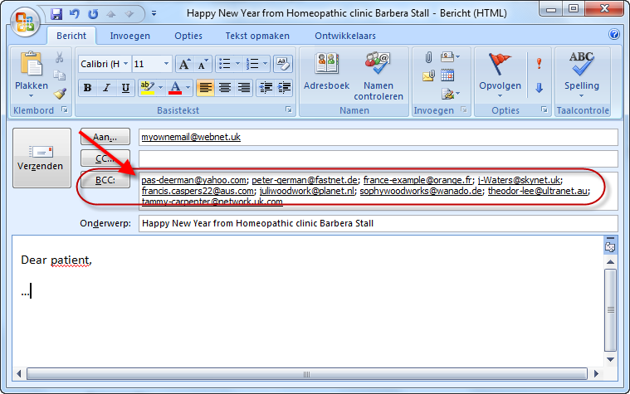

All email addresses will be added to the field BCC (hidden).

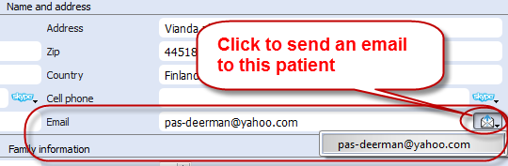
Tip: Email to one only person
To send an email to only one patient, you can click in the Administration window on the Send email icon (envelop).
Clificol

We invite you to participate with the Clificol project:
The collection of clinical experience with homeopathy!!

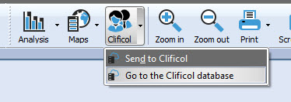
From the toolbar button Clificol you can:
- Upload a cured case to Clificol database
- Go to the Clificol database

For more information about the registration please see the chapter User Account

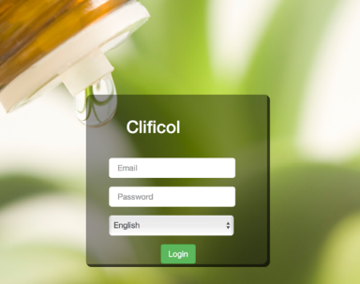
The Clificol project has two main objectives:

- To allow the homeopathic community present to governments and other organizations clinical evidence of the effectiveness of homeopathy.
- To offer the homeopathic community a place to share clinical information between each other, and also to be able to learn from the experience of others.

More information about the Clificol project can be found at: www.clificol.net

The login of the Clificol database can be found at:
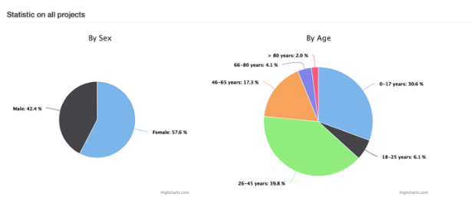
http://intranet.clificol.net

Clificol will offer you a wealth of information

After registration you can now share those cases which you think are interesting and well documented.

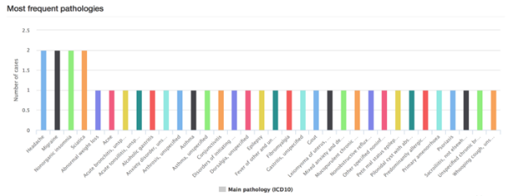
When uploading a patient case, it will be made anonymous automatically. All name and address information will be removed.

Vithoulkas Expert System

The Vithoulkas Expert System (VES)
With version 1.34 the Vithoulkas Expert has become available in RadarOpus.
The VES is a unique way to help you to repertorise a case, it will compensate the ‘pitfalls’ (limitations) of the repertory and give you suggestions for case taking and remedy differentiation.
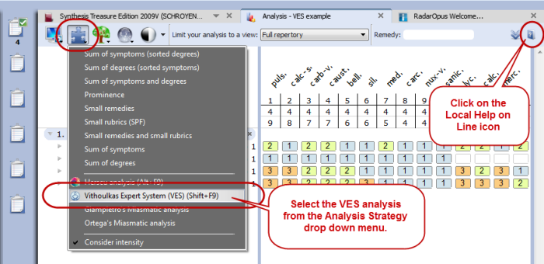
Click on the local Help icon to read the instructions on how to use the VES.

Start the VES analysis from the analysis strategy drop down menu or directly with the Hotkey (or from the main toolbar Analysis icon).

By default the VES uses the special Vithoulkas repertory view to obtain optimal results.
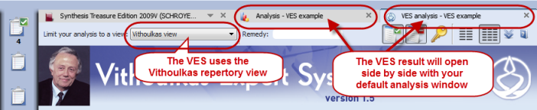
The VES window will open in a separate Tab, enabling you to switch between windows to compare results.
If you need to make changes to the intensity you need to do this in the default Analysis / Clipboards window.

Guidelines on how to use the VES (read the help on line)
Contrary to the normal way of doing an analysis (repertorisation), where you should be very cautious as to which rubrics you should take into a clipboard, the VES has the following guidelines:
- The VES will require a minimum of 4 symptoms to be taken.
- You can take rubrics varying in size from small, medium to large. Although you should try not to take too many very large rubrics (especially if you have only a limited number of symptoms in the clipboards), the VES will take the rubric size and its relative value into account.
- You need to apply symptom underlining (intensity/ strength). Use it to indicate the strength of the symptoms in the patient, not to indicate how important you find the symptom (or if you find it a SRP symptom).
- The VES does not use “Eliminative” symptoms (if you do use this, the VES will ignore it).
- The VES uses “Causality”. You can apply this to one or more symptoms (Coming soon)
- Be sure to read more in the local help on line!!
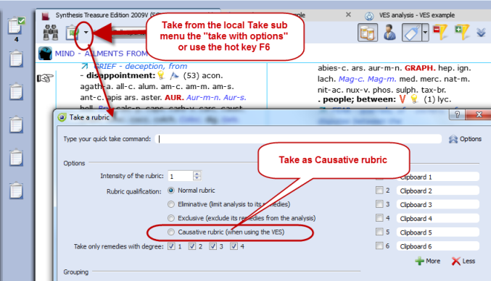
About: Causality (Causative rubric)
For the VES you should also indicate a symptom as Causative if this is appropriate.
To take a symptom as causative, you can use the sub menu of the local take icon, then select “Take with Options” (F6) to open the window with all the Take Options.
Then select: Causative rubric.

Using the F6 key to open the Take Option window will work much faster.

This Causative option (currently) only has an effect in the VES and not in any of the other default analysis methods.

Paul Herscu - Cycles and Segments

Read more about Cycles and Segments at the NESH website.

There are many useful resources available at this page, here are a few:
- Read a good basic over-view of the Cycles & Segments approach
- A Case of Severe Vertigo: A Cycles and Segments Approach
- Oppositional Defiant Disorder: A Case of Platinum metallicum

Cases from the New England Journal of Homeopathy:
- A Case of Childhood Depression by Robert Kaladish, MD
- Difficult Cases – Frustrating Ordeals or Learning Experiences? by Frank Gruber MD
Seizures and Romance Novels by Frank Gruber
- Difficulties In Repertorizing: Why We Need A New Perspective - by Paul Herscu

Herscu module: Cycles and Segments

The Philosophy of Paul Herscu his method is a radical new way to think about your patients and the materia medica.
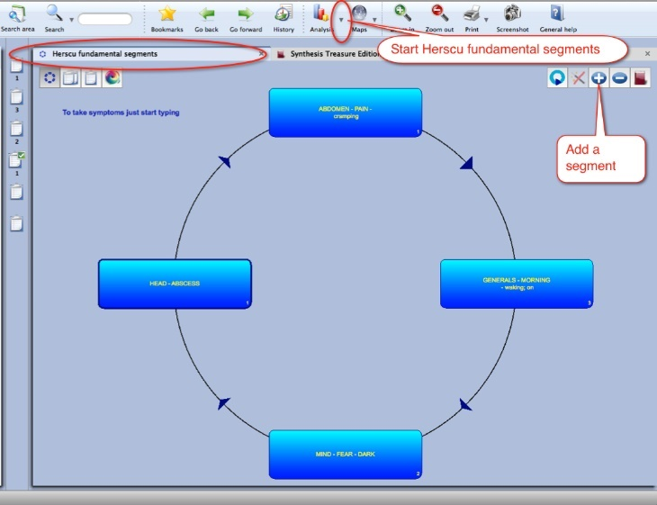
Paul Herscu offers us a different way to look at Homeopathy.

These insights do not contradict other methods, but the Cycles and Segments approach just simplifies and clarifies your case taking and case analysis.
The result will be that you can significantly increase your accurateness in prescribing.

Here are some of the radical ideas:
- You need to understand the patient. It is not enough to simply write down a list of all symptoms of your patient, and then repertorise. You need to understand what symptoms he has and what relationships exist between the symptoms. It is important to understand your case as a whole. This is needed to get order in your case.

- To analyze your case, and to select what symptoms to use various different methods and theories exist. How useful some are (e.g. Hahnemann’s guidelines, Kent’s instructions, André Saine’s method or Vithoulkas way to evaluate symptoms), still it is a difficult process, and often leads to great discussion and confusion which symptoms to use, especially with inexperienced homeopaths.
The method of Paul in fact combines all methods: the essence, the keynotes, the physical generals, the mental and the pathology.

- According to Paul Herscu, if you study your patients, it is ALWAYS possible to see a logic, a relationship behind the “individual symptoms”. Several symptoms can be joined together because they express the same idea, the same quality (a segment).

- The next step is that between these groups of symptoms a relationship can be detected. One symptom (or group of symptoms) will lead to another symptom(s) and this leads again to another symptom(s), until you will meet up with the first symptom (and have created a cycle of events).

- If you find a strong symptom in a case (and if it is really a characteristic issue of this patient) certainly you will be able to find one or more other symptoms that express the same idea (the same quality) somewhere else in the body. It is a certainty that every classical homeopath sees in his patients.
If you find for example a certain strong emotional symptom,… it is for sure that you will find on the physical level elsewhere in the body one or more symptoms expressing the same quality. Also the other way around. If you find a strong physical symptom, for sure you will find it in the mental sphere also.
For example Thuja: Split hair, split nails, split urine,…. You will find mentally: delusions being double, the split personality etc.
This theme of “duality” in Thuja is just ONE of the segments you can find in Thuja. In Thuja you first will find a “weakness”… a weakness that easily allows invasion. Easily invasion of foreign influences e.g. vaccination, germs, remarks of others etc.,.. this enters the body, and from this is created the sense of duality. So we have here already TWO of the segments of the remedy Thuja.

- You will be able to organize ALL the symptoms of your case into maximum 4, 5 or 6 groups of related symptoms. (related rubrics do not have to be in the same part of the body. It can be: mental, emotional, general or local symptoms, that express the same idea). You will not be able to find more than 6 “ideas” or groups of related symptoms in a case. Any symptom you will find, you will be able to fit into one of these existing ideas. So maximum 4-6 ideas will cover every symptom of your case.
- You then need to find out the relationship, the sequence between these groups, these ideas.

- If you start the case from the main complaint of the patients (to start from any symptom is possible, because it is a circle), you will most often be able to find more symptoms that express the same idea, that have the same quality to it. E.g. If you have an emptiness in the stomach, and if it is a major symptom, you MUST have it elsewhere also (one or more symptoms that have the same idea, the same quality).
This is in fact the experience of all great classical homeopaths, Hahnemann, Hering, Allen, Kent. They saw it, and expressed is often partially. E.g. if you see the essences of Vithoulkas, he often uses one or more of these basic “ideas” of a remedy.

- Here we come to the point of the Materia Medica.
If you take ANY remedy, you will be able to notice that any strong symptom you find in one part of the person, you will also find it elsewhere. So if you have a certain strong mental symptom, for sure you will find elsewhere symptoms that will express the same idea. So take any remedy from Allen’s materia medica and read through the mind section,…. Then check the rest of the body (usually you can take any part) and you will see the same issues.

- The method to organize your case into “groups” of symptoms, and to arrange them logically into a “cycle of events”, and then analyzing them with his module, will offer you a list of remedies that are present in ALL ideas/segments (or in as much segments as possible).

- It helps you to understand your case more easily.
- It will quickly reduce the huge number of remedies to a smaller group of possible options.
- In his method polychrests and smaller remedies have an equal chance to show up.
- You are now able to select several rubrics from the repertory that cover partially the symptom of the patient into one segment. In this way you are sure you will enter ALL remedies that might be listed in one of the smaller/incomplete rubrics.

E.g.: A patient comes in that is very abrupt,… you might not be able to decide if it is “Answers abruptly, answers hastily, answers rash:. By taking them all, you will be sure you have also included the remedy for this person. So with this method you are able to select several similar rubrics, that have a kind of relationship and all partially cover the symptom of your patient).
E.g.: So in a certain case, this patient laughed a lot, and on inappropriate times. So you are now able to select the rubrics that partially cover this case, without overemphasizing them (as you might risk in a normal analysis). E.g. in this case we could use, laughing causeless (which he did), laughing between convulsions (which he did), laughing immoderately (which he did) and laughing over serious matters (which he also did).

Some hints, remarks
- You can start by asking the main complaint of the patient, or just begin with the symptoms he comes with. Then you can ask for all symptoms of this patient that has the same quality, the same idea to it. E.g. if he has profuse discharge from his nose,… are there any other symptoms of “discharge” elsewhere?
So you can work by “filling in” all symptoms of the first segment. But if you prefer you can go with the flow of the case, and create a next segment and enter here his next symptom.
At first you need not to worry if you have the right logic between the segments. You can just create new segments, for symptoms that have a different “quality/idea”. In a later stage the program offers you the possibility to rearrange the segments in the correct order.

- You also do not need to worry too much in the beginning that you might enter symptoms in the wrong segment. The program offers you the possibility to quickly drag and drop symptoms between the segments, if you think they belong elsewhere.

- Of course it is best for the understanding of the case, of your patient, if you are able to organize the segments in a logical sequence of events. One symptom (or group of symptoms) that leads to next segment. But as long as you are able to organize all symptoms in certain clearly related groups/segments, you will be sure you have covered your case, even if they are not in the right order.

- Also you need not worry too much where you must start the cycle. So with which segment should you start?? Because it is a cycle, it is not a problem. And as said previously, you will be able to reorganize the sequence of segments later on if you think you have it wrong.

- If you have enough rubrics that covers a certain segment, you can stop adding new symptoms-rubrics,... if you know that they will only cover the same remedies that you are sure that are already covered with the rubrics you have. But if you still have small, unusual rubrics that cover the same idea, be sure to include them.

Start and taking symptoms
See video: Herscu module
View the video to get started quickly:

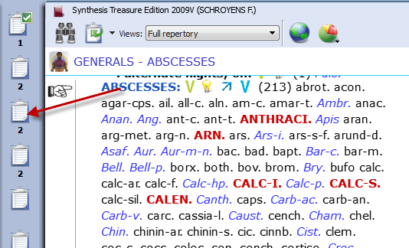
Taking symptoms in a Free way
You could use the Herscu approach in a free way where you take symptoms into different clipboards like you would do normally. Hereby you group the symptoms belonging to a certain ‘idea’ together in the same clipboard.

You can also move symptoms between clipboards via drag and drop, until you are satisfied with the result

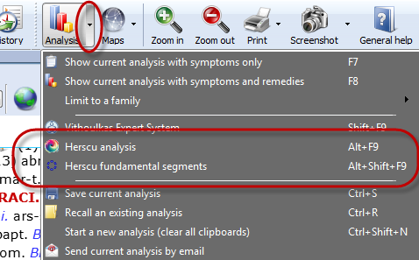
Then you can go directly to the Herscu analysis (Alt+F9), or open the Fundament Segments window first.

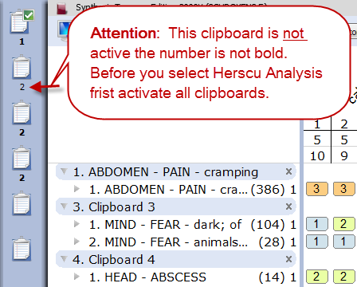
Attention: Pay attention to the fact that All symptom clipboards should be active and used before doing the Herscu Analysis.

You can activate all clipboards with Ctrl+Click on the clipboards, but you can also click once on the normal analysis button.
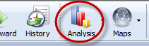

If you then start the Herscu Analysis all clipboards will be included in the analysis (calculation)

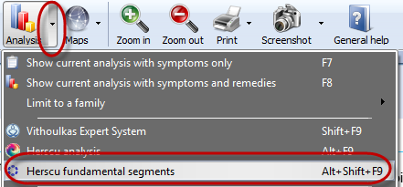
Taking symptoms from the Fundamental Segments Circle

You can also start with empty clipboards and open Fundamental Segments window.

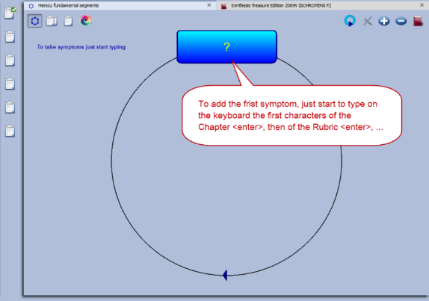
The Fundamental Segments window will open with the first segment.

To add the first symptom in this segment, just start to type on the keyboard the first characters of the chapter <enter>, then select the rubric <enter>, then the characters for a possible sub-rubric <enter>

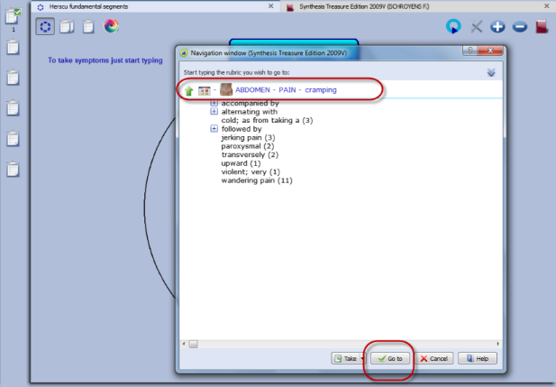
Take this symptom with a last time pressing <enter>.

In the Herscu module when pressing <enter> you select the button Go To. This button Go to will immediately take the symptom into the active segment.

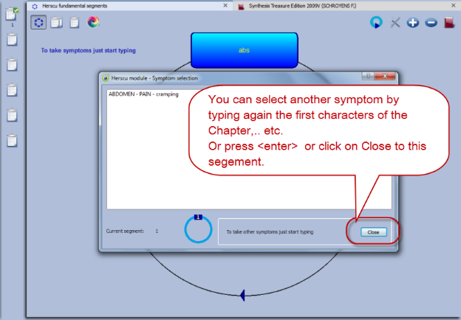
You can then take another symptom in this segment by typing from this window again the first characters of the chapter <enter>, then from the rubric etc.,…
Or you can press <enter> again, or click on the Close button to close this segment.

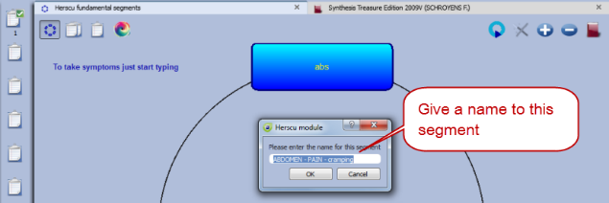
Then you will be asked to give a name to this segment.
By default the text of the first symptom in this clipboard will be used.

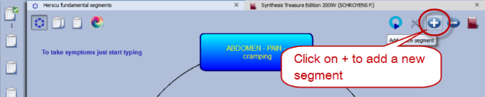
Add a new segment
To add a new segment click on the + icon.

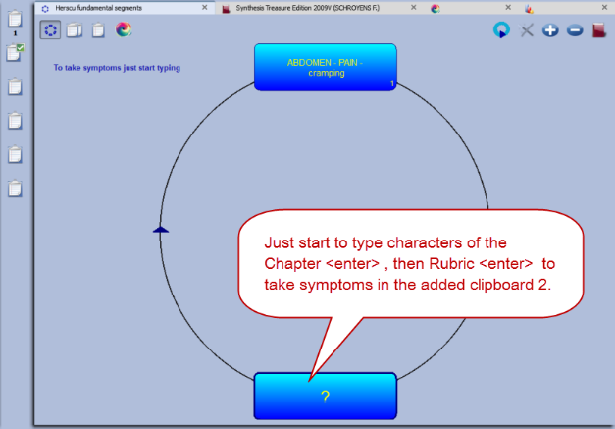

You can then start to add symptoms into the newly added clipboard like you did before with the first clipboard.

In this way you keep on adding symptoms to each clipboard, and adding new segments until you feel the case is fully described.

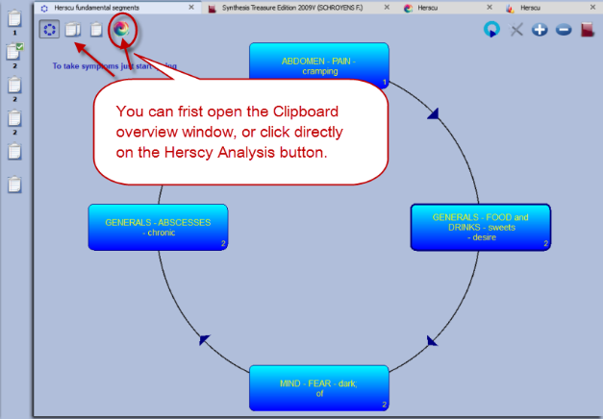

Then you can first open the Clipboard overview window, or click on the Herscu Analysis button.

Interactive mode
It is possible to select an interactive mode which will work slightly different.
To activate it, go via the RadarOpus Options (settings), then General options, then select Herscu. Here you can activate this mode. The result will be that a few messages will be shown while working with the module.

Herscu Analysis window

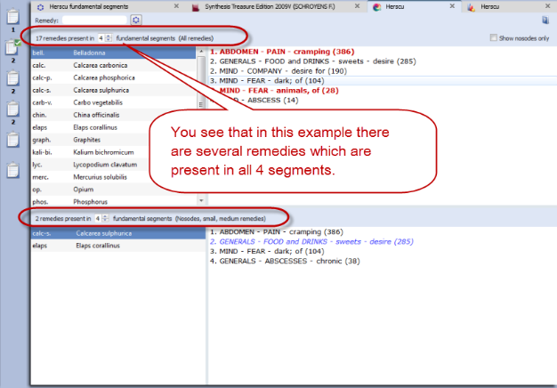
The Herscu Analysis
Because it is important to find the remedy which best covers all aspects of your patient, the Herscu Analysis shows which remedies are present in all segments.

If there is no remedy present in all segments, then those remedies are shown which are present in the highest number of segments.

There is a separate list at the bottom showing the nosodes, small and medium remedies.

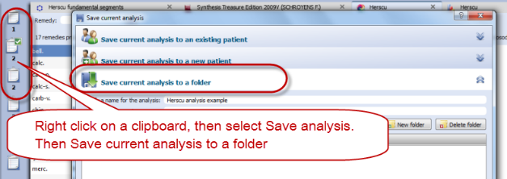
Save the clipboards (analysis)
You can right mouse click on one of the symptom clipboards at the left, then select save Analysis, and save the analysis to a folder

If you want to save the Analysis to a patient in the patient these clipboards will be saved automatically, when saving the patient file.

Boenninghausen Method
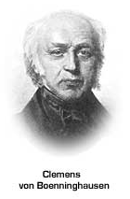

There are many things which could be said about the contribution and teachings of Clemens von Boenninghausen to the homeopathic world, but this is beyond the scope of this manual unfortunately.
RadarOpus offers all of Boenninghausen’s repertories (his German and English books). And three different editions of the Pocketbook repertory. The most extensively researched and annotated edition is the English re-translation by George Dimitriadis called: The Boenninghausen repertory.

Below you will find the following topics:
- A general introduction to the Boenninghausen
- The Boenninghausen Pocketbook repertory (corrected by Peter Vint) & Polar symptom analysis
- The Boenninghausen Pocketbook repertory authorized by Heiner Frei & Frei-Polar Analysis ®
- The Boenninghausen Repertory by George Dimitriadis

Introduction to Boenninghausen

Value of symptoms
In “The Lesser writings” of Boenninghausen you find an interesting article “A contribution to the judgement concerning the characteristic value of symptoms” which discusses in detail which symptoms are most useful to base your prescription on. This is just one of the writings you should really study.

Complete symptom
Boenninghausen discussed in great detail “How to describe a symptom fully”, also called a complete symptom. Later this was condensed and became known as the four aspects of Hering:
- Modalities
- Concomitant (some teachers consider adding this a ‘full case’)
- Sensation
- Location

The construction of the Pocketbook
The Boenninghausen “Pocket Book” repertory was constructed very different compared to his previous repertory called the “Systematisch-Alphabetisches Repertorium”.

The Pocketbook repertory contains mostly generalized rubrics. This in contrast to his previous ‘Anatomical based’ repertory, which contained mainly precise chapters and rubrics (like Kent did later in his repertory).
In reality the difference is not so much as often thought. The Pocketbook does have localized rubrics, and Kent repertory also has generalized rubrics. But Kent and later Synthesis are just much more expanded books.

The idea behind the pocketbook repertory is that symptom descriptions in a certain area, would apply to other areas of the same remedy as well. Therefore when looking up symptoms from your patient, you should look them up in the generalized rubrics first.

Boenninghausen included in Synthesis
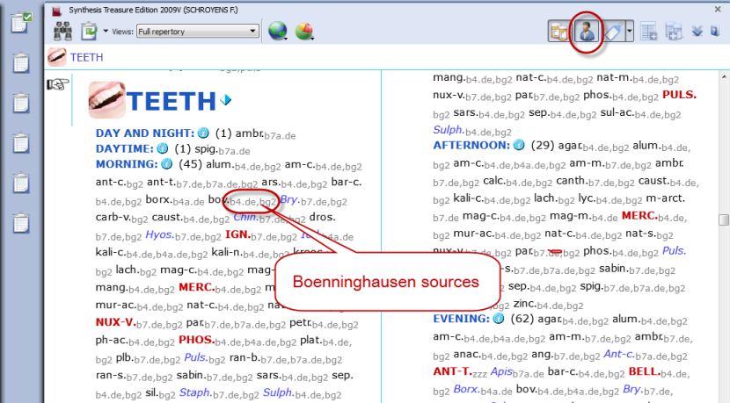
The unique feature of the Synthesis repertory is, that in Synthesis 2009 already almost all of Boenninghausen’s repertories have been included. This has been done in such a way that one can easily see the origin. If a rubric was very generalized, it was added as a separate rubric. Only if the information was very exact, it was added to an existing rubric if it existed, or a new rubric was added.

Example of a few generalized Boenninghausen rubrics:

The chapter Teeth, starts with a few rubrics from Boenninghausen

After you turn On the display of the author references, then double click on an author reference, to see the exact source.

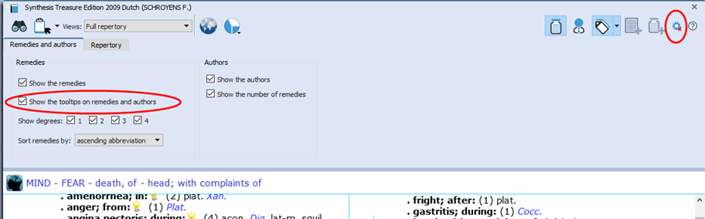
Tip: Via the local option menu you can select Show the tooltips on remedies and authors. This will allow you to see quickly the full description of the author abbreviations.

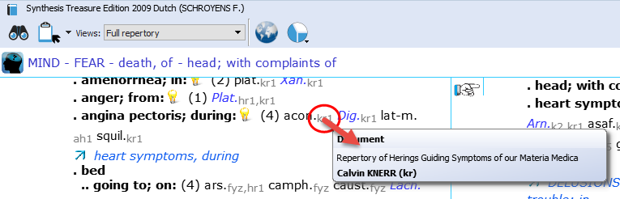

Boenninghausen Analysis Schema
In short here a schema how to analyze a case if you want to do a Boenninghausen analysis (based on information from Luc De Schepper):

You should go over the case, and fill out the schema below with as many symptoms as you can find, then you look them up in the repertory, and take them into a clipboard.

VB Method: Schema (From: Luc De Schepper)
Chief Complaint (I)

Modalities (I): Main Modality 1
Main Modality 2
Main Modality 3

Concomitant Symptoms (I)
Modality 1 of the Concomitant Symptom
Modality 2 of the Concomitant Symptom
Modality 3 of the Concomitant Symptom

CC (I): Sensations

CC (I): Generals (dreams)

CC (I): Location

CC (I): Pathology

CC (I): Mental Emotional Changes

There are possibly more Chief Complaints, which you can also work out, called: “CC - II” en “CC - III”.

Boenninghausen Pocketbook repertory (Allen edition)
RadarOpus comes with an up to date and reliable re-translated and corrected version of the Allen’s Therapeutic Pocket Book, edited by Peter Vint and other well knows German homeopaths.
See video: Polar analysis

- The Pocketbook repertory is available in Dutch, English, French, German, Italian, Portuguese, Spanish.
- There is also a Polar symptom analysis available (optional). This function adds the opposite Polar rubrics automatically with one click, and calculates the Polarity difference.

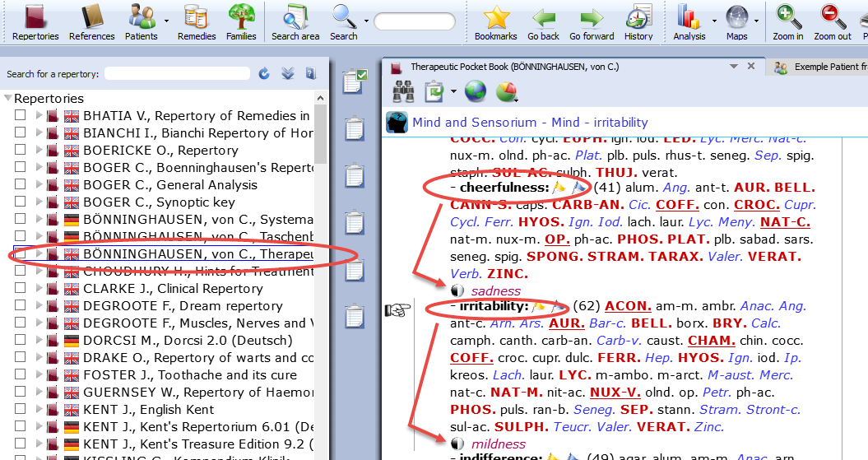
In the Therapeutic Pocket Book from Boenninghausen many rubrics have “opposite polar rubrics’ connected to them (Yin/Yang icon).

Polar symptoms are those symptoms which have an opposite symptom.

Polar difference calculation
In the analysis window you can add the opposite polar rubrics and calculate the polarity difference with a click on the Polarities button.

The following lines are present in the analysis window:
- Sum of symptoms (the remedies are sorted secondary on the sum of degrees)
- The polar symptoms (the sum of degrees of the patient symptoms which have an opposite polar symptom)
- Opposite polar symptoms (this is the sum of degrees of these opposite polar symptoms)
- Polar difference

The Polarity difference is calculated as follows:
- From the "sum of degrees of the patient symptoms which have an opposite polar symptom" are deducted the "sum of degrees of the opposite polar symptoms".
- The higher the Polar difference the better this is for the remedy. The lower the value (or even a negative value) means there are contra indications for that remedy.
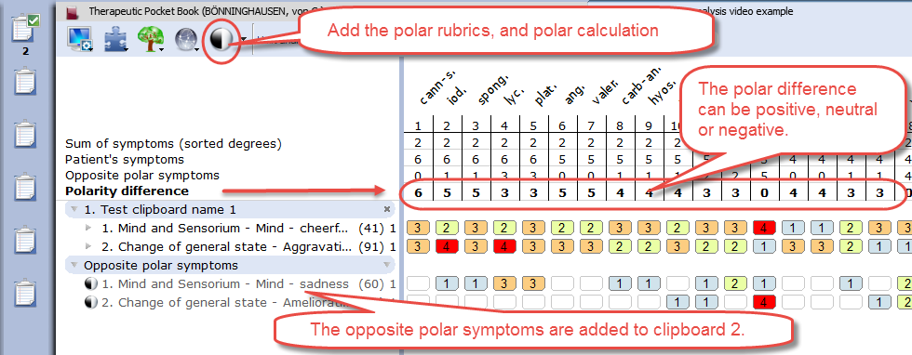

Only rubrics with polar rubrics are calculated: On/Off
Attention: By default, only the degrees of the rubrics that have opposite (negative) polar symptoms are used in the calculation of the polar difference.
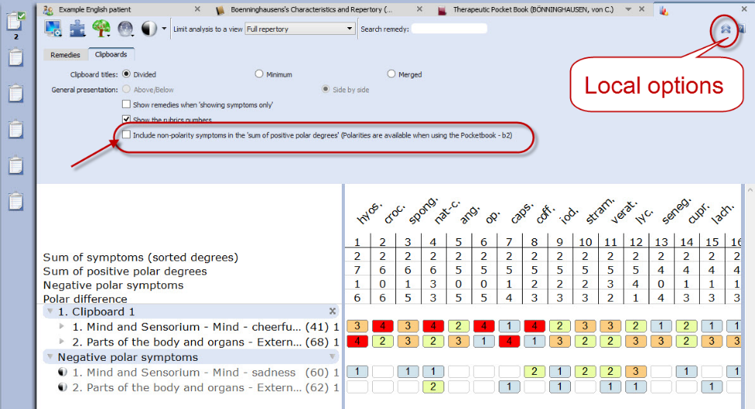
This means, that if you also have a few rubrics in the clipboard which do not have an opposite polar rubric connected to it, the degrees of the remedies mentioned in this rubric are not added to the number “Sum of positive polar degrees”.
Local options:
To switch between using the non-polar symptoms in the calculation or not, can be done via the local options in the analysis window: "Include non-polar symptoms in the calculation of the polar difference"

ATTENTION: Select in Synthesis: The Full repertory view
If your RadarOpus license also includes a Synthesis repertory, you should make sure the Repertory view in Synthesis is set to use the Full Repertory view.

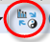
A click on the special button, switches between the “Normal analysis calculation” (Sum of symptoms, with secondary the sum of the degrees) and the “Polar analysis.

- With the normal analysis, the remedies are sorted according to the score in the line: Sum of symptoms.
- With the polar analysis, the remedies are sorted according to the score in the line: Polar difference

Heiner Fei: Pocketbook & Polarity analysis
This analysis method “Frei Polarity Analysis”, has been created in collaboration with Heiner Frei from Switzerland. It is different from the “Polar symptom analysis” done with the Allen’s version of the Pocketbook. The Frei Polarity Analysis comes with a special edition of the Boenninghausen Pocketbook repertory (b2f). This version, based on the 1846 edition but contains many changes to the symptoms, remedies, degrees and polarities as instructed by Heiner Frei.
See video: Heiner Frei – Polarity analysis

A summary of the unique features of the Heiner Frei Polar Analysis:
- The Pocketbook repertory (bf2) has unique corrections and additions from Heiner Frei.

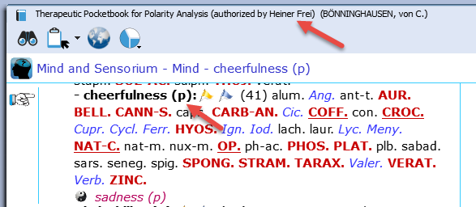
- The specific Heiner Frei Polar symptoms are indicated with a (p).

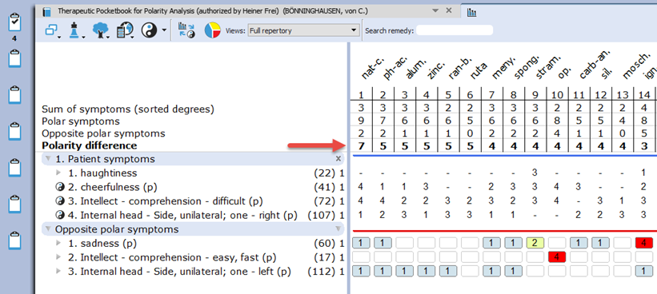
- When opening a clipboard (or a click on the Analysis button, or F8) the opposite polar symptoms are added automatically to the second clipboard (only if one or more symptom are taken which have an opposite Polar symptom).
There is a different graphical display of the analysis (blue and red line), and the contra indications are more clearly shown in red color.

- By default the analysis is sorted on the Polarity difference score.

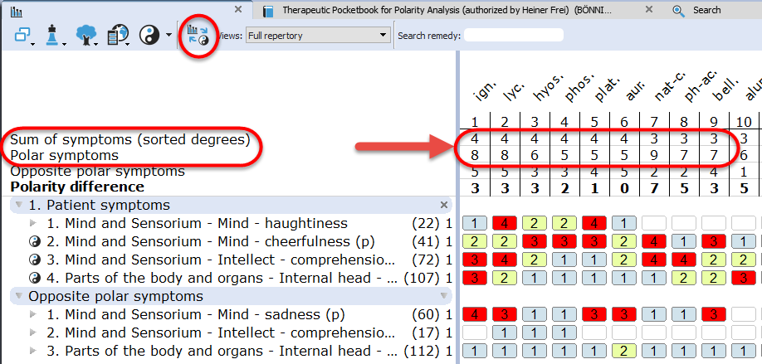

A click on the special button, switches between the “Normal analysis” calculation (Sum of symptoms, with secondary the sum of the degrees) and the “Polar analysis.

- With the normal analysis, the remedies are sorted according to the score in the line: Sum of symptoms.
- With the polar analysis, the remedies are sorted according to the score in the line: Polar difference

Only Polar symptoms are calculated
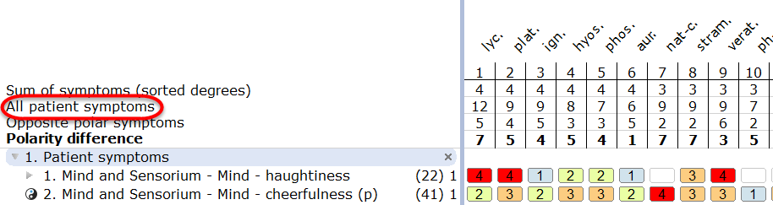
By default only the degrees of the rubrics which have opposite polar symptoms are calculated.
This can be set via the local options button.
If all symptoms are used in the calculation the message changes to: All patient symptoms. Also the full symptom texts are shown, including the chapter names.
(see below more)

- When taking symptoms in the clipboard, the first symptom levels (the Chapter names, and sometimes the main rubrics) are not shown in the clipboard, to improve readability. This is being done according differently in several parts of the repertory, to the instruction of Heiner Frei.
This option to hide/show the full symptom path can be set via the local options button in the Analysis window.
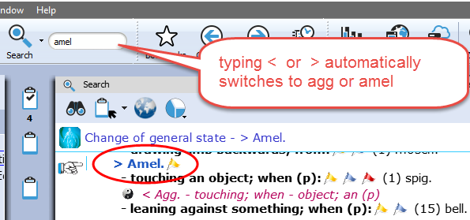
- When doing a word search, typing < or > automatically changes to agg or amel.

- Using Word search in the Pocketbook works often much faster compared to using the Find (navigation window).
You can use the Quick search box, the Simple search (? or F4), or the Advanced search (F5).
The search box or F4 window will always search in the Current document only

- Quick Take:
From the list of the search result an option is available to Take symptoms into a clipboard with only one click. (This can be set in the local options menu of the search window).

- By default, the symptoms that do not have an opposite polar symptom, are not used in the polar analysis score. Only the sum of degrees of the polar symptoms, minus the sum of degrees of the opposite is used in the Polarity difference calculation
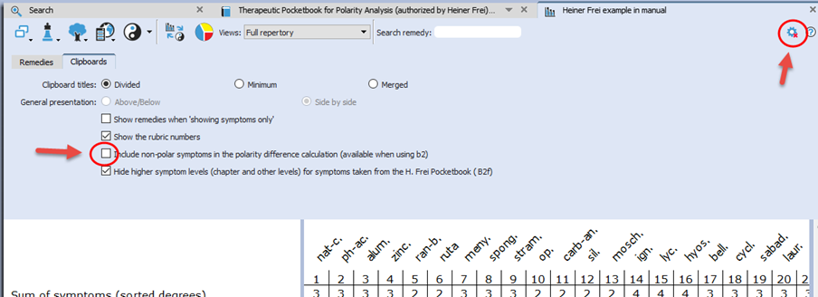

The option to include non-polar symptoms in the polar difference calculation can be changed in the local options of the Analysis window.

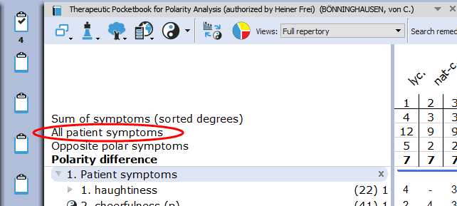
If you select to include also the non-polar symptoms for the Polar difference calculation it is indicated by a different message: All patient symptoms

Normally the message is Polar symptoms, if only the polar symptoms are used for the calculation.

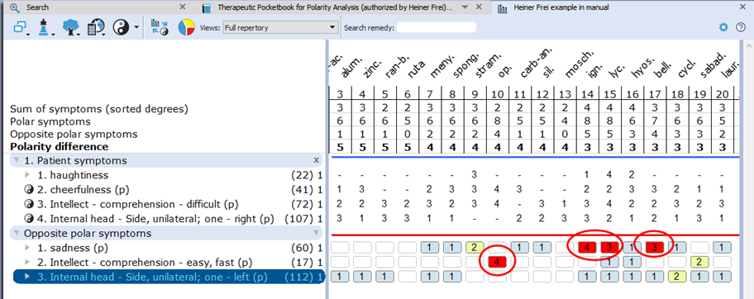
- The analysis window shows in the opposite polar symptoms clipboard more clearly the 3rd and 4th degree contraindications in red color.

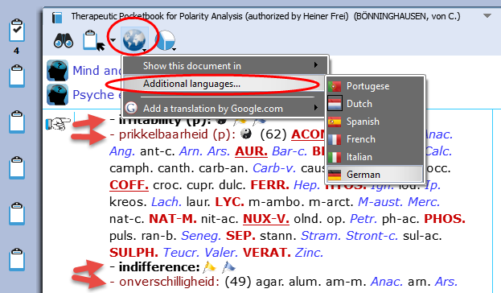
- The Pocketbook is optionally available in several languages. You can purchase a second language, then it is possible to show two languages via the World icon, then select: Additional language

You can also switch the First language.

Attention: a Word search can only be done on the First language.

In RadarOpus 2.0 the following Pocketbook languages are available: Dutch, English, French, German, Italian, Portuguese and Spanish.

Attention: Select in Synthesis: Full repertory view
If your RadarOpus license also includes a Synthesis repertory, you should make sure the Repertory view in Synthesis is set to use the Full Repertory view.

Dimitriadis - Boenninghausen

The Boenninghausen Repertory

Therapeutic Pocketbook Method (Second Edition)

George Dimitriadis, Editor
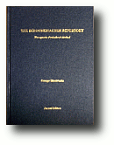
The most accurate English re-translation of Bönninghausen's Therapeutisches Taschenbuch, carefully corrected with reference to his original manuscript.

Available in RadarOpus
For the first time available to the Homeopathic community as electronic version in RadarOpus. Now you can use this unique edition of the Pocket Book repertory to work out your most complex cases. (Note that in this repertory the polar rubrics are not indicated with links, and polar analysis is not available, as Dimitriadis does not use them.)
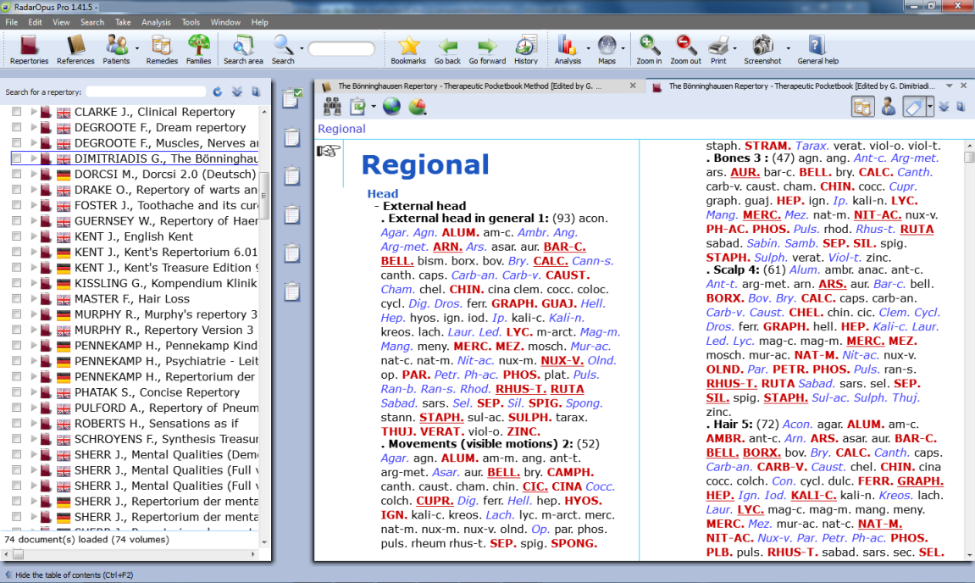

Besides the Boenninghausen Repertory in the RadarOpus repertory section, in the section of References, you can also find a document with an extensive description of the development of this unique edition, all footnotes and all rubric explanations. There is also a practical chapter with case examples how to use this repertory and the Boenninghausen method.

The amount of time, thoroughness and desire for accuracy which went into the creation of this new version of the Boenninghausen Repertory (Pocket Book) is really amazing.
Your cases analyzed according to the Boenninghausen method using this repertory will bring you the highest result possible for your patients.

If you consider purchasing this repertory, but you like to read first more about it, you can read the following articles by George Dimitriadis:

- The Boenninghausen Repertory. The reasons behind the new English translation and re-formation of Boenninghausen’s Therapeutic Tashenbuch.
- The First Repertory. Boenninghausen’s model for our profession.
- An introduction to The Boenninghausen Repertory. Therapeutic Pocket Book method.
- A guide to Homeopathic Diagnosis using the Boenninghausen Repertory, 2nd ed.

Summary of features:

The most accurate and compact repertory fully representing the 125 medicines contained within.
- Every entry checked against Bönninghausen's own TT manuscript and corrections made only after careful reference to source provings.
- Accurate rendering and re-translation of all rubrics from the original German.
- Contains only material from Bönninghausen's original TT thereby maintaining the integrity of the method as was originally intended.
- Removal of all duplicate and synonymous rubrics.

The only repertory with clarification of rubrics meanings.
- Each rubric referenced to its original German TT counterpart
- Expanded section of explanatory endnotes (first introduced in TBR1) clarifying the precise meaning of the rubric
- Many more rubrics now referenced to the source provings with full rendering of the entire symptom as found in the materia medica
The only repertory with consistent and meaningful grading system.
- Thorough rechecking of grades from the original TT manuscript
- Accurate representation of the original TT allows the consideration of Bönninghausen's own clinical experience in the analysis
The advantages using RadarOpus with the Bönninghausen Repertory
You can use all the advantages of RadarOpus with this repertory: A quick Find and powerful Word search function. The use of several symptom clipboards. You can store you Boenninghausen analysis efficiently in the same patient file together with all other details of the case.

The Advanced patient file search also allows you to trace back quickly things like: show all cases where you have used a certain symptom, mentioned a certain pathology or gave a certain remedy.

If you also have the book edition, you can also use ‘the rubric ID numbers’ in the electronic version to quickly select the rubrics to repertories on.

Disease Classification of Hahnemann

Ewald Stöteler

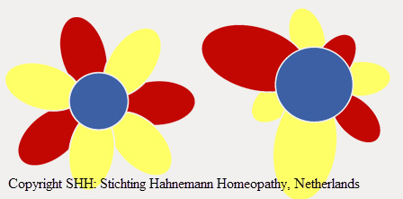
- In this chapter tips how to adapt your RadarOpus to use with the Disease Classification of Hahnemann.
- You need to have the special Disease Classification-package, or the largest general RadarOpus engine. Your package needs to include minimal 8 symptom clipboards, the advanced patient file, and the families repertories.
- Some general topics are repeated which are already explained in other chapters also.

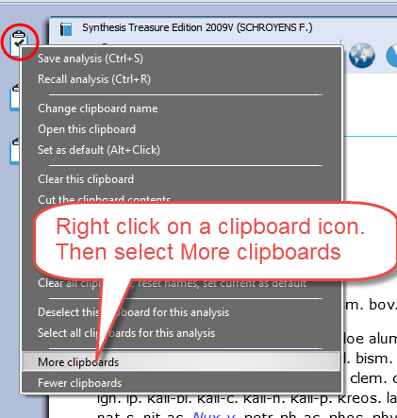
8 Symptom clipboards

Right mouse click on one of the symptom clipboard icons and select More clipboards until you have all 8 clipboards visible.

Clipboard names and order
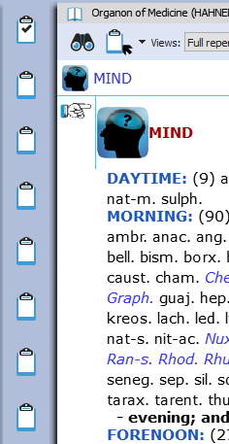
You could prepare a little note mentioning the order of clipboard names corresponding to the DC and stick it to the side of you screen as a reminder.
(In one of the next versions of RadarOpus it will be possible to permanently give clipboards a different name)

You could use the following description for the clipboards:
- Constitutional (psora)
- Acute miasmatic diseases
- Incidents
- Epidemic diseases
- Iatrogenic diseases
- Inherited tendencies
- Sycosis
- Syphilis

Create a new patient
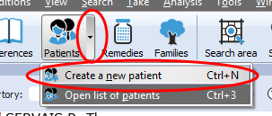
It is best to always start by creating a New patient files (or to open an existing one).

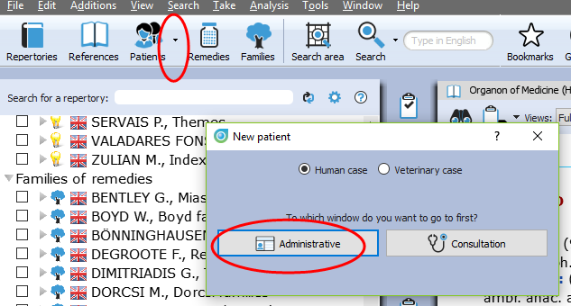
Then select Administration or go directly to the Consultation.

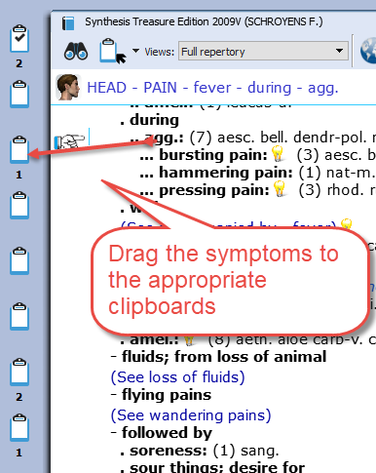
Taking symptoms
With the Disease Classification you will want to organise the symptoms which you take over the 8 clipboards.
- Take with the mouse: You can take the symptoms into the correct clipboard by drag and drop.

- Take with the keyboard: You can use the following keyboard commands to take symptoms directly into the correct clipboard:

For example, to place a symptom in clipboard 3:
Press the + key, followed by >3 then enter:
+ > 3 <enter>
This will place the symptom into clipboard 3, with the default intensity 1.

Take with a higher intensity directly into a different correct clipboard:
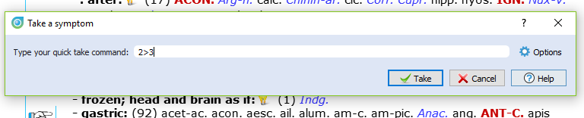
To take a symptom also with an additional intensity, for example 2, and place it into clipboard 3 you need to press the following keys:

+2 >3 <enter>

The + opens the take menu, the 2 indicates the intensity, the >3 sends it to clipboard 3.

Patient file - Disease Classification Labels
In the patient file text editor, you can type the symptoms of the case.
To help you organise the text into separate “topics” (symptoms, or related text) you can use the following two keys on the keyboard:
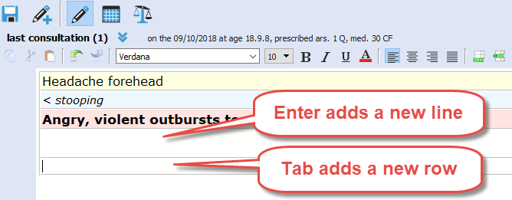
Adding new lines or new fields:
- If you press the <enter> key you will create a new line within the same field
- If you press the <tab> key you will create a new field (row).

Intensity
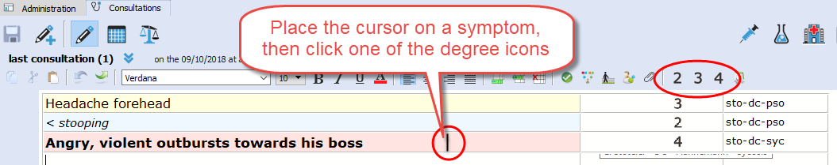
By default a symptom has the lowest intensity 1. You can add a higher intensity with the buttons 2, 3, 4.

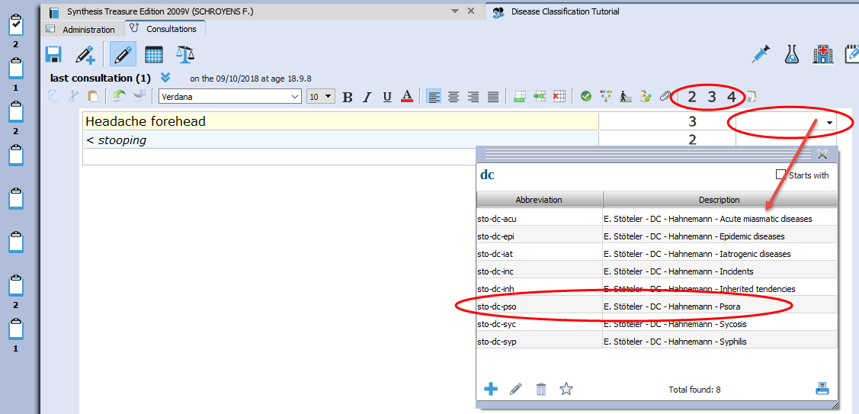
Disease Classification labels
For each symptom you can indicate to which Disease Classification group it belongs.
To open the picklist of labels (tags) you can use the following two methods:
- Press on the keyboard the F9 key.
- Or click in the last field on the arrow down.
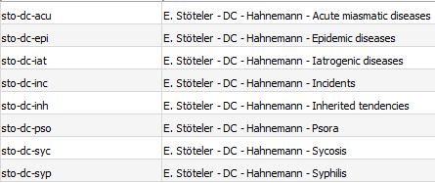

Just start to type a few letters, e.g. DC and select one of the Disease Classification labels.

In RadarOpus a “Label” is also called a “Tag”.

Show all symptoms belonging to a certain DC category
When you are ready with the consultation text and added the labels, with a single click in the last column on one of the added labels (tags), you will see all symptoms belonging to that category.

You can switch to see all tagged symptoms for the current consultation only or for all consultations.

A single click on a tag shows all symptoms of this category:

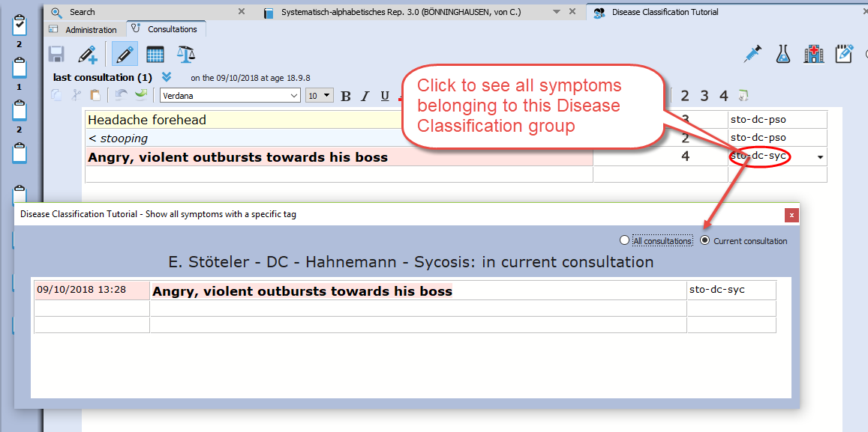

Prescription: note the remedies you prescribe
You should enter each remedy you prescribe in a different field at the bottom of the screen in the Prescription/Pathology window.

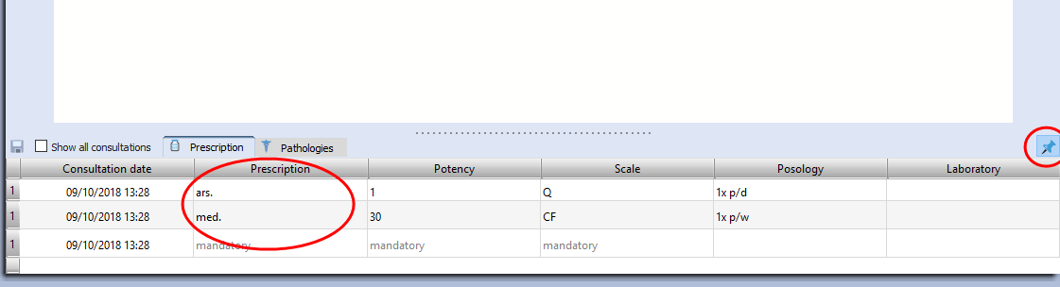

Contextual menu of the text editor
The text editor has powerful functions to study the case. Right mouse click on a symptom (sentence) to open a contextual menu.

Word search
From here you can select to search for words occurring only in the current consultation or all consultations of this patient.
Tip: If you want to search through all your patients on a word, use the menu bar Search, Search in the patient file.

Sow tagged symptoms
You can also limit the text to show only symptoms with a certain tag (category).
Or you can show all symptoms with a certain tag in the current consultation or all consultations.
Have a look at all the available options in the contextual menu.

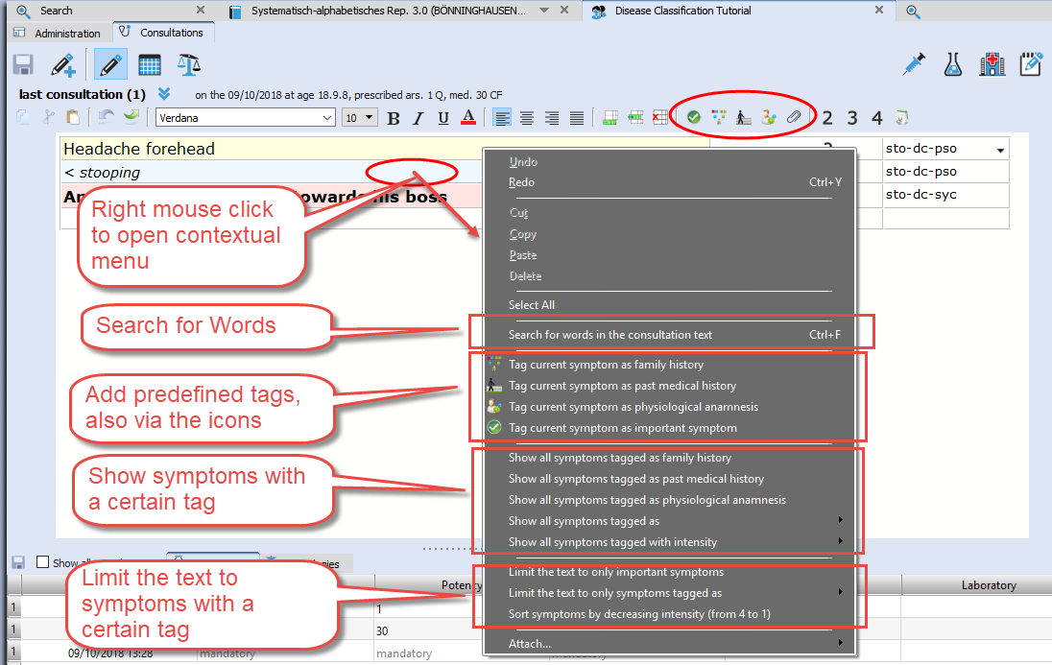

Extended search
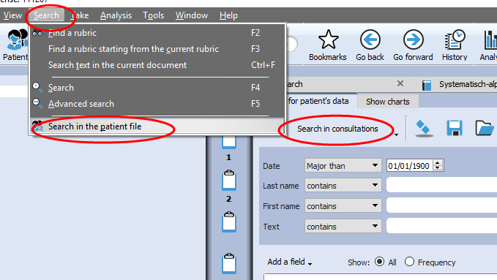
If you want to do a search through all patients, use the menu bar Search, Search in the patient file

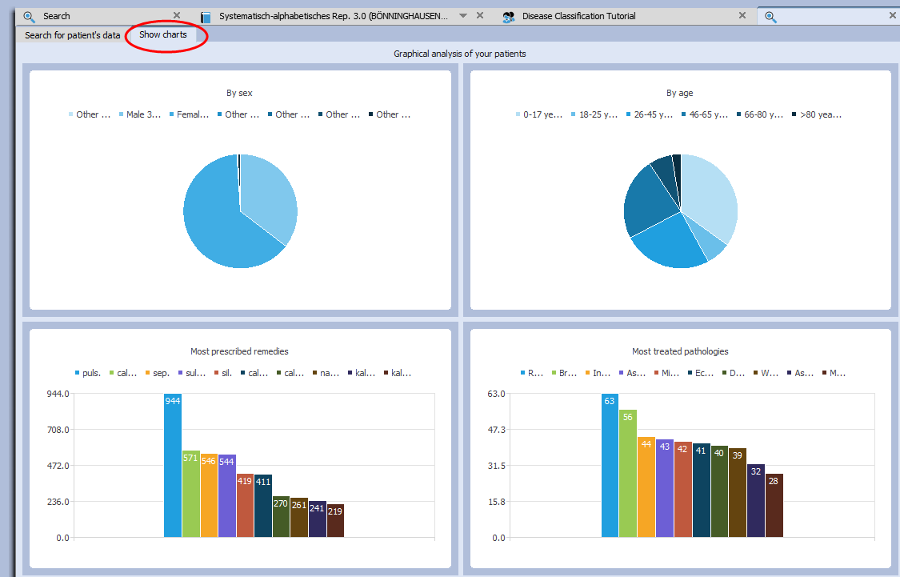
Here you can also see a statistical overview of your patient database.

Highlight or Limit a certain groups of remedies (family) in the analysis
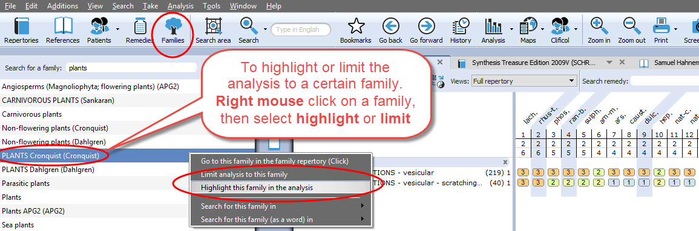
Open the list of families, select the family you need, e.g. PLANTS (Cronquist), then Right mouse click on it.
From the menu select highlight or limit this family in the analysis.

Remove a Limit to a family
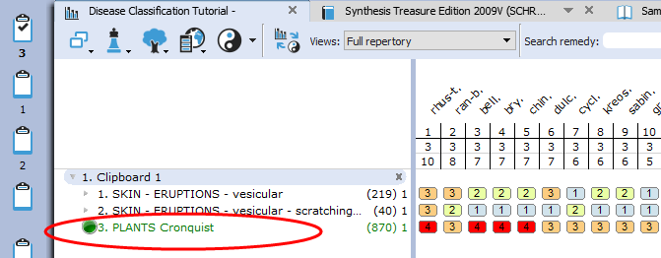
When you select a family to Limit the analysis to, an eliminative rubric has been added to clipboard 1.

To delete is, you can just delete the rubric, with the DEL key on the keyboard or Right mouse click, Delete.

For more information about Hahnemann’s Disease Classification, please visit
https://www.klassiekehomeopathie.nl/de-ziekteclassificatie2/

Analyzing using several clipboards
Read also the chapter about symptom clipboards for more information, here is only mentioned how to turn a clipboard On/Off for the analysis.

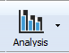
The Analysis button in the main toolbar will open the analysis with all clipboards On.

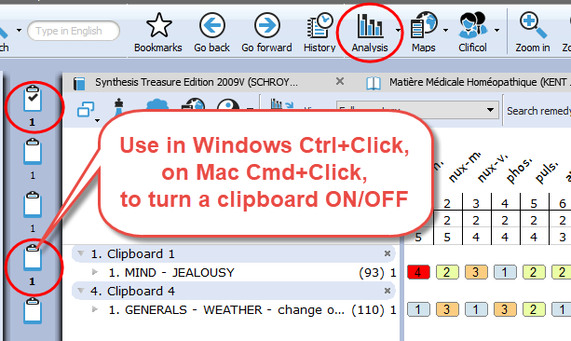
A single click on a clipboard icon shows only that single clipboard.

With Ctrl+Click (Windows), or Cmd+Click (Mac) on any of the other clipboards will turn these clipboards ON or OFF.

In this way you can analyze on any combination of clipboards.

Moving symptoms between clipboards
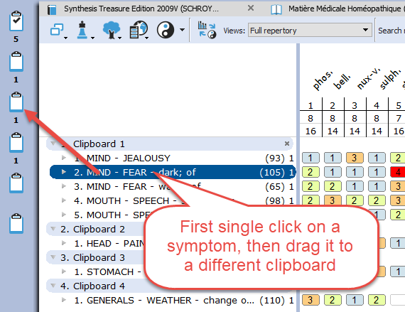
First single click on a symptom to highlight it, then drag it to a different clipboard icon.

Tip:
You can also select several symptoms with Ctrl+Click (Windows) of Cmd+Click (Mac)
Then drag them to a different clipboard.

Miasmatic Analysis:
Giampietro – Ortega
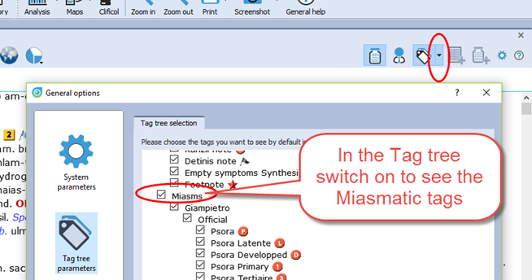
Settings:
To work with the Miasmatic analysis, you should change in the default settings two things:

- Show the miasmatic tags: From the Synthesis window, open the List of tags, and select Miasms.

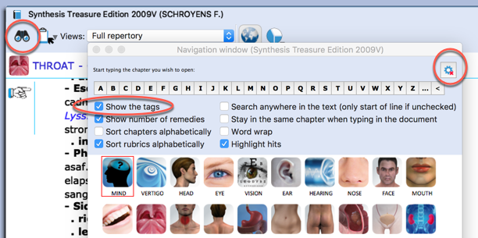
- In the Find window you can also select to show the Miasmatic tags if you like to see them.

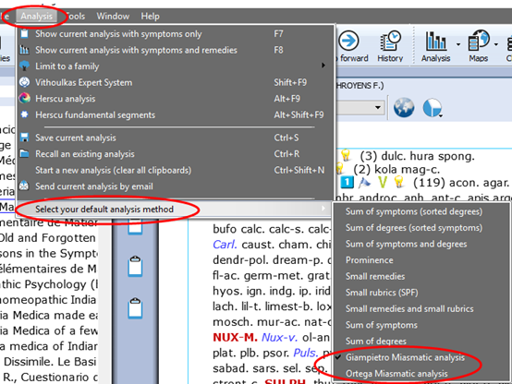
Step 1: Activate the Miasmatic module

- Select as default analysis method one of the miasmatic methods:
- Giampietro Miasmatic analysis
- Ortega Miasmatic analysis

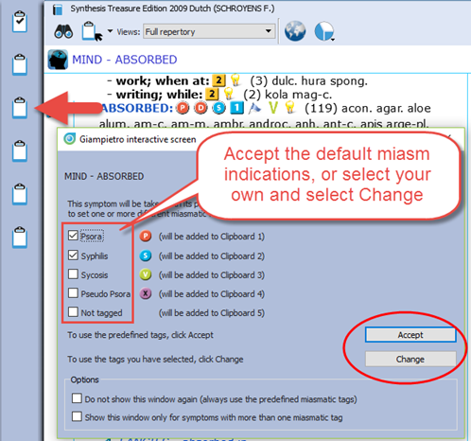
Step 2: Take symptoms
Drag a symptom to the clipboard bar to take it.

You do not need to drag and drop it to a specific clipboard, just drag to any location on the clipboard bar.

Step 3:
A dialog box will open, asking what to do with this symptom:

You can keep the indicated miasm(s), or make changes and select your own miasm(s) tags:

- To keep the default miasm(s) select Accept.
- If you make changes, select: Change

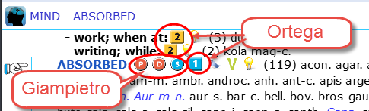
Giamietro tags are round circles
Ortega tags are the square boxes

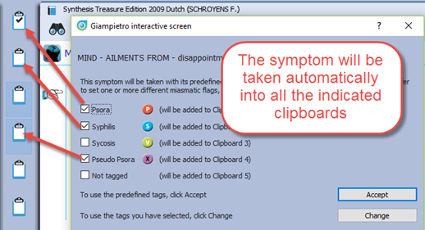
Click on Accept (or on Change if you have made changed), and the symptom will be taken into all the indicated clipboards.

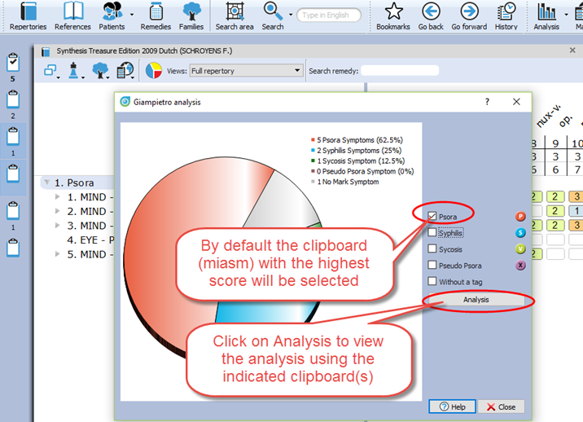
Step 4:
A graph opens showing the relative importance of each miasm.

By default the miasm with the highest number of symptoms will be selected.
You can make changes to the selected miasm, or select several miasms.

Step 5:
Click on Analysis to show the analysis using the selected miasms.
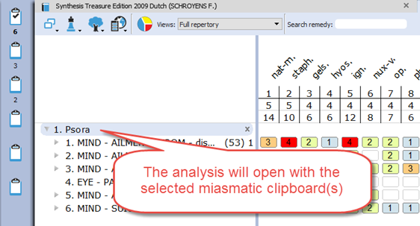

Then the analysis window opens, using the indicated miasmas (clipboards).

